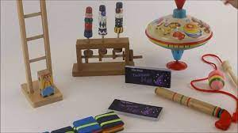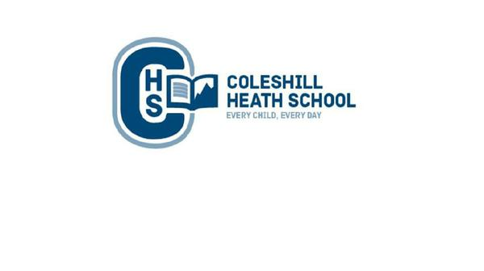

**RE**

Judaism

Shabbat and Hannukah

**Science**

**Everyday Materials**

* distinguish between an object and the material from which it is made
* identify and name a variety of everyday materials, including wood, plastic, glass, metal, water, and rock
* describe the simple physical properties of a variety of everyday materials
* compare and group together a variety of everyday materials on the basis of their simple physical properties.

**Seasons**

* observe changes in the spring and summer season.
* Discuss changes in the weather linked to the seasons.

**Computing**

**Summer 1 – Spreadsheets**

* To understand what a spreadsheet looks like.
* To add images to a spreadsheet
* To use tools to count items on a spreadsheet

**Summer 2 – Technology outside school.**

* To find and understand examples of technology used in our community
* To record examples of technology outside of school.

**Art & Design and Technology**

**Art** – Paul Klee – Create a collage that makes a portrait

**D&T** – Harry Corbett - Handpuppets

**Music**

Create music using instruments. Use pictures to notate music.

**Maths**

Division

Fractions

Geometry: Position and Direction

Place Value within 100

Money

Time

**Connecting Curriculum**

**Summer 1 – Connecting to a Safer Me**

**Summer 2 – Connecting to a changing me**

**English**

**Summer 1**

**Fiction Text:** Toy Story/ Supertato

**Non-Fiction Text:**

Persuasion: Advert for a new toy

Playscript**:** Jack and the Beanstalk

**Summer 2**

**Fiction Text**: The Magic Pebble

**Non-Fiction Text:** Diaries

**Year 1 summer**

**MEMORY BOX**

**History**

Understand that things have changed from the past until now.

Learn about how toys, schools, transport and hospital have changed over time.

Learn about Florence Nightingale and Mary Seacole and understand their contributions to the improvement of hospitals.