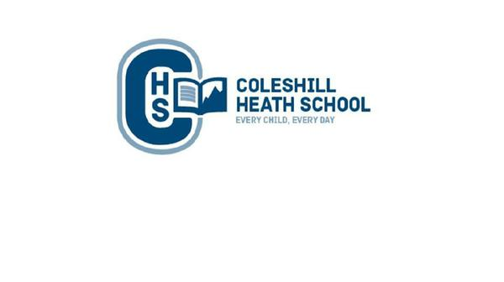

**English**

**Fiction Text:** The Story of Pirate Tom – An adventure story.

**Non-Fiction Text:** Discussion:Should pirates be captured?

*Should we do more to look after our oceans?*

Pirate poetry by Kenn Nesbitt

**Fiction text:** How Kangaroo got her Pouch **-** Folk Tale

**Non-fiction focus:** Non-chronological Report -A fact file/report about Kangaroos.

**History**

We will be learning about how the use of beaches have changed overtime.

We will be learning about Captain James Cook.

**Computing**

Creating Pictures- We will learn how to use a computer program to create art by repeating patterns in a variety of ways.

Spreadsheets- We will learn how to produce a graph from a spreadsheet.

**Maths**

Measurement**:** Mass, Capacity and Temperature

We will be learning to measure mass accurately in grams using weighing scales.

We will be learning to measure in litres and millilitres to describe the volume

We will be learning to estimate temperature and read scale on a thermometer

Measurement: Time, We will be telling the time to the nearest 5 minutes.

Number: Revising the four operations. Addition, subtraction, multiplication and division.

**Science**

Plants- We will be learning about what a plant needs to survive. We will observe seeds and bulbs growing.

**Geography**

We will be using maps to locate seas around the UK and oceans around the world.

We will be looking at human and physical features of Weston - Super – Mare.

We will be learning about the Gold Coast and beaches around Australia.

**RE**

We will be learning about Islam, looking at Haji and belonging.

**Music**

We will be exploring improvisation

**Art, Design and Technology**

Art – We will be learning about the artist Kaffee Fassett and produce a textiles product.

DT – We will be learning how to produce a seaside snacks

**Year 2 Off to the beach!**

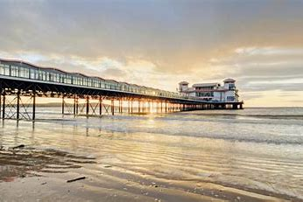

**Connecting Curriculum**

We will be learning about how to keep safe physically and mentally

We will be learning about the human life cycle.