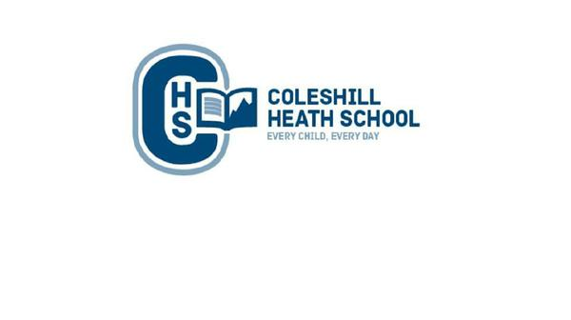

**Geography**

Location and place knowledge /Physical and Human environment

We will be learning to:

* Locate the world’s countries and continents using maps to focus on Europe.
* Name and locate rivers in the United Kingdom (The Thames, The Severn and Mersey). Learn about the River Thames journey from source to mouth. Understand what pollution and flooding is and its effect. Identify the use of rivers and their importance to humans and wildlife. Understand the water cycle.
* Learn about the different types of natural disasters including recent events. Children to understand and label tectonic plates on a map of the world.
* Research about a significant volcano and earthquake disaster.
* Identify the different layers of the earth – crust, mantle, outer core and inner core.

**Year 3 – Summer**

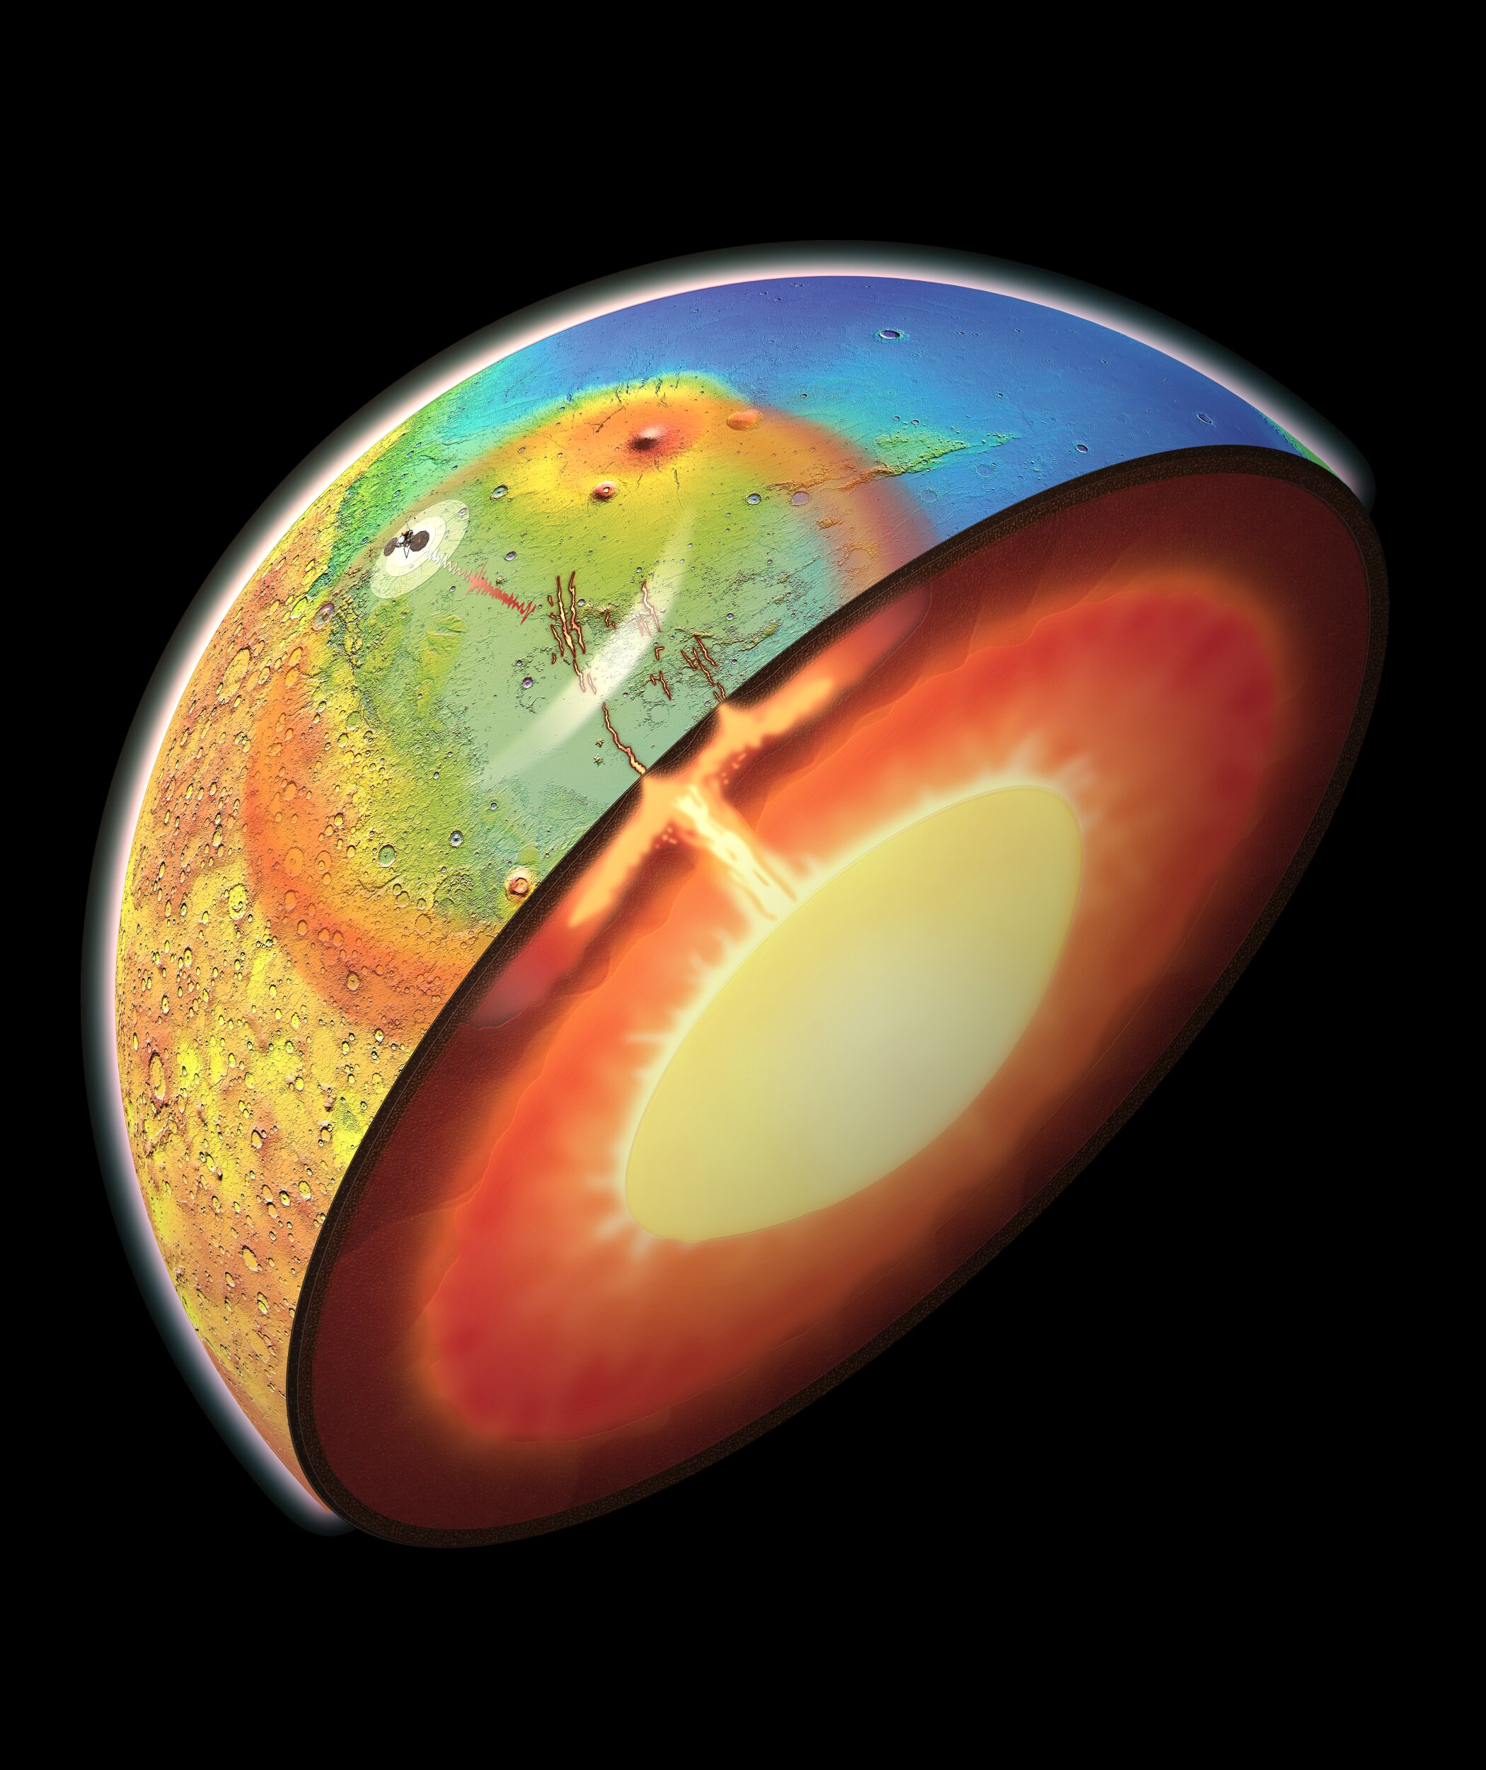

**active planet**

**English**

**Fiction Text:** *Charlie and the Chocolate Factory* – Wishing Tale

This half term we will be orally rehearsing and learning Charlie and the Chocolate Factory. We will be focusing on effective use of vocabulary and punctuation.

**Non-Fiction Text:**– Explanation – How is chocolate made?

**Cross curricular writing:**

* Explanation – A natural disaster (news reporter)
* Letter – Key issues around the world.

**Maths**

**Summer 1:**

Number: Fractions  
Measurement: Time  
  
  
**Summer 2:**Geometry: Position and Direction   
Measure: Mass, Capacity and Temperature

**Connecting Curriculum**

The children will be learning about keeping safe both physically and mentally. They will also be looking at the human life cycle (female and male body changes).

**Computing**

**Spreadsheets**- We will use learning how to use spreadsheets.

**Branching Databases** – We will learn what branching data is and how to create one.

**Music**

We will be continuing to learn how to hold and play the ukulele.

**RE**

Hinduism - Understand Diwali beliefs and looking at the Pilgrimage to the River Ganges.

**Art, Design and Technology**

Research, explore and create a layered picture using pastels and paint. Children will also be learning how to tint and shade for desired effort.

**Science - Plants / Animals including humans**

**Plants -** We will also be identifying functions of a plant, investigate how water is transported within plants and explore the life cycle of a plant.

**Animals including humans-** Children will identifyhuman and animal skeletons / muscles. We will also be looking at the diet / nutrition of animals**.**

We will also be learning how to work scientifically.