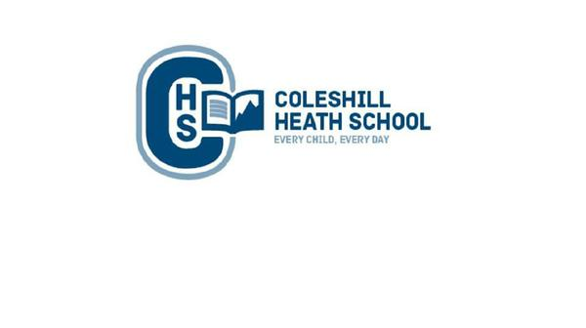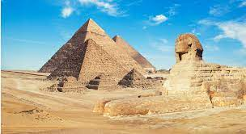

**Science**

**Electricity/ Animals including humans**

**Electricity –** We will be looking at electrical circuits and the components needed to make one. We will be identifying which items need batteries and which items don’t.

**Animals including humans-** Children will identifyhuman and animal skeletons / muscles. We will also be looking at the digestive system.

We will also be learning how to work scientifically.

**Music**

We will be looking at how music is written to express feelings using different types of musical notes.

**RE**

Christianity- Understand the importance of prayer and worship in the Christianity religion.

**Computing**

**Effective searching:** We will use search engines and key words to search effectively.

**Spreadsheets**- We will learn how to use spreadsheets to retrieve key information.

**Art, Design and Technology**

In Art we will be using stencils to show repeated patterns. Looking at the artist Andy Warhol.

In Design and Technology, we will be baking Egyptian style bread.

**History**

We will be learning about:

* Learn about their way of life including religion, settlement and social and economic factors.
* Learn about the importance of the River Nile.
* Understand the process of mummification and the purpose of Pyramids.

**English**

**Fiction Text:** *The Door and the Dragon – A portal story*

**Non-Fiction Text:**– Persuasive travel – Enchanting Egypt **Poetry** - Portable paradise poem – Roger Robinson

**Cross curricular writing:**

* Explanation – How are the pyramids made and what are the different levels used for?
* Letter – A letter about the finding of Tutankhamun.

**Maths**

**Summer 1:**

Measure: Money Measure: Time Statistics  
  
**Summer 2:**Geometry: Properties of shape Geometry: Position and direction Number: Revising the four operations. Addition, subtraction, multiplication and division.

**Geography**

Location and place knowledge /Physical and Human environment

We will be learning to:

* Locate Egypt on a world map.
* Locate surrounding seas and oceans near Egypt
* Find and plot the Tropics of Cancer, Tropics of Capricorn and Equator.

**Year 4 – Summer**

**Ancient Egypt**

**Connecting Curriculum**

The children will be learning about keeping safe both physically and mentally. They will also be looking at the human life cycle (female and male body changes).