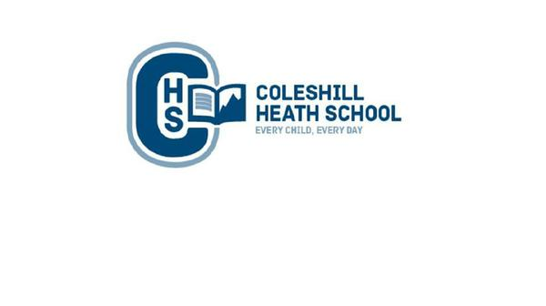

**History**

We will be learning about:

* Ancient civilisations of the Mayans and using artefacts to discover how they lived (i.e. religion, settlements, and trade).
* Traditions of the Mayans and taking part in a Day of the Dead day.
* The achievements of the Mayans and their developments within astronomy and architecture.

**Geography**

We will be learning to:

* Locate countries and name principal cities in Mexico
* Compare Mexico to the UK by identifying similarities and differences in human and physical features.
* Identify the development of human geography and the change in land use from the Mayans through to modern day.

**RE**

Sikhism: Understanding the importance of prayer and worship.

Christianity: Understanding the beliefs and practices for Christians.

**Computing**

Spreadsheets- We will use learning how to use spreadsheets.

3D Modelling – We will be learning how to create 3D modelling.

**Year 5 – Summer**

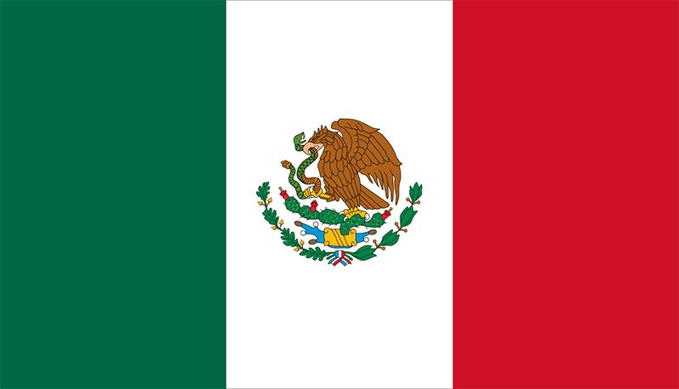

**Hola Mexico**

**English**

**Fiction Text:** *Tibicena – defeating a monster story.*

This half term we will be orally rehearsing and learning ‘The Tibicena. We will be learning a number of skills to be able to write a detailed character description.

**Non-Fiction Text:**– Debate - Range of topics such as: Should plastic be banned? Write a balanced argument.

**Cross curricular writing:**

Persuasive writing - Children to create a travel brochure for tourists.

* Children to complete a diary entry of someone who has time travelled from Ancient Maya to modern day Mexico.

**Maths**

**Summer 1:**

Number: Decimals

Geometry: Properties of Shape

Geometry: Position and Direction  
  
  
**Summer 2:**Measure: Converting Units

Measure: Volume

**Connecting Curriculum**

The children will be learning about keeping safe both physically and mentally. They will also be looking at the human life cycle (female and male body changes).

**Music**

We will be learning how to play steel pans focusing on being able to maintain rhythms, read notations and play a piece of music in unison.

**Art, Design and Technology**

Research, explore and create a portrait of Frieda in the style of Anthony Browne. Children will be using Mexican flowers for their innovation linked with our topic.

Portrait with oil pastels – Frieda Kahlo

**Science – Forces/Earth and Space**

**Forces -** We will be identifying different forces and investigating how they can have an impact on day to day life.

**Earth and Space:** Children will be describing the movement of planets, the moon and the sun within the solar system. They will then be using this information to explore and investigate how day and night on earth occurs.