

Movement Monday – Be Active

**2**



Physical activity can improve wellbeing, reduce anxiety and depression

• Aim to be active every day and minimise the amount of sedentary inactive time

• Over a week aim to accumulate at least 2½ hours of moderate intensity activity eg. 30 minutes on at least 5 days a week

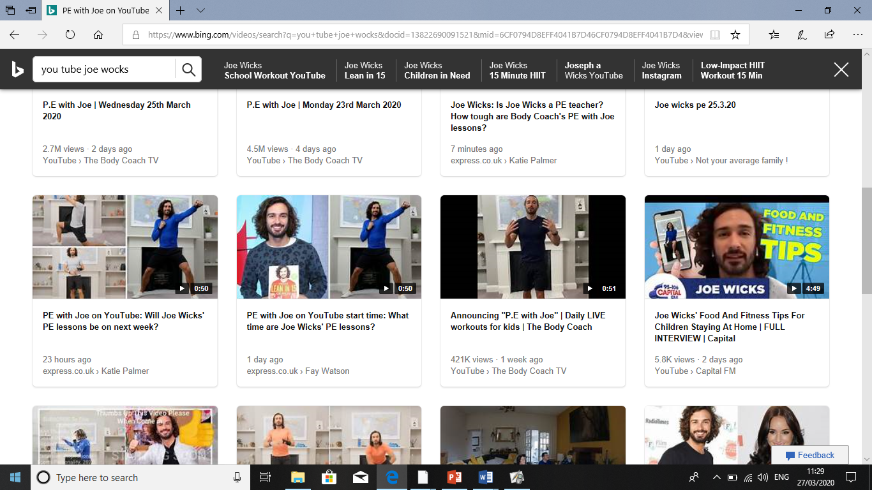

**1**

Just Dance videos on **You Tube** or on the Nintendo Wii (if you have one) are great for keeping active. Our favourite at home is Waka Waka. The kids like to choose which character they are at the start. Great family fun.



**3**

Joe Wicks, The Body Coach is streaming live every weekday on YouTube at 9am. This is a great start to the day.

The government have said that we can leave the house for one exercise a day with other members of our household. This week try a family run together. Here is the weather for **Chelmsley Wood** this week. Try to get out everyday, just to see the world beyond our house.

