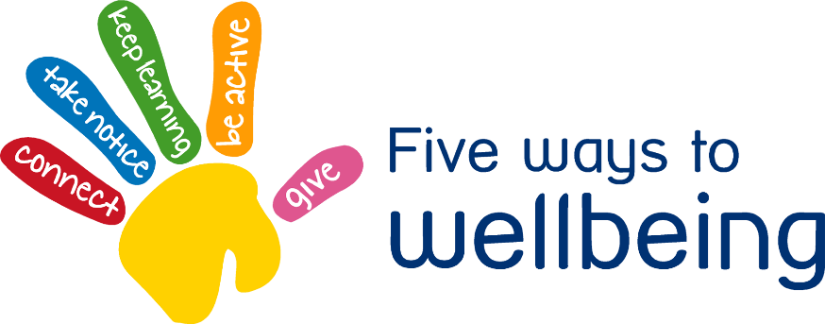

Physical activity can improve wellbeing, reduce anxiety and depression

• Aim to be active every day and minimise the amount of sedentary inactive time

• Over a week aim to accumulate at least 2½ hours of moderate intensity activity eg. 30 minutes on at least 5 days a week

Movement Monday – Be Active

**2**

[](http://www.nationaltrust.org.uk/)



**3**

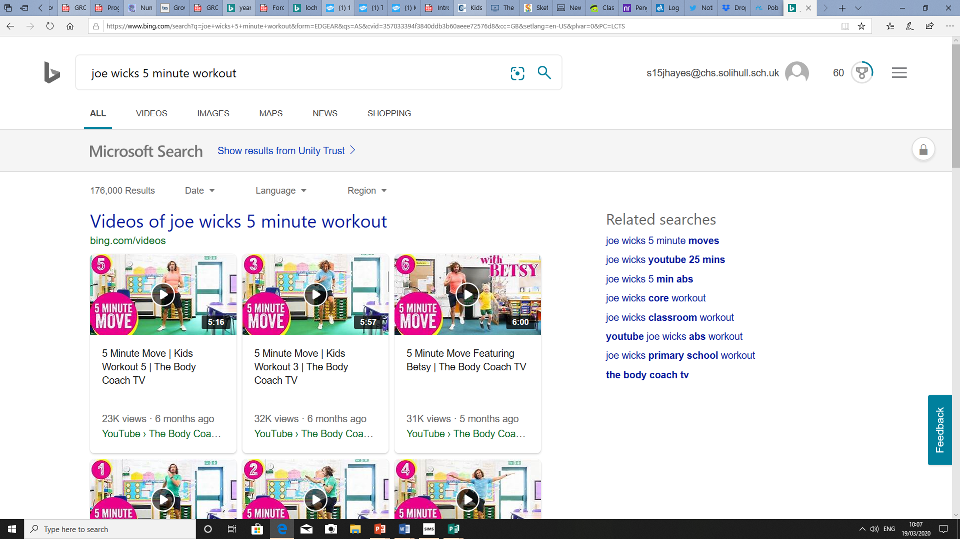

Joe Wicks, The Body Coach has 5 minute workouts for Kids. We use these in the classroom for brain/movement breaks, they are a great way to get active and release energy and anxiety.

**1**

During the Coronavirus outbreak the National Trust are opening their beautiful grounds to the public **free of charge**. It is important to **get fresh air**, without contact with others, during this difficult time.

Go Noodle is a great website that combines catchy songs to dance routines. This is used, in particular, in our EYFS and KS1 classrooms. However, this is great fun for all of the family.

**4**



There are lots of lovely parks and open spaces in **Chelmsley Wood.** Go for a walk, just remember to take the necessary precautions.