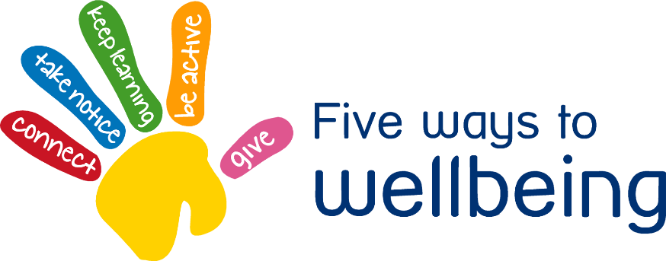

Take Notice Tuesday

Take notice, being aware and mindful is associated with positive mental health and wellbeing

• Take time to notice and appreciate nature, everyday life and moments

• Be aware of the world around you and how your body responds to this and what you are feeling

• Pause and reflect – think about what you are grateful for.

• Learn to recognise signs of poor mental health and stress in yourself and your friends and family : - Changes in sleep or eating patterns - Angry for no reason - Anxiety - Difficulty concentrating and making decision

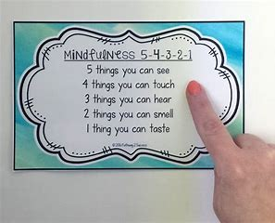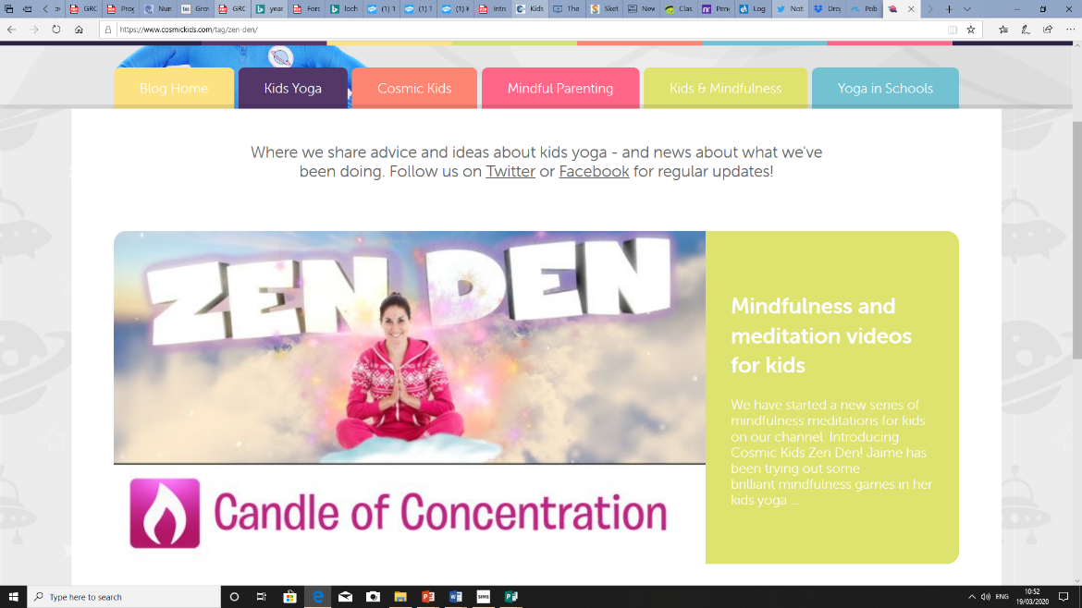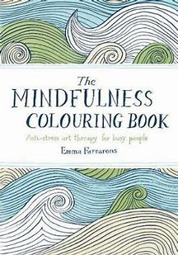

**1**

**3**

https://www.cosmickids.com/tag/zen-den/

We use Yoga with Adriene in Class Inspire all the time. There are lots of different sessions and you can choose a difficulty to suit you. We find this very calming and challenging at the same time.

There are lots of Mindfulness colouring books available if you are able to get to shops.

**2**