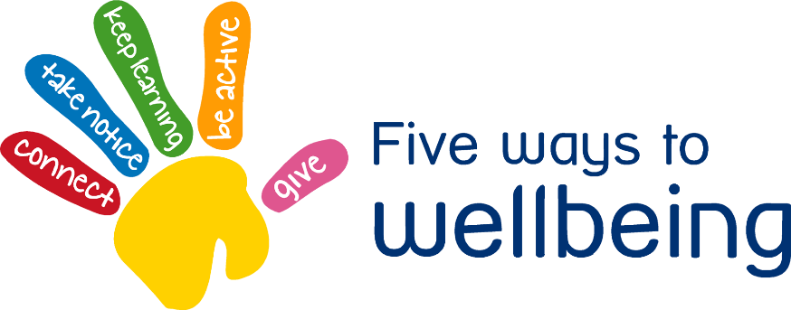

Want to Learn Wednesday

Learning something new is positively associated with mental health and wellbeing

• Try something new or rediscover an old interest

• Take on a challenge or skill you will enjoy achieving

• Think about what you would like to learn, what your interests are and what would be useful in your life.



Learn to cook – why not include the family in cooking dinner together?

**1**

**3**

**2**



Learn a new skill or perfect an old one. Learn a new times table or spelling rule. Don’t give up.

Learn to play an instrument







**4**

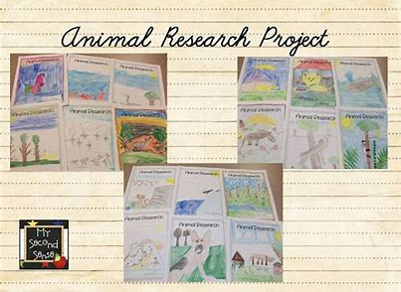

Read a book

**5**

Research and write a project about a new interest.