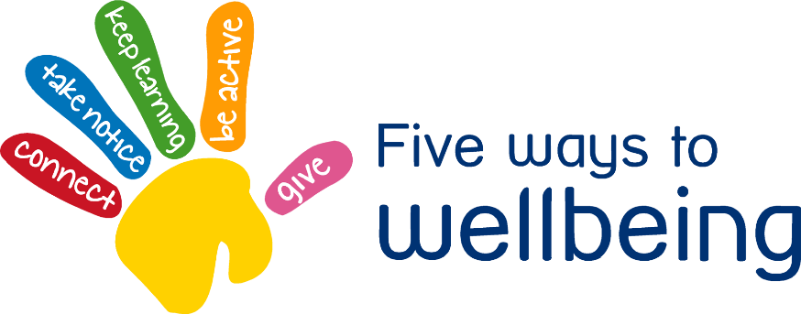

Think about Thursday – Connect

Staying well connected and sociable with people around us is good for wellbeing and mental health especially during isolation.

* Stay in touch with friends and family
* Adults might like to keep in touch with other adults on groups on social media.
* Stay connected to our **Coleshill Heath** Primary Facebook group. Request to join as this is a closed group for parents of the school.
* Children can **blog** and other pupils/staff can comment on their blogs
* Stay connected with our **School Dojo** system.
* Join us on Twitter **@nfowles5 @ColeshillHeath @lil_missteacher**

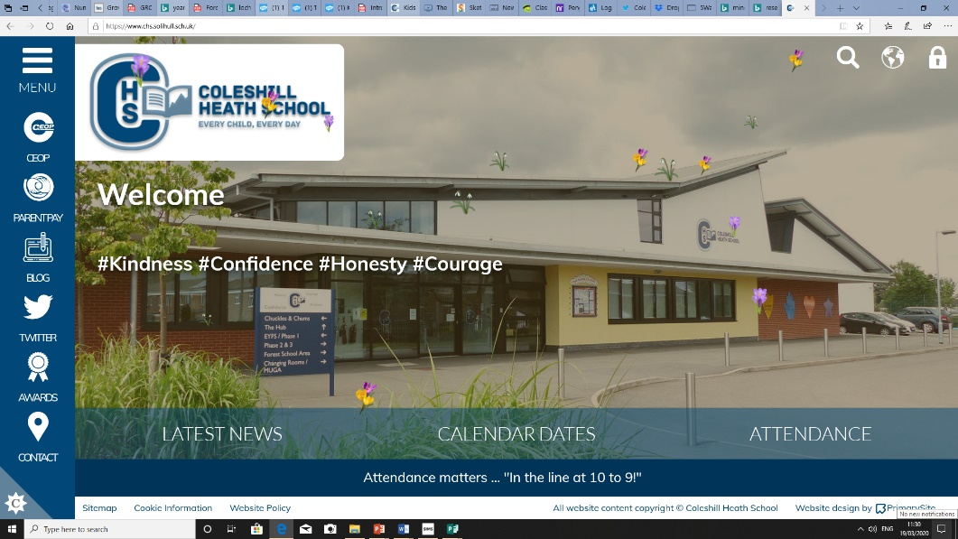

Encourage children to still access and write their blogs for our **Coleshill Heath School** website blog section. Other children and staff, even celebrities can then comment on these.

**2**

**1**

Children could write a letter to one of their friends. You could record them reading it to them and then send it to their parents (check all permissions and social media guidelines to stay safe online).

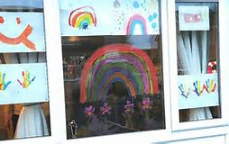

**3**



Create a rainbow to put in your window so others can spot it when they are walking.