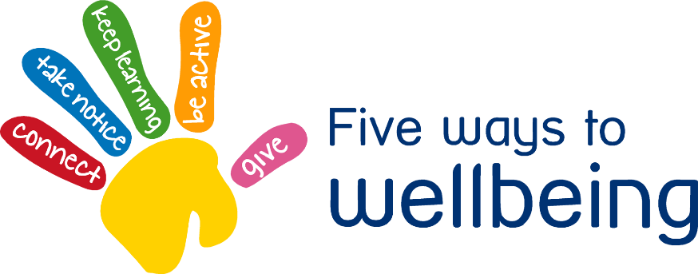

Think about Thursday – Connect

Staying well connected and sociable with people around us is good for wellbeing and mental health especially during isolation.

* Stay in touch with friends and family
* Adults might like to keep in touch with other adults on groups on social media.
* Stay connected to our Coleshill Heath Primary Facebook group. Request to join as this is a closed group for parents of the school.
* Children can blog and other pupils/staff can comment on their blogs
* Stay connected with our School Dojo system.
* Join us on Twitter **@nfowles5 @ColeshillHeath @lil_missteacher**



**1**

Stay in touch with friends and family on social media. Please follow Online safety guidelines with children accessing social media, if you are unsure please check our **Coleshill Heath School** website.

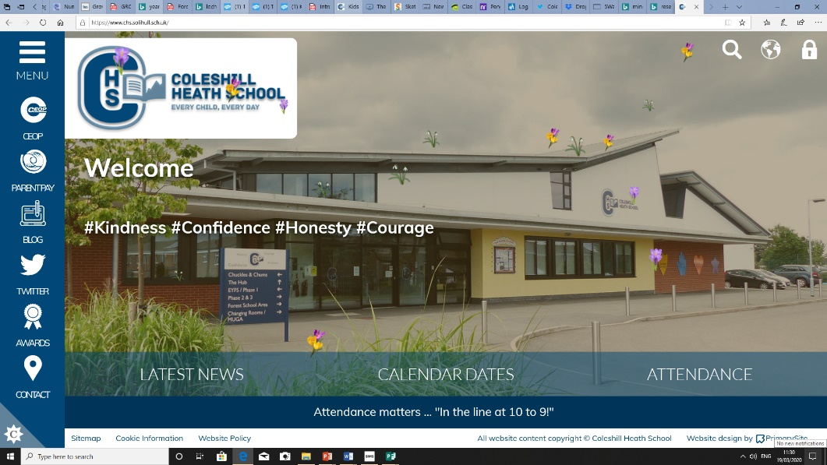

Encourage children to still access and write their blogs for our Coleshill Heath School website blog section. Other children and staff, even celebrities can then comment on these.

**2**

[ClassDojo logo](https://teach.classdojo.com/#/launchpad)

**3**

We will be continuing to stay connected with parents through our Class Dojo School Stories site so please check regularly. There are whole sections on our website for our continuous learning. We will be posting tweets on Twitter from**@ColeshillHeath**  **@nfowles5 @lil_missteacher**