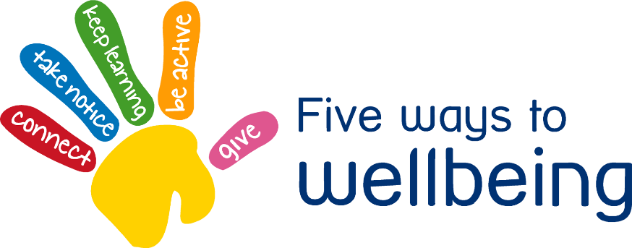

Free Giving Friday

People who enjoy giving are open to receiving, have improved mental health and wellbeing

• Do something nice for a neighbour or friend

• Thank others who give you their time

• Smile more

• Enjoy helping friends and doing things to help other



**2**

Send a message to a loved one. Write and record a song or poem and send it to someone you’ve not seen for a while or for someone you know is on their own or lonely.

**1**

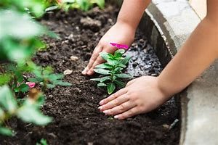

Get children to give some time to help in the garden. Giving your time increases your mental health.

Give someone a hug.

**3**