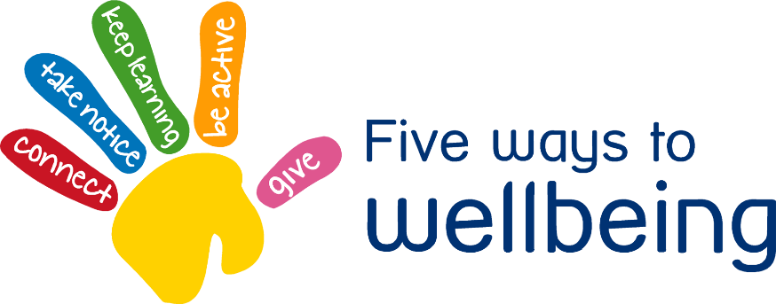

Free Giving Friday

People who enjoy giving are open to receiving, have improved mental health and wellbeing

• Do something nice for a neighbour or friend

• Thank others who give you their time

• Smile more

• Enjoy helping friends and doing things to help other



**2**

Send a note through a neighbours door who may be vulnerable or in an at risk group through isolation. Ask if there is anything you can do, stay in contact with them.

**1**

**3**

Plan in for whole family house jobs. Try to make this less of a chore but more of children knowing they are really helping to make a difference rather than being forced.

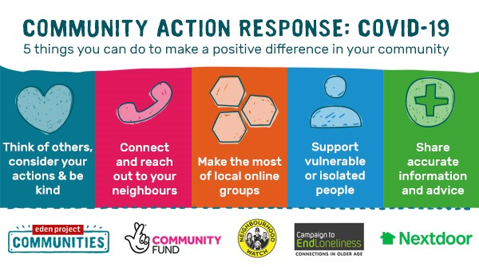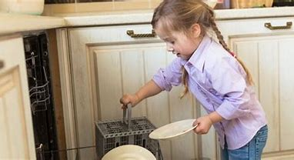

Children at **Coleshill Heath School** have already been writing letters to vulnerable people in the community to cheer them up through isolation. Write a letter or draw a picture and send it to a local **care home**. Maybe a gratitude card to **nurses, police workers or shop workers** who are working tirelessly through this time.

**4**