[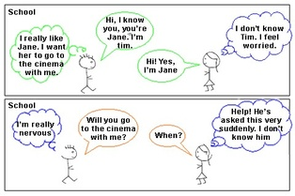](https://www.google.co.uk/url?sa=i&url=https://946698206292905720.weebly.com/other-activities-to-consider.html&psig=AOvVaw2iYQjD6Ru0c_jvgjppxqb7&ust=1583155974560000&source=images&cd=vfe&ved=0CAIQjRxqFwoTCIjH196x-ecCFQAAAAAdAAAAABAQ)

[](https://www.google.co.uk/url?sa=i&url=https://peakcrimson.weebly.com/blog/category/all&psig=AOvVaw2iYQjD6Ru0c_jvgjppxqb7&ust=1583155974560000&source=images&cd=vfe&ved=0CAIQjRxqFwoTCIjH196x-ecCFQAAAAAdAAAAABAd)