Maths CPD:
Website: https://www.ncetm.org.uk/self-evaluation/area-selection/1
Aim: To evaluate your Mathematics Content Knowledge against topics from specific Key Stage.
Who: Teachers and support staff from EYFS to Year 6
How to access:
- Log follow the link and log on to NCTEM
- Click on: Mathematics Content Knowledge
- Select Key Stage (EYFS, Key Stage 1 or Key Stage 2)
- Click on the tick, where you can evaluate yourself against the topic.
- Complete the Self-evaluate for each Mathematical strand. If you do not understand what the question is asking you, click on ‘example’.
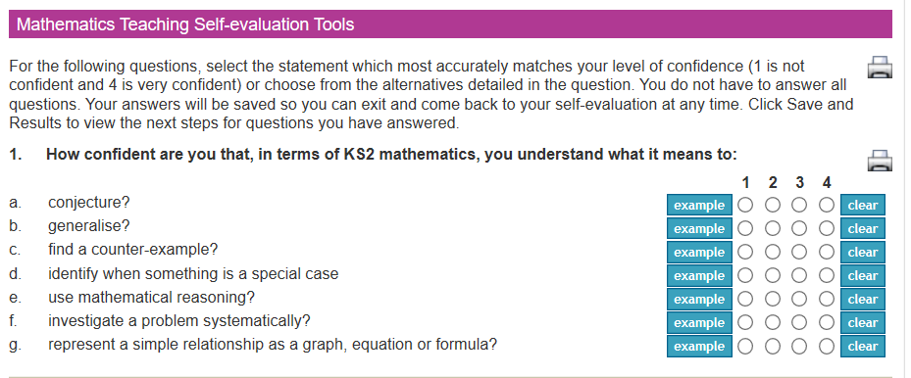

- Once you have evaluated your confidence in each strand in Maths, you will have some next steps. You can develop your own subject knowledge based on your confidence in each area of the curriculum. This website will give you some next steps, or you can select your own.
Complete your self-evaluation for the following areas:
EYFS:
- Using and applying mathematics
- Numbers as labels and for counting
- Calculations
- Shape, space and measures
- Handling data
Key Stage 1:
- Reasoning and problem solving
- Number and place value
- Knowing and using number facts
- Number: Addition, subtraction, multiplication and division
- Fractions
- Geometry
- Measurement
- Statistics

Key Stage 2:
- Reasoning and problem solving
- Number and place value
- Knowing and using number facts
- Number: Addition, subtraction, multiplication and division
- Fractions, decimals, percentages, ratio and proportion
- Algebra
- Geometry
- Measurement
- Statistics

Please make your own professional development learning notes, so that you can refer back to these at a later date.

Website: https://www.ncetm.org.uk/self-evaluation/area-selection/1
Aim: To evaluate your Mathematical Specific Pedagogy against topics from specific Key Stage.
Who: Teachers and support staff from EYFS to Year 6
How to access:
- Log follow the link and log on to NCTEM
- Click on: Mathematics Specific Pedagogy
- Select Key Stage (EYFS, Key Stage 1 or Key Stage 2)
- Click on the tick, where you can evaluate yourself against the topic.
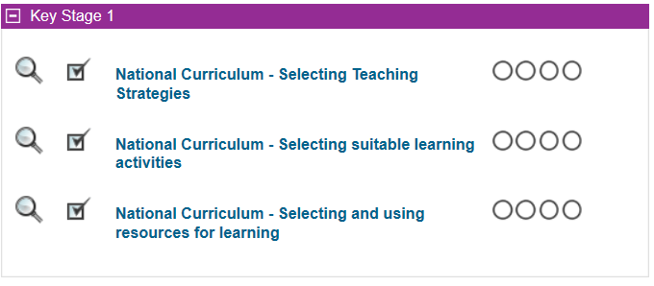
- Complete the Self-evaluate for each Mathematical strand. If you do not understand what the question is asking you, click on ‘example’.
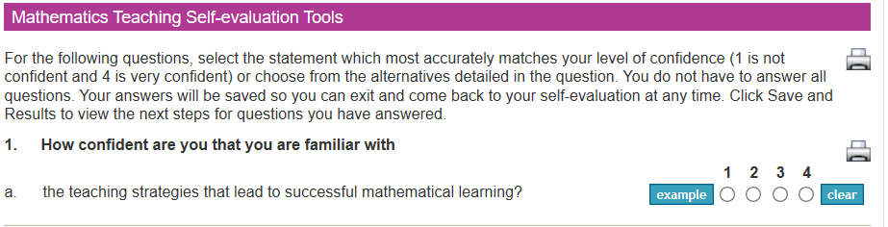

- Once you have evaluated your confidence in each strand in Maths, you will have some next steps, which will be a list of documents that you can read to develop your Maths-specific Pedagogy.

Teaching for Mastery Podcast: https://podcasts.apple.com/gb/podcast/teaching-for-mastery-with-mark-mccourt/id1448601060?i=1000446500074

