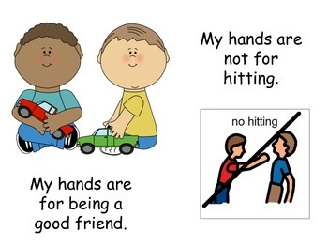
Our House rules

I use kind hands. I do not hit.
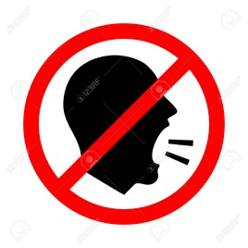
I use a kind voice. I do not need to shout.
I can ask for help without getting angry.

If I feel very angry I can go to a safe place to calm down.

When I do these things, everyone is please with me. I can have a reward.

