Blue tray

Red tray

Green tray

Print bottom squares out twice

Instructions:
Cut around the black border and laminate the sheet.
Cut out TWO lots of the BOTTOM individual coloured squares and laminate all. Stick Velcro on coloured squares and attach them to the top of the corresponding colours on the previous laminated sheet.
Find red, green and blue trays. Attach second coloured squares to these trays and add Velcro.. The child is shown how to transfer their coloured square from their main sheet to the tray to demonstrate which task they are completing.
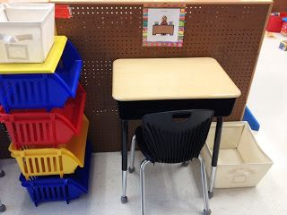

- These tasks MUST be achievable and enjoyable- we want them to feel comfortable accessing learning.
- Use motivating tasks and special interests. These do not have to be ‘academic’ tasks just yet. We need to build up the routine of sitting at a desk and accepting an instruction.

