Reception Speak like a ‘Scientist’-Discussion-How well did our beans grow?
Oracy is the ability to express ourselves fluently and accurately through speech. In Science, we need to be able to explain tricky concepts, give our opinion, use specific vocabulary, and listen to and understand one another.
Voice and Body Language

- Fluency and pace of speech
- Clear pronunciation
- Gesture and posture
- Facial expressions
- Eye contact

Vocabulary and Language

- Speaking in sentences
- Using specific vocabulary e.g. lighter/heavier rather than bigger and smaller
- Start to answer what, where, when, how and why questions
- Using joining connectives for longer sentences
Thinking and Understanding

- Answers that match what has been asked; relevant, appropriate
- To ask simple questions.
Teamwork and Confidence

- Waiting for a turn
- Listening and responding appropriately
- Building friendships
- Using language to express needs and feelings (e.g. rather than snatching).
Use Your Body

Use gestures to add emphasis | Make eye contact with your audience | Use facial expressions to engage the audience
Use visual aids as a prompt, not a prop | Project your voice so your message is heard clearly | Ensure the audience can see you
Speak slowly and use pauses | Vary the pitch and tone of your voice | Read your audience
Use scientific vocabulary.
Beanstalk, grow, stem, soil, seed, light, sun, root, shoot, trowel, water,

Sentence Stems
First we…
Then,
Next…
After that
Finally,
How tall is your plant?
What did your plant need to grow?
What might happen to your plant next?
Check Your Contributions
- Are you speaking too much?
- Are you speaking too little?
- Are you listening to others?
- Do you understand?
- If not, are you asking for clarification?
- What about the rest of the group?

Actively Listen
- Look them in the eye
- Don’t interrupt unless the time is right
- Focus carefully on what they’re saying
- Come up with questions
- Be open-minded
- Use your body to show you are listening
- Give positive and honest feedback

Express Your Opinion
I dislike…
I think…
I enjoyed…
Next time, I’d like..
I like

This is the ….
I’d like to know more
You need this to …
This part is for…
It is tall because
I Know..
I can see
I don’t understand..
Be Reflective
What worked well? What did not work well?
What important skills were needed for everyone to carry out the task successfully?
What are the important learning points to take forward?

Elaborate Your Ideas
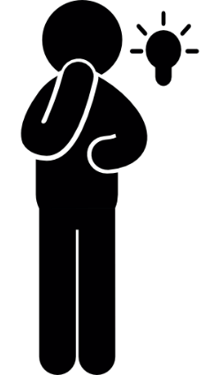
Summarise Effectively
- Make sure you understand the key information or arguments.
- Clarify anything you don’t remember or that isn’t clear.
- Identify what you think are the most important points

