Yr 2 Speak Like an ‘Architect’-to explain and justify the features of castle design.
Oracy is the ability to express ourselves fluently and accurately through speech. We need to be able to explain tricky concepts, give our opinion, use specific vocabulary, and listen to and understand one another.
Voice and Body Language

- Clear pronunciation
- Gesture and posture to be increasingly natural
- Eye contact
- Correct volume so that others can hear
Vocabulary and Language

- To vary sentence structures and length for effect when speaking
- To use conjunctions to organise and sequence ideas eg. firstly, secondly, finally
- To use sentence stems to link to other’s ideas in group discussion e.g. ‘I agree with… because..’ ‘linking to…
- To make precise language choices e.g. instead of describing a cake as ‘nice’ using ‘delicious’
Thinking and Understanding

- To be able to build on others ideas in discussions.
- To make connections between what has been said and their own and others’ experiences.
- To recognise when they haven’t understood something and asks a question to help with this.
Teamwork and Confidence

- To take turns showing patience.
- To listen for extended periods of time.
- To speak with increased confidence in front of a small audience
- Begin to consider the impact of their words on others when giving feedback.
Use Your Body

Use gestures to add emphasis | Make eye contact with your audience | Use facial expressions to engage the audience
Use visual aids as a prompt, not a prop | Project your voice so your message is heard clearly | Ensure the audience can see you
Speak slowly and use pauses | Vary the pitch and tone of your voice | Read your audience
Use precise vocabulary.
bailey, moat, motte, tower, tunnel, turret, drawbridge, portcullis, materials, size, measure, glue, connect, construct, build, equipment, tools,

Sentence Stems
I chose….
My design include…
The purpose of ….
We decided that ….
Firstly,….
We changed our design idea, as a result of…
The most successful part …
The least successful part..
The main difficulty we had was…
Check Your Contributions
- Are you speaking too much?
- Are you speaking too little?
- Are you listening to others?
- Do you understand?
- If not, are you asking for clarification?
- What about the rest of the group?

Actively Listen
- Look them in the eye
- Don’t interrupt unless the time is right
- Focus carefully on what they’re saying
- Come up with questions
- Be open-minded
- Use your body to show you are listening
- Give positive and honest feedback

Express Your Opinion
In my opinion…
I understand...
I don’t agree with…
In my view…
Another way of deciding..

This was tricky…
After that..
Next time..
We needed help to…
Therefore…
This represents..
We needed to
Using the design…
Be Reflective
What worked well? What did not work well?
What important skills were needed for everyone to carry out the task successfully?
What are the important learning points to take forward?

Elaborate Your Ideas
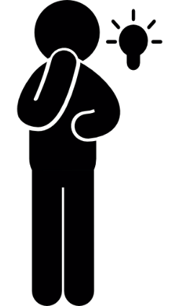

Summarise Effectively
- Make sure you understand the key information or arguments.
- Clarify anything you don’t remember or that isn’t clear.
- Identify what you think are the most important points

