Yr 1 Speak Like a ‘Palaeontologist’-to inform and teach others.
Oracy is the ability to express ourselves fluently and accurately through speech. We need to be able to explain tricky concepts, give our opinion, use specific vocabulary, and listen to and understand one another.
Voice and Body Language

- Fluency and pace of speech
- Clear pronunciation
- Gesture and posture
- Facial expressions
- Eye contact

Vocabulary and Language

- Speaking in sentences
- Using specific vocabulary e.g. lighter/heavier rather than bigger and smaller
- Start to answer what, where, when, how and why questions
- Using joining connectives for longer sentences
- To use sentence stems to link to other’s ideas in group discussion e.g. ‘I agree with… because..’ ‘linking to…
Thinking and Understanding

- Answers that match what has been asked; relevant, appropriate
- Retell stories and experiences
- To ask simple questions.
Teamwork and Confidence

- Waiting for a turn
- Listening and responding appropriately
- Using language to express needs and feelings (e.g. rather than snatching).
Use Your Body

Use gestures to add emphasis | Make eye contact with your audience | Use facial expressions to engage the audience
Use visual aids as a prompt, not a prop | Project your voice so your message is heard clearly | Ensure the audience can see you
Speak slowly and use pauses | Vary the pitch and tone of your voice | Read your audience
Use subject specific vocabulary.
Fossil, excavate, extinct, vertebrate, invertebrate, palaeontologist, Jurassic, prehistoric, Mary Anning, dinosaur,

Sentence Stems
First we…
Next..
After that…
Did you know..
I found out…
A __________________ is someone who…
We know about dinosaurs because..
The most interesting thing I have learnt…
I would like to find out….
Check Your Contributions
- Are you speaking too much?
- Are you speaking too little?
- Are you listening to others?
- Do you understand?
- If not, are you asking for clarification?
- What about the rest of the group?

Actively Listen
- Look them in the eye
- Don’t interrupt unless the time is right
- Focus carefully on what they’re saying
- Come up with questions
- Be open-minded
- Use your body to show you are listening
- Give positive and honest feedback

Express Your Opinion
In my opinion…
I agree with..
I disagree with..
The most interesting fact
I also know..

I’d also like to know…
I can prove it…
This shows…
I found out…
I used this book to find out…
This means.
This photograph shows
Based on the evidence…
Elaborate Your Ideas
Be Reflective
What worked well? What did not work well?
What important skills were needed for everyone to carry out the task successfully?
What are the important learning points to take forward?

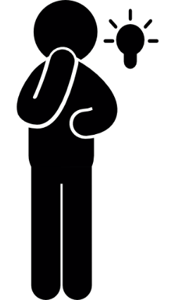
Summarise Effectively
- Make sure you understand the key information or arguments.
- Clarify anything you don’t remember or that isn’t clear.
- Identify what you think are the most important points

