New Build Update
Everyone is now beginning to think about the move to the new school. Plans are being made for the move and the school are beginning the huge task of a major ‘Spring Clean’ and declutter!!! Exciting times ahead for everyone, as all that planning has now become a reality!!!
The contractors, Morgan Sindall, continue to make good progress and the weather has been a major contributor in allowing that to continue. It is anticipated that the Project will finish at the end of June and a removals firm will move everything from the current site, during the course of the summer holidays. There will be some closure days to allow for packing and, of course, unpacking!!!
Internal walls are being built so, consequently, the building inside is really taking shape. Some of the external features are also now being developed. A new logo design has been approved for the new school; the colour scheme has been chosen as well as a range of fixtures and fittings for different areas within the school.
On Thursday 16th April, arrangements were made for the Year 3 pupils to walk over to look at the new school. This was a follow up to the talk they had in February, from myself, the architect and the Project Manager. Mrs Whiting reported that the children had really enjoyed the presentation and were looking forward to their visit yesterday.
Progress Photos
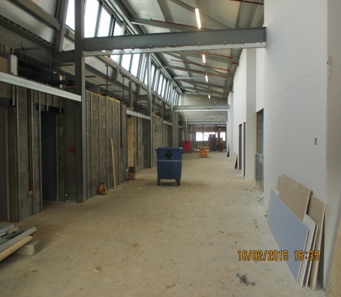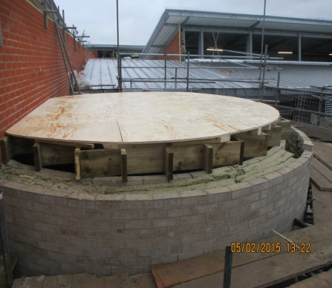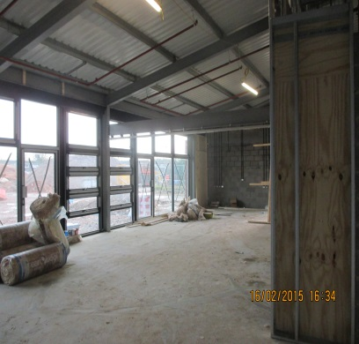
Internal Walls started in Phase 3 Beginning of the Circular Inside of a typical classroom
Group Room
Mrs S. Dickie, Northern Schools Programme, Schools Liaison Advisor.

