

**NEW BUILD NEWS!**

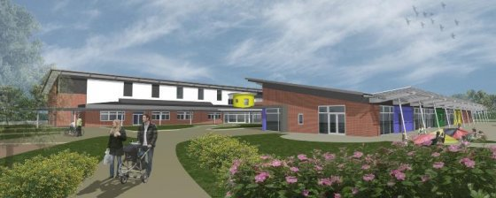

Our new school building is ON TRACK to be completed ON TIME.

Nick Palmer and Sue Dickie continue all of their hard work to ensure that the transition is as smooth as possible. It is a very exciting time for us and we hope that we can rely on your full support throughout the process.

We have started to think about the decant procedures and intend to work on this in more detail over the February half term holiday.