New Build Update June 2015
Well, I can’t believe the children will be finishing for their summer holidays on Tuesday 14th July!! How quickly this year has passed!
I have had the privilege, on Wednesday 8th and Thursday 9th of July, of talking to all the children about their new school. On Wednesday, I led the assembly for KS2 and on Thursday, I spoke to the children in KS1. It was a great opportunity to tell the children all about their new school. They were shown plans; architects images; a virtual flythrough of the new school as well as some of the most recent progress photos. The children were fantastic and sat very attentively for quite a long time. I was especially impressed with the pupils in Year 6 as they sat very sensibly, watching and listening, despite the fact they will not be moving into the new Coleshill Heath!!
The children had the opportunity to ask questions and a special mention has to be made about children in Year2. They have obviously been studying the topic of ‘The Great Fire of London’ as there were some serious questions asked about fire safety at the new school. Brilliant!!
We had hoped that we would be in the position to take the children over to their new school before the summer. However, the contractors are behind with their schedule, finishing things like the installation of the school kitchen; adding acoustic panels; fitting a sound and light system to the hall, as well as finishing off the school playing field. An awful lot of soil has to be moved off site and that is happening at the moment. Turf then needs to be laid so that the pitch can establish itself before the children move in September.
As I said in my last article for the newsletter, there will still be a slight delay in the handover of the building but this will not impact on the arrangements relating to the move.
Final discussions have taken place regarding the signage for the school. There will be directional signs in the grounds as well as in the building. The three Phases will each have numbers displayed on the rear of the building. Signs will be situated near each access point to the grounds.
Progress Photos June 2015
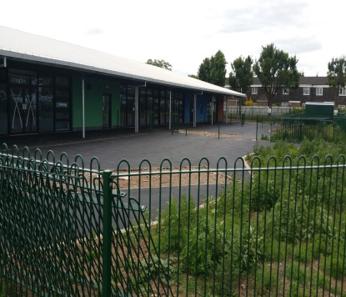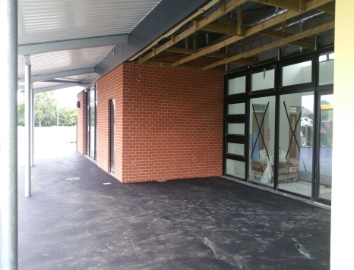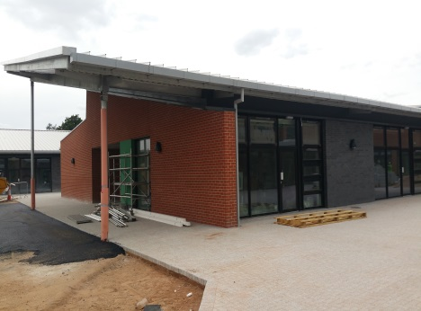
View of the Nursery and Outdoor Canopy for Canopy at the end of Phase 2
Reception Playground Space Reception and Year 1 pupils for Year 2 and Year 3 pupils

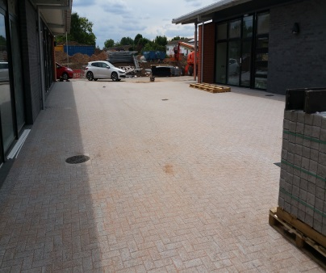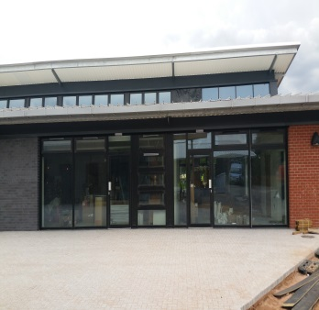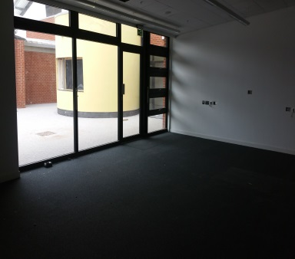
Teaching Court between Phases Entrance to a Phase Three Classroom, with carpet laid,
under construction Classroom in Phase 2

Parking
I need to re –emphasise the need to think about how your children will get to school.
Parking, in the roads leading to the school, will be restricted. There will be four points of access for pedestrians and cyclists, as well as two vehicle entrances. However, one vehicle access (Walnut Close) is for staff and deliveries only. Lime Grove will be the access to the main entrance but it is a very narrow road, with limited opportunities to park or turn round. There are to be lines put in place by Solihull Highways which will restrict parking along Lime Grove.
The plan below indicates the four access points to the new Coleshill Heath School:
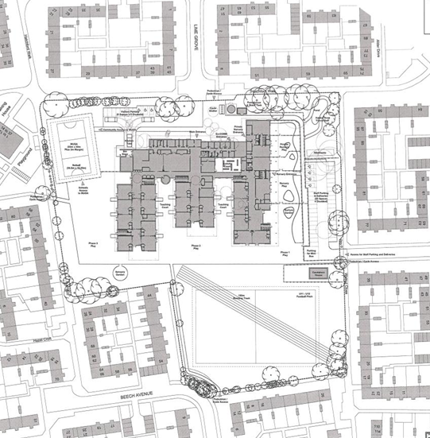
Pedestrian and cycle entrance, from Willow Way.

Entrance for Staff cars only, via Walnut Close
Main Entrance, via Lime Grove
Pedestrian and cycle entrance, off Beech Avenue. Potential drop off point on Berwicks Lane.

It would be very much appreciated that, if you are using a car to drop your children off at school, you consider looking at roads and walkthroughs, to access the school grounds from different directions. This would really help to alleviate any parking issues along Lime Grove.
It may be possible to turn round/drop off at The Christian Renewal Centre, at the far end of Walnut Close. Attempting to drop off in the Walnut Close approach to the staff car park, will cause a lot of problems and should not be considered.
An easy drop off point would be along Berwicks Lane, as the children would then have a very short walk along Beech Avenue to reach the school grounds.
As part of the planning conditions for the new school, there is to be a parking monitoring scheme put in place. Your cooperation and assistance, with being considerate when you park, would really be appreciated.
I wish everyone every success as the move to the new school takes place. It is a great addition to the local area and is, along with Fordbridge, one of the last new schools to be built in North Solihull.
Have a wonderful summer.

Mrs S. Dickie, Northern Schools Programme, Schools Liaison Advisor.

