New Build Update May 2015
Wow!! What a fabulous new school building this is!!
I am sure that the children, and families, of Coleshill Heath are going to be delighted when you first get to see your new school. I know Miss Fowles, and the staff, are all very excited about the move and are looking forward to welcoming everyone to the school in September. I believe an Open Afternoon is being planned, before the actual term begins, and I know details of that will be given to you in due course.
It is anticipated that there will be a slight delay in the handover of the building due to some issues relating to the supply of some of the windows and the preparation of the football pitch. However, this delay will have no effect on the move during the summer and the children should start school, officially, on Monday 7th September.
The internal fixtures and fittings are being fitted, with sinks being installed and carpets being laid. Final plans are being made with regard to what the internal and external signage will look like.
There needs to be some thought given about how your children will get to school. Parking, in the roads leading to the school, will be restricted. There will be four points of access for pedestrians and cyclists, as well as two vehicle entrances. However, one vehicle access (Walnut Close) is for staff and deliveries only. Lime Grove will be the access to the main entrance but it is a very narrow road, with limited opportunities to park or turn round.
I will give further information about how to access the new school in the next newsletter but my plea is that thought is given to finding a way of getting your child(ren) to school without driving to the entrances. This will help alleviate parking problems and help local residents, who still need to be able to get on and off their drives.
Progress Photos May 2015
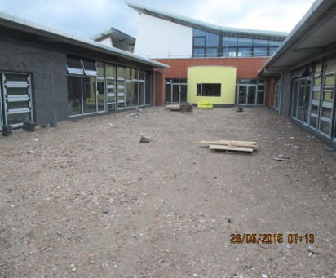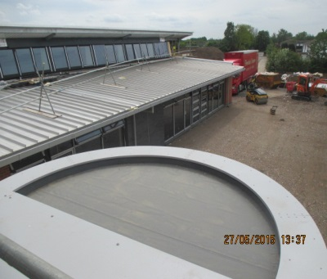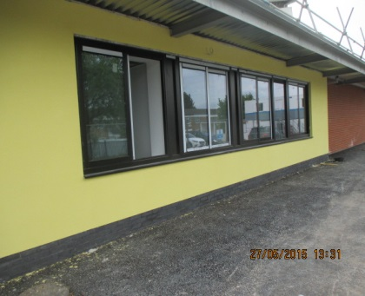
View of the Teaching Court, View from the roof of Front Office Windows
between Phase 2 & 3 the Round Room
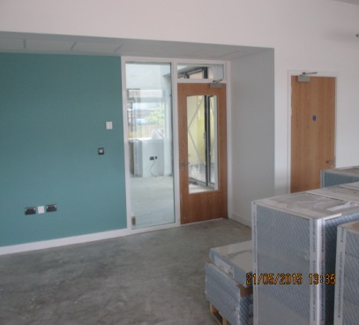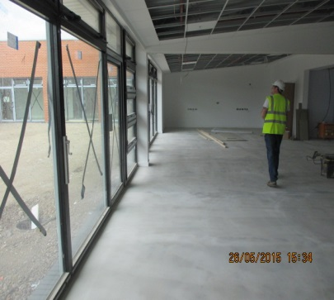
Classroom Entrance in Phase 3 Looking out from a classroom
These images only give you a feel of the building – seeing it in reality is very, very different!

As I said in my article for the April newsletter, everyone is working really hard to make sure that this is going to be a fabulous school for the children, and all the people who are going to work in it.
I have been invited to speak to the children, about their new school, before they finish for their summer holidays. I am very much looking forward to that and know I will be asked lots of great questions!
Mrs S. Dickie, Northern Schools Programme, Schools Liaison Advisor.

