New Build Update
Great news about the new Coleshill Heathl!! The contractors, Morgan Sindall, are confident that the school will be completed for the end of June, this year. Plans are being made for the move and staff are having to begin to think about packing!!!
At the moment, the Phase 3 (Years 4, 5 and 6) block is being plastered and Phase 2 (Years 2 and 3) has also been started. All the brickwork has been finished and windows are being fitted.
I am working with the staff at the school to discuss colours, signage and some of the fittings to go in the building. Play equipment has been chosen and is now on order.
On Thursday 26th February, the architect, Mr. Paul Harries, the Project Manager, Mr, Paul Clements and I had the pleasure of talking to all the Year 3 pupils about their new school and about our jobs. The children asked some brilliant questions and were really excited when we showed them the plans and some photos of the school.
So, everything is taking shape and good progress is being made. Details of the move will be sent to you in due course.
Progress Photos from January 2015
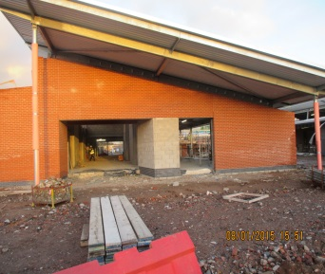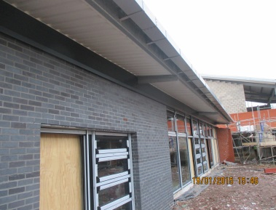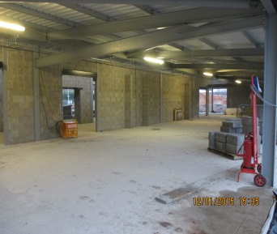
Mrs S. Dickie, Northern Schools Programme, Schools Liaison Advisor.

