New Build Update
Progress at the new Coleshill Heath School continues to be good. Staff visits to the site are continuing and decisions are being made about finer details, such as the position of display boards and what types of signage is going to be put in place.
Internal painting is going ahead and doors are being fitted throughout the building. The classrooms are really taking shape, with cloakroom areas being included in them as well as store cupboards, for all the teachers’ resources!!
Outside work has really progressed. The MUGA (multi use games area) has been fitted with goals; targets and other games activities (see photo below). The area outside Phase 1 (Nursery, Reception and Year 1) is now taking shape, with the fencing being put in position and the tarmac being laid. Work is also going on in the ‘Forest School’ and Sensory Garden by the Phase 3 (Years 4, 5 & 6) play area.
Progress Photos April 2015
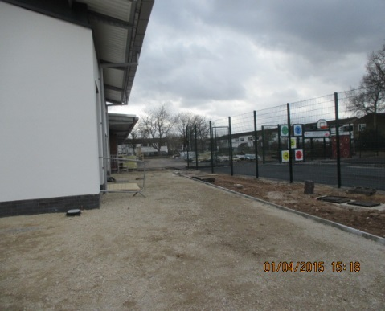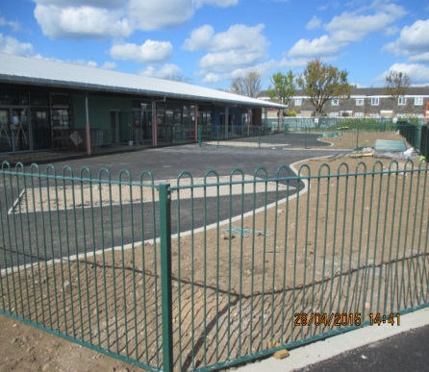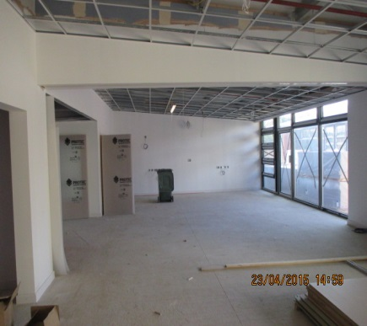
View of the MUGA The play area outside Phase 1 Inside of a typical classroom

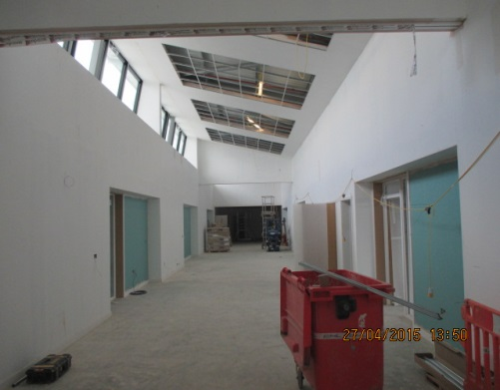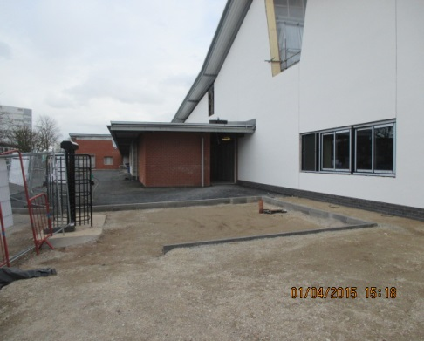
Phase 3 Interactive Teaching Space View from MUGA towards the Main Entrance
I hope these photos give you an idea of what a wonderful school is being constructed for the children and staff of Coleshill Heath. Everyone is working together to ensure the move from the ‘old’ to the ’new’ will go ahead on time and with minimal disruption to the education of the children.
Mrs S. Dickie, Northern Schools Programme, Schools Liaison Advisor.

