February 2025
Dear Parents / Carers,
Over the last six weeks I have once again been very proud of the love and care shown by our community and the large number of achievements of our students.
We have had many accomplishments this term, from one of our Year 7 students achieving the millionth achievement point to our Year 8 students winning the Rotary Young Chef competition. Seeing our students achieve excellence across our school and in our community is inspiring to all. I hope you will enjoy reading about our achievements this half term in our newsletter which you can access from the link at the end of this letter.
Our Year 9 Options Evening was a success on 23rd January, it was lovely to meet with parents and show our Year 9 students what we offer as they enter their GCSE’s. Our Deputy Headteacher, Mrs Salt is working tirelessly to give our Year 9 students as many options as possible of their choosing, updates on this will be sent to Year 9 parents in due course.
Year 11 and 13 will be shortly starting their second phase of Mock Exams on Monday 3rd March. Both year groups are working extremely hard in their revision sessions each morning giving them the opportunity to discuss with their teacher where they are struggling and allowing the teacher to support.
Before Easter we will be transferring our MIS system of SIMS onto a new and exciting system called Arbor. We believe this will improve our administrative efficiency. I will write to you later in the term with more detail about how this change will affect families. This is a significant system change which requires additional staff training. Therefore, on the last day of next term 4th April school will close to students at 12.30pm with staff involved in training in the afternoon. I also wish to remind families of the final staff INSET day of this academic year planned for 11th July.
I would like to wish you all a nice half term and I am looking forward to seeing you on Monday 24th February refreshed, recharged and ready for the next half term.
Kind regards,
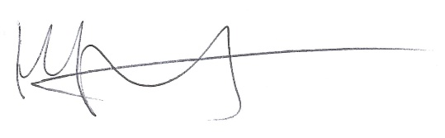
Heidi Thurland

If you need support when school is closed, the following information may be useful:
Cheshire East Children's Social Care - 0300 123 5012 (03000 123 5022 after 4pm) ChECS - Cheshire East Children's Consultation Service
Staffordshire Children's services 0300 111 8007 Children and Family Services - Staffordshire County Council
Child line 0800 11 11 Childline | Childline
NSPCC 0808 800 5000 NSPCC | The UK children's charity | NSPCC
CEOP online safety CEOP Safety Centre
How to Talk to Your Child about Mental Health | YoungMinds
Relaxation Tips - The Sleep Charity 03303 530 541
Parenting Tips & Tricks - Families Under Pressure - Maudsley Charity
Children's mental health - Every Mind Matters - NHS
Home | My CWA, Cheshire Domestic Abuse Support
Visyon | Empowering Young People - Supporting children's mental health in Congleton
Samaritans | Every life lost to suicide is a tragedy | Here to listen Call 116 123

Feb Half Term Newsletter

