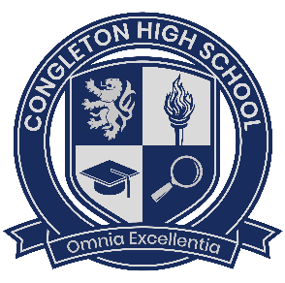
Headteacher’s Blog – October 2024
Dear Parents, Carers and members of our school community,
Welcome to the October Head’s blog. I am looking forward to updating you on what has been a busy and productive half term.
Our school newsletter (see link below) demonstrates just how diverse and varied our first half-term has been. We have very much enjoyed welcoming new students to Year 7 and to our Sixth Form College in Year 12. Through the half-term we have also enjoyed preparing our students for their next steps through mock interviews and careers events. We have invited a number of speakers in to school to cover a range of topics - this included PC Cornell who provided presentations on staying safe online and in the community, and BAE systems who presented to Year 7, inspiring them with possible career pathways.
Year 8 enjoyed visiting Jodrell Bank and we have also seen a number of theatre trips and a multitude of PE fixtures and clubs attended by a wide range of students. We enjoyed welcoming potential students to the school at our Year 6 Open Evening at the end of September. Our Year 7 and older students were the perfect ambassadors for the school and our visitors remarked on their smart presentation and confidence!
It was great to meet with so many families through the half-term at various information events. Thank you for your feedback on these as this really helps us to improve our communication with you.
The House competitions are in full swing and it is brilliant to see so many students actively contributing to the success of their House through attendance, attitudes to learning, individual achievement and the House competitions. Attenborough are out in front at this early stage but all four Houses remain in close competition!
Looking ahead, students return to school on the 5th November (staff return on the 4th for INSET). On the 7th November we welcome our students and families to attend our Sixth Form College Open Evening (17.00-20.00pm). Congleton Sixth Form College offers a range of courses from vocational courses to A Levels and during our Open Evening you can get a real feel of the College experience. Please come and visit us on Thursday 7th November.
On Monday 11th November we will be taking the time to reflect on those who have served our country. This is always a moving experience in our community as we take time to reflect on those who have given so much for so many. I would also like to wish Year 11 and Year 13 every success in their first set of practice exams. This is a key opportunity to gain practice in the examination experience, a big first step in our journey to excellence together.
Wishing all families, students, staff and our wider community a happy and restful half term.
Sept-October Newsletter: https://sway.cloud.microsoft/JvW4F1pVdHEWmNGm?ref=Link
Kind regards,


Heidi Thurland
Headteacher

