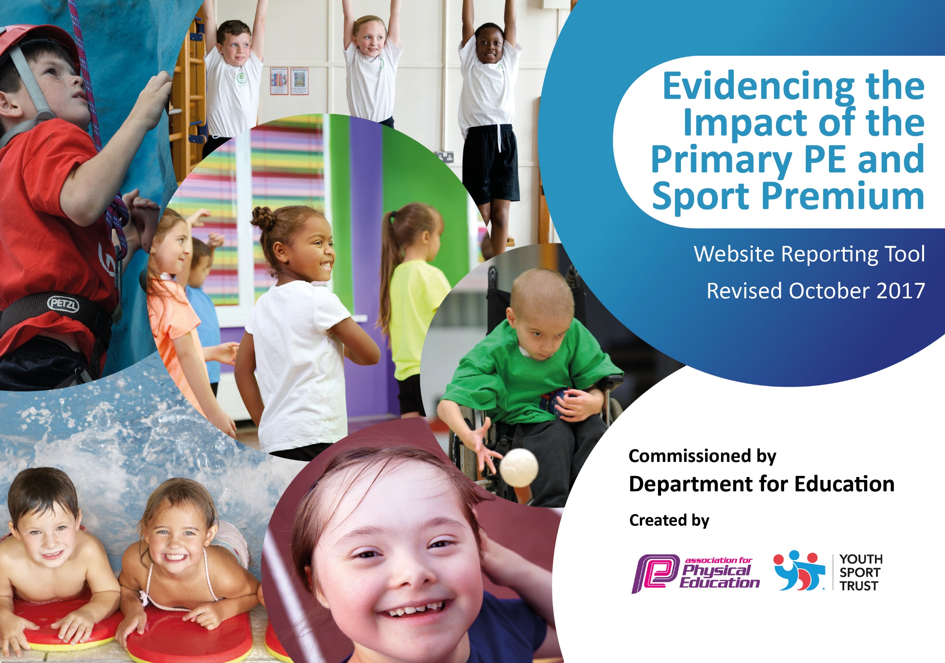

Schools must use the funding to make additional and sustainable improvements to the quality of PE and sport they offer. This means that you should use the Primary PE and Sport Premium to:

- develop or add to the PE and sport activities that your school already offers
- build capacity and capability within the school to ensure that improvements made now will benefit pupils joining the school in future years

Please visit gov.uk for the revised DfE guidance including the 5 key indicators across which schools should demonstrate an improvement. This document will help you to review your provision and to report your spend. DfE encourages schools to use this template as an effective way of meeting the reporting requirements of the Primary PE and Sport Premium.

We recommend you start by reflecting on the impact of current provision and reviewing the previous spend.
Under the Ofsted Schools Inspection Framework, inspectors will assess how effectively leaders use
the Primary PE and Sport Premium and measure its impact on outcomes for pupils, and how effectively governors hold them to account
for this.

Schools are required to publish details of how they spend this funding as well as on the impact it has on pupils’ PE
and sport participation and attainment.
We recommend regularly updating the table and
publishing it on your website as evidence
of your ongoing review into how you are using the money
to secure maximum, sustainable impact. To see an example of how to complete the table please click HERE.

Support for review and reflection - considering the 5 key indicators from DfE, what development needs are a priority for your setting and your students now and why? Use the space below to reflect on previous spend, identify current need and priorities for the future.

Key achievements to date: | Areas for further improvement and baseline evidence of need:
Range of extra-curricular sports increased  Access to competition increased  Staff CPD on introducing new sports e.g. handball  Staff have observed/team taught with a specialist secondary PE teacher and have been given access to her knowledge and expertise e.g. joint planning  Staff have developed methods of assessing progress and attainment in PE  Staff confident with new curriculum and using updated Lancashire scheme of work.  School currently hold School Games Silver Award  Majority of pupils achieving expected standard in swimming | Staff CPD to raise confidence and skill in teaching all areas of PE  Clear, easy and manageable assessment for PE across the year and Key Stage.  Provide a range of activities and club to broaden the children’s experiences.  Find and use resources to link active learning and the extra 30 minutes of PE a day.  Increase the uptake of children in school competitions.

Meeting national curriculum requirements for swimming and water safety | Please complete all of the below:
What percentage of your Year 6 pupils could swim competently, confidently and proficiently over a distance of at least 25 metres when they left your primary school at the end of last academic year? | 86%
What percentage of your Year 6 pupils could use a range of strokes effectively [for example, front crawl, backstroke and breaststroke] when they left your primary school at the end of last academic year? | 86%
What percentage of your Year 6 pupils could perform safe self-rescue in different water-based situations when they left your primary school at the end of last academic year? | 93%
Schools can choose to use the Primary PE and Sport Premium to provide additional provision for swimming but this must be for activity over and above the national curriculum requirements. Have you used it in this way? | Yes – pupils in Year 5 who have not yet attained 25m are attending further lessons.

Action Plan and Budget Tracking
Capture your intended annual spend against the 5 key indicators. Clarify the success criteria and evidence of impact that you intend to measure to evaluate for students today and for the future.

Academic Year: 2017/18 | Total fund allocated: £16,900 | Date Updated: 1/4/18
Key indicator 1: The engagement of all pupils in regular physical activity – Chief Medical Officer guidelines recommend that primary school children undertake at least 30 minutes of physical activity a day in school |  |  |  | Percentage of total allocation:
 |  |  |  | 12.5%
School focus with clarity on intended impact on pupils: | Actions to achieve: | Funding allocated: | Evidence and impact: | Sustainability and suggested next steps:
Children to have more active lessons in maths and set times to use maths program  TA/Welfare to target children less active at playtimes to ensure they are getting the extra 30 minutes a day  Equipment to support welfare and children to become more active  Online resources to be used in assemblies and in classrooms for move active time  Elaine Smith (SSCO) to deliver health ambassadors training to upper KS2 with a focus on healthy eating – pupils to follow this up by becoming ‘health ambassadors’ to younger pupils. | Purchase active Math program (Maths of the Day) – disseminate to all staff so they are confident in its use in the classroom. Use  Welfare/TA on courses  Equipment  Purchase online resource for active time  As part of SSCO Buy-in | £500  £330  £100  £1200  £500 | Teachers using more active strategies in lessons to increase the amount of time pupils are being active.  Pupils are taking part in a range of activities and sports at lunchtime, including running, football and organised exercise sessions. Also took part in the ‘Chorley Loop’ challenge.  Wake Up and Shake Up is well attended and children are benefitting from an active start to the day. Progress is improving in academic subjects.  Session delivered – pupils now in process of designing ways to inform and assist younger pupils to make healthy food choices. | Program used repeatedly and accessible over a number of years  Staff trained and experience can be used for many years and pass on training  Equipment to be reused and kept  Resource is purchased for 3 years and resources can be downloaded.  The knowledge and skills can be passed on to younger pupils – staff will actively promote this process.
Key indicator 2: The profile of PE and sport being raised across the school as a tool for whole school improvement |  |  |  | Percentage of total allocation:
 |  |  |  | 23.5%
School focus with clarity on intended impact on pupils: | Actions to achieve: | Funding allocated: | Evidence and impact: | Sustainability and suggested next steps:
Organize and run a number of competitions – accessible for all children.  Provide support and training for staff when needed/required – improve PE lesson for children.  Teach children for a half term providing high quality teaching – teacher to work with to improve own knowledge and skills  Provide a range of clubs for all children. Focused work on targeted children to support PE and healthy lifestyle choices. Organize children for competition and coach them for these competitions. | Support from local High school –SSCO  Teacher wage to run clubs, sports council, work with targeted children, organize competitions | £2500  £1000 | Uptake in competitions is showing an upward trend. This is to be continuously monitored throughout the year.  To date, competitions include cross country, netball, orienteering, football and handball.  To date pupils have accessed Zumba, Rugby, Archery, Cricket Netball, Basketball, Fitness and Football.  Pupils were coached for netball competition and as a result achieved silver – this shows positive impact. | Children more engaged with competitions and provide links with outside clubs  Staffs knowledge and skill is improved leading to better quality PE lessons  Next Steps – extra gifted and talented events and inclusion events.  Changing children’s lifestyle choices they can make.  Children more active and more like to take part in clubs and sporting activities.

Key indicator 3: Increased confidence, knowledge and skills of all staff in teaching PE and sport |  |  |  | Percentage of total allocation:
 |  |  |  | 26%
School focus with clarity on intended  impact on pupils: | Actions to achieve: | Funding  allocated: | Evidence and impact: | Sustainability and suggested  next steps:
Higher quality PE lessons for all children. Staff to be supported in their lessons and watch teacher with PE expertise leading to better PE lessons.  Better assessment and planning for all children so that more children reach ARE every year and the required standard for PE by the end of each Key Stage.  Staff to gain more expertise in areas they require. Staff to become more confident in all areas of PE, thus leading to higher quality PE lessons for all children | Teacher wage to support and improve staff in PE teaching, planning and assessment  Staff CPD | £3000  £1500 | Lesson obs and pupil interviews shows that PE is being taught to a high standard across the school. Pupils are positive in their views about PE.  Staff have attended a range of PE courses, including one to attain an AfPE qualification. Staff report an improvement in confidence in delivering high quality PE. | Assessment procedures improved and staff more able to assess with better quality and confidence.  Staff are more confident at planning for all groups to succeed.  Staff to pass on information and resources for course. Higher quality PE teaching.
Key indicator 4: Broader experience of a range of sports and activities offered to all pupils |  |  |  | Percentage of total allocation:
 |  |  |  | 29%
School focus with clarity on intended  impact on pupils: | Actions to achieve: | Funding  allocated: | Evidence and impact: | Sustainability and suggested  next steps:
Children to participate in activities that they have never previously been able to.  Children to build in a ranges of areas – confidence, self believe, motor skills, teamwork.  Provide children with a range of high quality afterschool clubs differing in the range of sports. | Whole school trip  Chorley Council clubs | £2500  £2500 | The visit took place and pupils developed skills including resilience, teamwork, communication, alongside physical skills such as climbing, canoeing, orienteering and hand to eye coordination.  To date pupils have accessed Zumba, Rugby, Netball, Cricket, Judo, Archery, Basketball, Fitness and Football. | Children to be signaled out and signposted to clubs/people that can take these activities further.  Children to be singled out and signposted to clubs/people that can take these activities further.
Key indicator 5: Increased participation in competitive sport |  |  |  | Percentage of total allocation:
 |  |  |  | 9%
School focus with clarity on intended  impact on pupils: | Actions to achieve: | Funding  allocated: | Evidence and impact: | Sustainability and suggested  next steps:
Children able to compete in more competitions with more chance of succeeding in the competitions. Bigger range of competitions so more children can access them  Equipment ensure the competitions can be organized and run so children can take part.  Children feel that their effort and determination is rewarded during competitions.  Pupil questionnaires and interviews | Teacher wage to organize new competition  Equipment for new competitions  Medals and trophies for new competition  To be carried out in Spring Term. | £1000  £400  £200 | More success in competitions is already evident – 2 medals won so far this year.  WM has organised inter-school competitions amongst the local schools – pupils have benefitted from easy access to these. CSJ has organised and hosted these competitions.  Questionnaires indicated a positive view of PE from pupils – follow-up pupil interviews have confirmed this. Pupils enjoy PE and are happy with the range of opportunities they have. Some older pupils | Competition organized and can be ran every year once started.  Equipment can used year after year for all competitions  Medals can be used for all competitions and encourage children to continue in their sporting life.

Actual Money Spent | Item | Cost | Total
Key Indicator 1 | Maths of the Day | £500 | £2605
 | TA/Welfare course | £330
 | Equipment | £75
 | Imoves Dance Resources | £1200
 | E. Smith specialist support | £500
Key Indicator 2 | E. Smith specialist support | £2500 | £3500
 | Teacher wage - clubs | £1000
Key Indicator 3 | Teacher wage – class support | £3000 | £4300
 | Staff CPD & AfPE course | £1300
Key Indicator 4 | Whole School Trip | £2850 | £4950
 | Chorley Council Trips | £2100
Key Indicator 5 | Teacher wage – competitions | £1000 | £1625
 | Equipment for competitions | £350
 | Medals | £275
 |  |  | £16980

