Friday 16th October 2020
‘We are growing and learning together in God’s Love’
Flu Vaccinations
The health team will be in school on Monday 9th November for children to receive their flu vaccination. Please ensure you have applied online before Thursday 5th November. https://www.nhsimms.uk/FLU/information?Id=119469&Type=FLU
if you would like your child to receive this. Paper copies are available if you struggle to use the e-consent link.

Parents Consultations
From Monday 19th October class 2 and 4 telephone consultations will take place. For those conversations which took place last week, I hope that you found them useful and a reasonable alternative to face to face meetings.

RSE policy
Please look out for the email with the final draft of the ‘Relationships and Sex Education Policy’. This is an important policy which sits within the PSHE curriculum taught at Coppull St John’s. Your thoughts and feedback would be most welcome and are part of this final consultation process.
Reading Champions
In addition to the Reading Champions running throughout school, class 4 have recently embarked on the Big Book Awards and are reading a selection of books.

Congratulations to our Bronze Award
Reading Champions
Class 1 | Class 2 | Class 3 | Class 4
Tobie, Poppy T, Oliver | Brandon | Charlotte  Rose, Erin, Mia, Charlie, Jade, Luke | Archie, Keagan, Mackenzie, Alex
Congratulations to our Silver Award
Reading Champions
 | Emmie | Charlotte, Jensen | Ethan, Samantha
Congratulations to our Gold Award
Reading Champions
 | Jennifer, Netanya, Kian, Henry C | Alice

‘The Boy, the Mole, the Fox and the Horse’
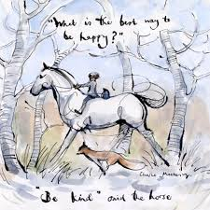
You may have wondered where these clips are from that I have been sharing in my newsletters and letters home to you.
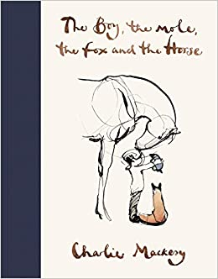
A close friend gave the book to me right at the beginning of lockdown. It is truly wonderful. It can be read as a story from cover to cover or dipped into for inspirational words and phrases- along with some great humour.
The author, Charlie Mackesy, is a Christian and the friendship which develops between the characters is very much driven by the Christian values we explore in school, in our lives and gives us all moments to reflect upon.
Coppull St John’s PTFA Fabulous Sponsored Fun Run!

Look out for the letter and sponsor form telling you all about the
event

School photographs
Individual school photographs will be taking place on Monday 2nd November. Photographs with any siblings not in school can take place from 8.30am. Please come to the black gates on the playground for this time. Please observe social distancing as you wait. Siblings within school will have their photograph taken as classes are called. 8.30am is only for any sibling not attending school.

End of half term
School closes on Friday 23rd October for one week reopening on Monday 2nd November. Sincere thanks are offered to all our families and friends of school for adhering to the systems put in place as part of the COVID 19 risk assessments.
The staggered start and finish to the school day have certainly avoided the congestion both on the playgrounds and especially in the cloakrooms and corridors around school.

Staff have been vigilant in cleaning communal areas after each session and children have remained in their bubble during the school day, with plenty hand washing throughout the day.
The children have shown incredible resilience and enthusiasm towards their learning and general school life, it has been a joy to see.
Thank you for your continued support. We look forward to seeing you all safely return on Monday 2nd November.

‘Encourage one another and build each other up’ 1 Thessalonians 5 v11

