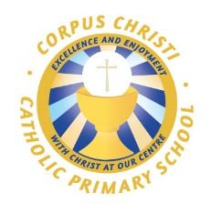

Swimming Information July 2020

Swimming and water safety are an extremely important part of the PE curriculum at Corpus Christi Catholic Primary School. Swimming is also another way of helping children to lead healthy and active lives. Throughout the academic year, pupils in Years 4 and 5 attend swimming lessons. Furthermore, we provide additional opportunities for pupils in Year 6 who have not yet met the national curriculum requirements to have booster swimming lessons in the Autumn and Summer term of Year 6.

Pupils are grouped according to their ability and are taught to:
- Swim competently, confidently and proficiently over a distance of at least 25 metres
- Use a range of strokes effectively (for example front crawl, backstroke and breaststroke)
- Perform safe self-rescue in different water-based situations.

Swimming Information July 2020
Meeting national curriculum requirements for swimming and water safety

What percentage of your current Year 6 cohort swim competently, confidently and proficiently over a distance of at least 25 metres?  (N.B. Even though your pupils may swim in another year please report on their attainment on leaving primary school at the end of the summer term 2020.) | 93%
What percentage of your current Year 6 cohort use a range of strokes effectively [for example, front crawl, backstroke and breaststroke]? | 91%
What percentage of your current Year 6 cohort perform safe self-rescue in different water-based situations?  (N.B. Complete this section to your best ability. For example you might have practised safe self-rescue techniques on dry land.) | 93%
Schools can choose to use the Primary PE and sport premium to provide additional provision for swimming but this must be for activity over and above the national curriculum requirements. Have you used it in this way? | Yes

