Learning Support Assistant 1 to 1 (Full or Part Time)
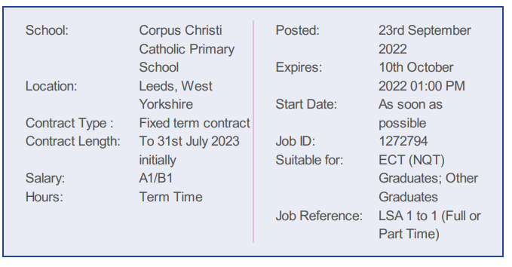

We require a committed Learning Support Assistant to support a child with additional learning needs in Reception/Year 1.
The role will involve working on the Individual Education Plan with the child as well as small group work and general support to ensure full access to all aspects of school life. The successful candidate will need to be able to use their own initiative as well as working as part of a team under the direction of the teacher.
It would be preferable if the successful candidate has experience of working with children in setting boundaries and promoting self- esteem and social and emotional development. Training will also be provided in school.
Full Time- The hours are 28.75 hours per week 8.45am-3.30pm Monday to Friday term time only plus 5 days. The post is initially until July 2023 with the potential to be extended subject to funding.
Part Time Mornings- The hours are 22.5 hours per week 8.30am-1.00pm Monday to Friday term time only plus 5 days. The post is initially until July 2023 with the potential to be extended subject to funding.
Part Time Afternoons- The hours are 20 hours per week 11.30am-3.30pm Monday to Friday term time only plus 5 days. The post is initially until July2023 with the potential to be extended subject to funding.
We can offer you:
- the opportunity to be part of our fantastic team who are committed to educational excellence a positive, highly supportive working environment rooted in the Gospel values
- exceptionally well-behaved, happy and motivated children who are eager to learn and so deserve the best teaching possible
- a highly supportive and strategic leadership team and Governing Board
- excellent CPD and career development opportunities
- the chance to really make a difference to the lives of our pupils.
Interested? If so, we would like to meet you. Prospective candidates are actively encouraged to visit the school prior to application; visits can be arranged (and are positively welcomed) by contacting the school.
Safeguarding Statement
Corpus Christi Catholic Primary School is committed to ensuring a vigilant and safe school culture so as to safeguard and promote the welfare of children and expects staff to share this commitment by working within an agreed code of conduct. The Governing Body is obliged by law to operate a checking procedure for employees who have access to children and young people. Therefore, the successful candidate will be subject to an Enhanced Disclosure Barring Service check and we will require proof of identity and relevant qualifications prior to the appointment being made according to the Local Authority’s policy on safeguarding children and safer recruitment. Please note that employment references must be from the most senior person in the organisation.

