Curriculum Overview: PE
Physical Education at Corpus Christi Catholic Primary
In PE we must ensure we always wear the correct PE kit.
 | Autumn 1 | Autumn 2 | Spring 1 | Spring 2 | Summer 1 | Summer 2
Reception | 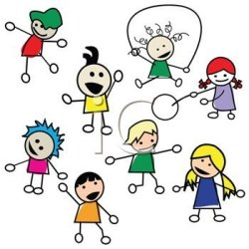 | 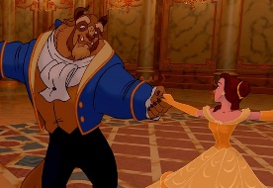 | 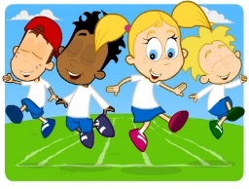 |  | 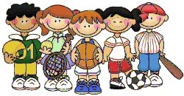 | 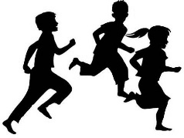
 | We are great at Fundamentals  - Multi skills  - Travelling and changing direction  - Agility.  To jump off an object and land appropriately  To move confidently in a range of ways, safely negotiating the space. | We are dancers & movers  - Diwali Dancing  - Experiment with different ways of moving  To experiment with different ways of moving  To move confidently in a range of ways, safely negotiating the space. | We are recapping the Fundamentals  - Agility  - Balance  - Coordination  To travel with confidence and skill around, under, over and through balancing and climbing equipment. | We are great at invasion games  - Simple invasion games.  - Travelling with confidence.  - Developing speed and agility.  To show increasing control over an object in pushing, throwing, catching or kicking it | We are brilliant at bat & ball skills  - Using a large bat and a soft ball developing agility & co-ordination.  To show good control and co-ordination in large and small movements.  To move confidently in a range of ways, safely negotiating the space. | We are great at Multi Skills  - Developing coordination.  - Introducing multi skills  To show good control and co-ordination in large and small movements.  To move confidently in a range of ways, safely negotiating the space.

 | Autumn 1 | Autumn 2 | Spring 1 | Spring 2 | Summer 1 | Summer 2
KS1  Year 1, 1/2 and 2 |  |  |  | .
 | We are fit and athletic  Fitness and Athletics  - Fundamentals of agility, balance and coordination  To change direction and style of movement comfortably and confidently | We are dancers and movers!  Dance and Gymanstics  - Agility  - Flexibility  - Balance  To explore movement patterns.  To change direction and style of movement. | We are great at Multi Sports  Net and wall games  To develop basic movements including running, jumping, throwing and catching, as well as developing balance, agility and co-ordination, and begin to apply these in a range of activities | We are great at Invasion Games  Invasion games  - Teamwork, spatial awareness, passing.  - Using a large ball, throwing and catching  - Passing  To throw and catch a confidently with two hands.  To continue to develop balance, agility and co-ordination, and begin to apply these in a range of activities | We are super at striking and fielding games.  Striking and fielding  - Bat and ball skills  - Hand-eye co-ordination  - Throwing-javelin and target practise  To master basic movements including running, jumping, throwing and catching. | Outdoor Adventure  To take part in outdoor and adventurous activity challenges both individually and within a team

LKS2
Year 3, 3/4 and 4

 | We are fit and athletic  Fitness and Athletics  - Fundamentals of agility, balance and coordination  To change direction and style of movement comfortably and confidently | We are dancers and movers!  Dance and Gymanstics  - Agility  - Flexibility  - Balance  To explore movement patterns.  To change direction and style of movement. | We are great at Multi Sports  Net and wall games  To develop basic movements including running, jumping, throwing and catching, as well as developing balance, agility and co-ordination, and begin to apply these in a range of activities | We are great at Invasion Games  Invasion games  - Teamwork, spatial awareness, passing.  - Using a large ball, throwing and catching  - Passing  To throw and catch a confidently with two hands.  To continue to develop balance, agility and co-ordination, and begin to apply these in a range of activities | We are super at striking and fielding games.  Striking and fielding  - Bat and ball skills  - Hand-eye co-ordination  - Throwing-javelin and target practise  To master basic movements including running, jumping, throwing and catching. | Outdoor Adventure  To take part in outdoor and adventurous activity challenges both individually and within a team

 | Autumn 1 | Autumn 2 | Spring 1 | Spring 2 | Summer 1 | Summer 2
UKS2  Year 5, 5/6 and 6 |  |  |  |  | 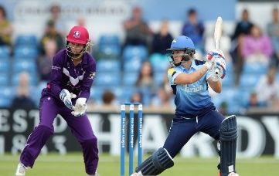
 | Fitness and Athletics  We are mastering our skills in Sports Hall Athletics  - Baton pass  - Effective use of a turning board  To compare performances with previous ones and demonstrate improvement to achieve their personal best. | Dance and Gymanstics  We are dancers and rugby players  - Dance  - Rugby  To perform dances using a range of movement patterns  To play competitive games, modified where appropriate and apply basic principles suitable for attacking and defending | Net and wall games  We are netballers and volleyballers  - Positional play  - Overarm, chest and bounce pass  - Shooting and defending  To play competitive games, modified where appropriate and apply basic principles suitable for attacking and defending | Invasion games  We are footballers  - Football  - Mini games  - Rules  - Defending and attacking  To play competitive games, modified where appropriate and apply basic principles suitable for attacking and defending | Striking and fielding  We are mastering striking and fielding  - Cricket  - Summer Athletics  - Orienteering  To take part in outdoor and adventurous activity challenges both individually and within a team | Outdoor Adventure  We are runners  - Cross Country  - Recording personal best  To use running, in isolation and in combination  To compare performances with previous ones and demonstrate improvement to achieve their personal best.

