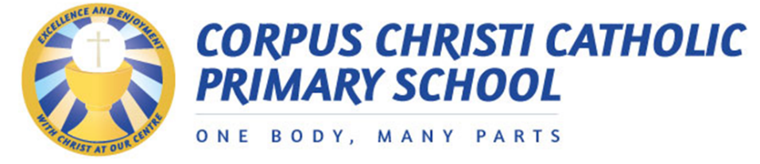

School Calendar Academic Year 2020-2021

Holiday | School Closes | School Opens
Summer break |  | Monday 7th September 2020
Autumn mid-term | Friday 23rd October 2020 | Monday 2nd November 2020
Christmas break | Friday 18th December 2020  at 1pm | Monday 4th January 2021
Spring mid-term | Friday 12th February 2021 | Monday 22nd February 2021
Easter break | Wednesday 31st March 2021  at 1pm | Monday 12th April 2021
May bank holiday | Friday 30th April 2021 | Tuesday 4th May 2021
Summer mid-term | Wednesday 26th May 2021 | Monday 7th June 2021
Summer break | Friday 23rd July 2021  at 1pm

Year 2 | May 2021
Year 6 SATs | Week beginning Monday 10th May
Year 1- Phonics Screening Check week | Week beginning 7th June
Year 4 Multiplication Tables Check | Monday 7th – Friday 25th June

Highlighted dates differ from Leeds City Council school term dates

Training day dates to be confirmed and parents will be notified by text/website/DoJo/Tapestry

