Curriculum Overview: English, Grammar, Punctuations and Spelling

EGPS at Corpus Christi Catholic Primary
Year 1 | Autumn 1 |  | Autumn 2 |  |  |  |  | Spring 1 |  |  |  | Spring 2 |  |  |  |  | Summer 1 |  |  | Summer 2
Grammar  and  Punctuation  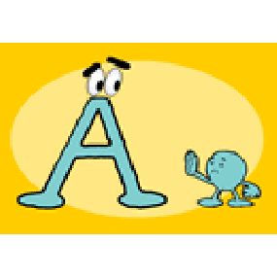 | Punctuate simple sentences with capital letters and full stops  Separate words with spaces  Orally plan and rehearse ideas  Identify and use question marks  To use capital letter for the personal pronoun I |  | Punctuate simple sentences with capital letters and full stops  Use the joining word ‘and’ to link to words and clauses  Compose and sequence their own sentences to write short narratives  To use capital letter for names. |  |  |  | Punctuate simple sentences with capital letters and full stops  Use the joining word ‘and’ to link to words and clauses  Write in different forms with simple text type features  Orally plan and rehearse ideas |  |  |  |  | Punctuate simple sentences with capital letters and full stops  Focus on prediction, question generation and character inference  Identify characters, settings and events  Select key vocabulary and create word bank |  |  |  |  | Punctuate simple sentences with capital letters and full stops  Focus on prediction, question generation and character inference  Extend range of joining words to link words and clauses using ‘but’ and ‘or’  Use phrases to open and close text |  |  | Punctuate simple sentences with capital letters and full stops  Extend range of joining words to link words and clauses using ‘but’ and ‘or’
Terminology | - letter, capital letter,  - word,  - singular,  - plural,  - sentence,  - punctuation,  - full stop, question mark, exclamation mark
Year 2 | Autumn 1 |  | Autumn 2 |  |  |  |  | Spring 1 |  |  |  | Spring 2 |  |  |  |  | Summer 1 |  |  | Summer 2
Grammar  and  Punctuation  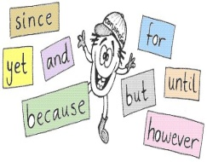 | Word classification  Commas separating items/adjectives in a list  Secure use of full stops, capital letters, question marks and exclamation marks  Use suffixes –er and –est (adjectives for comparison).  Present tense and present tense verbs |  |  | Sentence types (e.g. question, statement, exclamation sentences)  Secure use of full stops, capital letters, question marks and exclamation marks  Homophones: see/sea, quite/quiet,  Apostrophes for possession.  Co-ordinating conjunctions |  |  |  | Apostrophes for omission  Subordinating conjunctions  Subordination of time: when, before, after  Use suffix –ly  Co-ordinating conjunctions |  |  |  | Subordination of reason: because, if  Suffixes: -ed and –ing –ment, -ness–ful, -less  Progressive verbs (link suffix –ing)  Select, generate and effectively use verbs and nouns. |  |  |  |  | Suffixes –ment, -ness  Revisit post SATs any areas where learning is not embedded. |  | Revisit post SATs any areas where learning is not embedded.
Terminology | - noun, noun phrase  - statement, question, exclamation, command,  - compound,  - adjective,  - verb,  - suffix  - adverb  - tense (past, present)  - apostrophe, comma
Year 3 |  | Autumn 1 |  |  | Autumn 2 |  |  |  |  | Spring 1 |  |  |  | Spring 2 | Summer 1 |  |  | Summer 2
Grammar  and  Punctuation |  | Clauses  Conjunctions  Introduction to inverted commas to punctuate direct speech  Dictionary  Past tense verbs |  |  |  | Prepositions  Irregular plurals  Use of the forms a or an according to whether the next word begins with a consonant or a vowel (a rock. an open box) |  |  | Adverbs  Complex sentences  Suffixes |  |  |  |  | Determiner  Formation of nouns using a range of prefixes (for example super-, anti-, auto-) |  | Comma to separate clauses  Perfect form of verbs  Homophones |  | Word families based on common words, showing how words are related in form and meaning (for example: solve, solution, solver, dissolve, insoluble)
Terminology |  | - adverb,  - preposition  - conjunction  - word family, prefix  - clause,  - subordinate clause  - direct speech  - consonant,  - consonant letter vowel,  - vowel letter  - inverted commas (or ‘speech marks’)
Year 4 |  | Autumn 1 |  |  | Autumn 2 |  |  |  |  | Spring 1 |  |  |  | Spring 2 | Summer 1 |  |  | Summer 2
Grammar  and  Punctuation  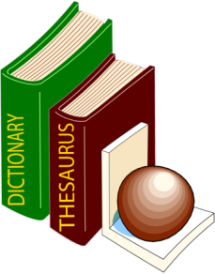 |  | Create complex sentences  Use commas to mark clauses  Dictionary  Investigate further prefixes  Use further suffixes |  |  |  | Fronted adverbials when / where with commas  Use of commas after fronted adverbials  Investigate words ending in f when a suffix is added |  |  |  |  | Determiners including articles demonstratives, possessives and quantifiers  Use of inverted commas and other punctuation to indicate direct speech. |  | Pronouns  Use apostrophes for single and plural possession  Possessive apostrophe |  | Nouns for precession  Explore, identify, collect and use noun phrases  Investigate ways jn which nouns and adjectives can be made into verbs |  |  | Use verb inflections for writing Standard English instead of local spoken forms (for example: we were instead of we was)
Terminology |  | - determiner  - pronoun,  - possessive pronoun  - fronted adverbial

Year 5 | Autumn 1 | Autumn 2 |  |  | Spring 1 | Spring 2 | Summer 1 |  | Summer 2
Grammar  and  Punctuation | Relative clauses using commas  Writing using -ing openers  Converting nouns or adjectives in to verbs using suffixes |  | Simile starters  Use of commas to clarify meaning or avoid ambiguity  Adverbs to indicate degrees of possibility | Expanded noun phrases  Sentences where the relative pronoun is omitted |  | Parenthesis using brackets (formal)  Parenthesis using dashes (informal)  Sentences opening with –ed opening clauses |  | Link ideas across paragraphs using adverbials for time, place and numbers  Verb prefixes (dis-, de-, mis-, over- and re-) | Create and punctuate sentences using simile starters  Modal Verbs
Terminology | - modal verb,  - relative pronoun  - relative clause  - parenthesis,  - bracket,  - dash  - cohesion,  - ambiguity
Year 6 | Autumn 1 | Autumn 2 |  |  | Spring 1 | Spring 2 | Summer 1 |  | Summer 2
Grammar  and  Punctuation  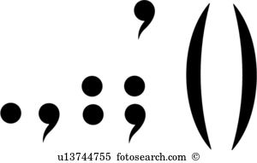 | Year 5 Revision:  Relative clauses  Link ideas across paragraphs using adverbials for time, place and numbers  Parenthesis |  | Punctuation of bullet points to list information  Use of the colon to introduce a list and use of semi-colons within lists  How hyphens can be used to avoid ambiguity [for example, man eating shark versus man-eating shark, or recover versus re-cover] | Build cohesion  Verbs  Self-checking and proof reading strategies  How words are related by meaning as synonyms and antonyms [for example, big, large, little]. |  | Subject/object  Ellipsis  Formal/informal vocabulary  Use of the semi-colon, colon and dash to mark the boundary between independent clauses [for example, It’s raining; I’m fed up] |  | The difference between vocabulary typical of informal speech and vocabulary appropriate for formal speech and writing [for example, find out – discover; ask for – request; go in – enter]  Active and Passive | Revisit post SATs any areas where learning is not embedded.
Terminology | - subject,  - object  - active,  - passive  - synonym,  - antonym  - ellipsis, hyphen,  - colon,  - semi-colon,  - bullet points

