KS2 Learning Support Assistant (Full Time)

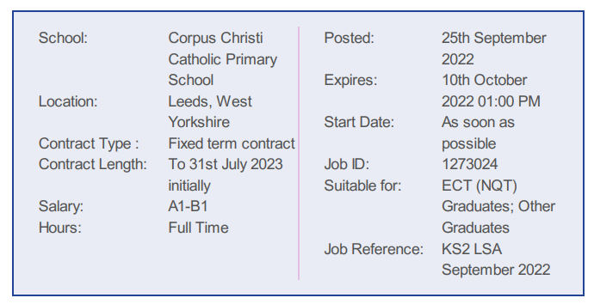

An exciting opportunity has arisen for an experienced Learning Support Assistant to join our well-established Key Stage 2 team. The successful candidate will need to be able to use their own initiative as well as working as part of a team under the direction of the classteacher and Senior Leadership Team. Ideally you will have the flexibility to work across all age groups and be willing to undertake further appropriate training.
We believe that all our children are capable of making outstanding progress and would like to appoint an individual who shares this belief. We welcome candidates who are supportive of the Catholic ethos of the school.
The hours are 28.75 hours per week (8.45am-3.30pm) Monday to Friday term time only plus 5 days.

We are looking for a Learning Support Assistant who:
- is committed to the education, well-being, self-esteem and progress of all our pupils
- is able to maintain a safe and positive environment for all learners
- is committed to high standards of attainment and behaviour
- will work with class teachers to deliver excellent teaching and learning
- will create opportunities for all learners to reach their potential, irrespective of ability
- be able to deliver a range of high quality interventions on a 1:1 or group basis
- will work with the teacher to create stimulating learning resources and displays
- has adaptable and open to new ideas and practices
- has a First Aid qualification or is willing to undertake any training necessary for the role
- is willing to participate in all aspects of school life including some events outside of the normal school day
We can offer you:

- the opportunity to be part of our fantastic team who are committed to educational excellence
- a positive, highly supportive working environment rooted in the Gospel values
- exceptionally well-behaved, happy and motivated children who are eager to learn and so deserve the best teaching possible
- a highly supportive and strategic leadership team and Governing Board
- excellent CPD and career development opportunities
- the chance to really make a difference to the lives of our pupils.
Please note only shortlisted candidates will be contacted.

Safeguarding Statement
Corpus Christi Catholic Primary School is committed to ensuring a vigilant and safe school culture so as to safeguard and promote the welfare of children and expects staff to share this commitment by working within an agreed code of conduct. The Governing Body is obliged by law to operate a checking procedure for employees who have access to children and young people. Therefore, the successful candidate will be subject to an Enhanced Disclosure Barring Service check and we will require proof of identity and relevant qualifications prior to the appointment being made according to the Local Authority’s policy on safeguarding children and safer recruitment. Please note that employment references must be from the most senior person in the organisation.

