Corpus Christi Catholic Primary School – We are Explorers!
Geography Topic:  Why should we help to save the Amazon Rainforest? | Phase:  LKS2 | Strand:  Locational Knowledge, Place Knowledge and Skills and Fieldwork
What I should already know?
. We know that the world is made up of many countries. The countries are grouped into seven continents that are surrounded by oceans. We know how to locate North America on a map and are able to identify some of its countries. We can name some of North America’s physical and human features. We have an understanding of latitude, longitude and time zones. We know how to locate hot and cold places relating to the Equator.
Top Facts
- There are 12 countries in South America and 3 dependencies.
- South America’s biggest country is Brazil.
- South America’s smallest country is Suriname.
- Brazil is home to the Amazon Rainforest, where a huge number of animals, plants and insects live.
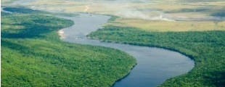
- The Amazon River is the longest river of South America. It is 4,080 miles long.
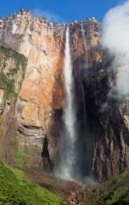
- Angel Falls is the world’s largest waterfall and it is located in Venezuela.

- The most commonly spoken languages in South America are Spanish and Portuguese.
- Rio is the second largest city in Brazil and is referred to as the ‘marvellous city’.
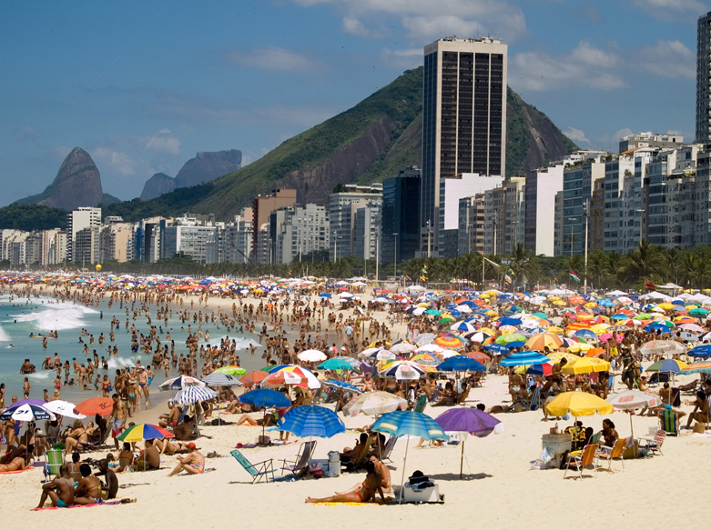
- People all over Brazil dream of living in Rio: it is adored by Brazilians far and wide as a city of great natural beauty, year-round sunshine, amazing beaches and rich culture.
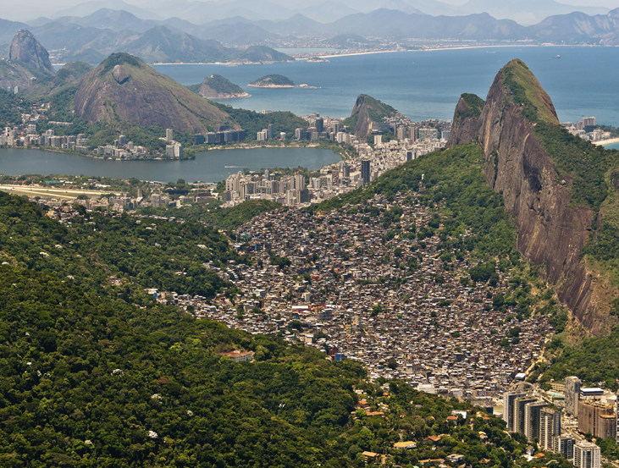
- Many of South East Brazil’s poorer citizens, born in rural areas, want to live here. That’s why Rio’s steeper slopes are covered in favelas.
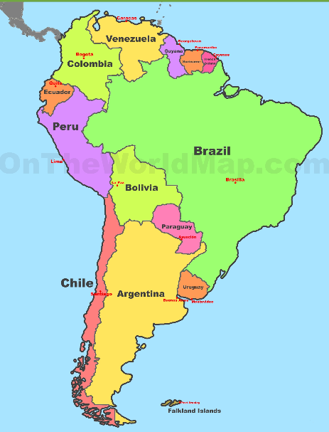
What will I know by the end of the unit?
We will know how to locate South America on a map and be able to identify some of its countries. We will be able to name some of South America’s physical and human features. We will have a deeper understanding of Latitude, Longitude and Time Zones. We will be able to compare Brazil to the UK and will be able to say how our lives are linked to Rio, Brazil.
Top Vocabulary
Latitude | The distance between the Equator and a point North or South on the Earth’s surface measured in degrees or hours, minutes and seconds.
Longitude | The distance between the Prime Meridian at Greenwich, England and a point East or West on the Earth’s surface, measured in degrees or hours, minutes and seconds.
Time Zone | An area on Earth that has been given a specific time of day that is earlier or later than neighbouring Time Zones. This is because when it is daytime on one side of the Earth it is night time on the other side.
Rainforest | A very dense, warm and wet forest.
Dependency | A country controlled by another country.
Favelas | Tightly packed, tin-roofed houses, in poor neighbourhoods.
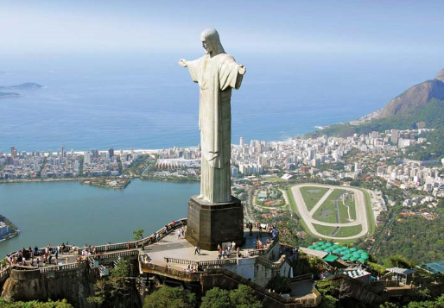
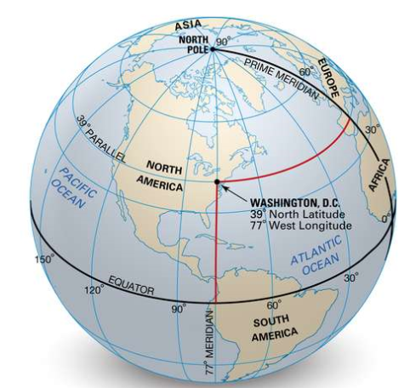
Christ the Redeemer Statue, Rio, Brazil

