Curriculum Overview: Geography
Geography at Corpus Christi Catholic Primary
 | Autumn 1 | Autumn 2 | Spring 1 | Spring 2 | Summer 1 | Summer 2
Reception |  | 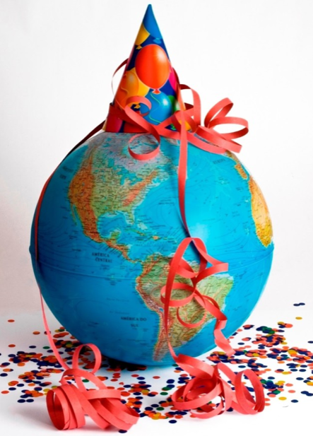 | 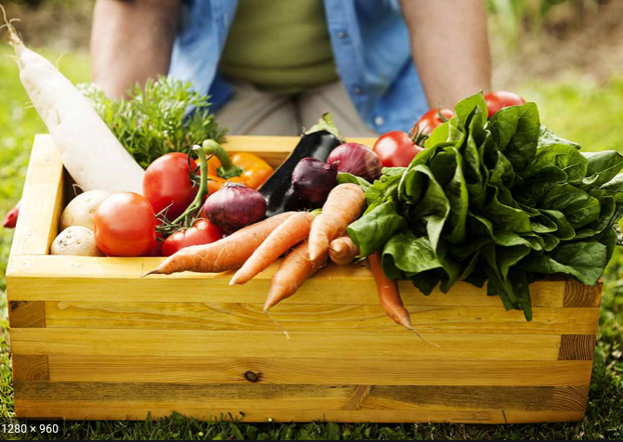 |  | 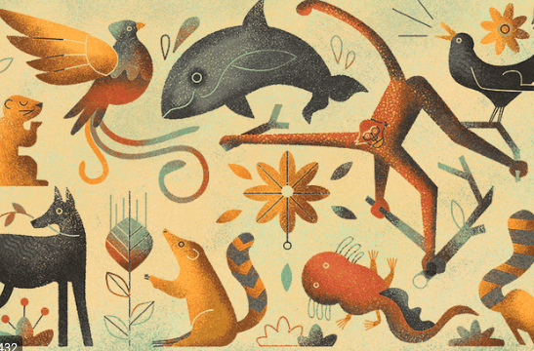
 | How can I travel the world?  - Where can we visit?  - How will we get there?  - What will we see? | How the world celebrates.  - Learning about different celebrations around the world. | What can I grow and eat?  - Finding out where our food comes from.  - Tasting different foods.  - Growing our own food. |  | Which creatures share our world?  - Finding out about different animals and the  habitats they live in.

 |  | Autumn 1 |  | Autumn 2 |  | Spring 1 |  | Spring 2 |  | Summer 1 |  | Summer 2
Year 1 and Year 1/2 |  | 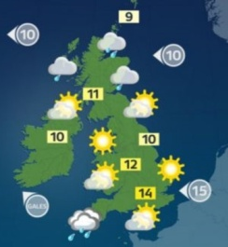 |  |  |  | 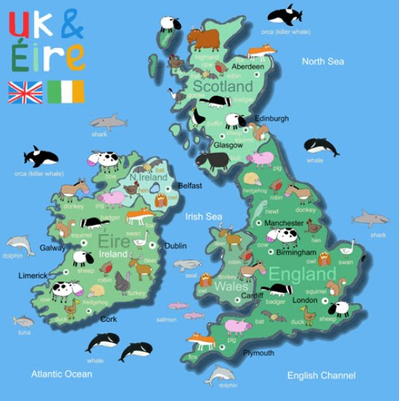 |  |  |  | 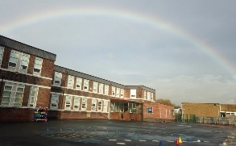
 |  | What is the weather like where we live?  - Identify seasonal and daily weather patterns in the UK. |  |  |  | What is it like in the UK?  - Name, locate and identify characteristics of the four countries and capital cities of the UK.  - Use world maps, atlases and globes.  - Use basic geographical vocabulary to refer to key physical and human features, |  |  |  | How has our local area changed?  (Linked to History)  - Use simple fieldwork and observational skills to study our local area.  - Use simple compass directions and locational and directional language.  - Use aerial photographs and plan perspectives to recognize landmarks  - Devise a simple map.
 | Autumn 1 |  |  |  | Autumn 2 |  | Spring 1 |  | Spring 2 |  | Summer 1 |  | Summer 2
Year 2 | 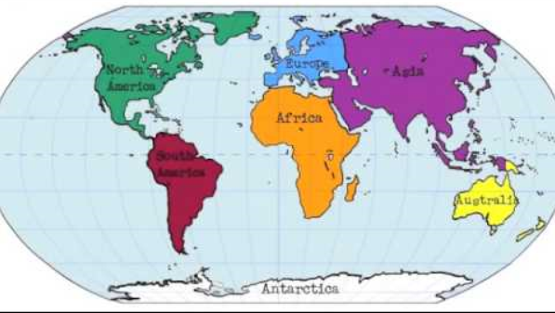 |  |  |  |  |  |  |  | 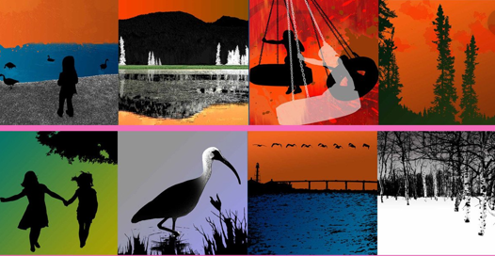 |  |  |  | 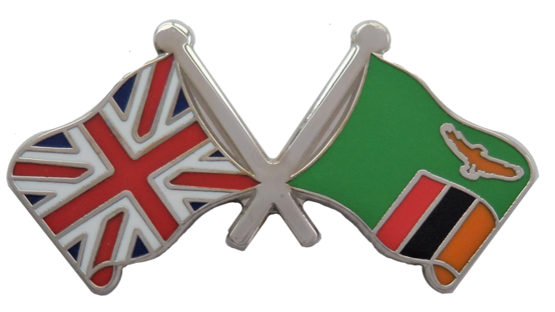
 | Do you know your continents?  - Name and locate the world’s seven continents and five oceans.  - Use world maps, atlases and globes to locate the continents and five oceans.  - Use compass directions and locational and directional language.  - Use geographical vocabulary to refer to key physical and human features. |  |  |  |  |  |  |  | Who would live in a place like this?  - Identify the locations of hot and cold areas of the world in relation to the equator and the North and South Poles.  - Use world maps, atlases and globes. |  |  |  | How is Zambia different to the UK?  - Understand geographical similarities and differences through studying a village in Zambia and comparing it to Halton Village.  - Use aerial photographs to recognise landmarks and basic human and physical features when comparing the villages.  - Use world maps, atlases and globes.

 | Autumn 1 | Autumn 2 | Spring 1 | Spring 2 | Summer 1 | Summer 2
Year 3, Year 3/4 and Year 4 Cycle A |  | 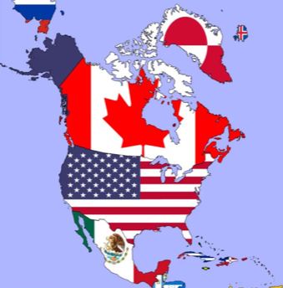 |  |  | 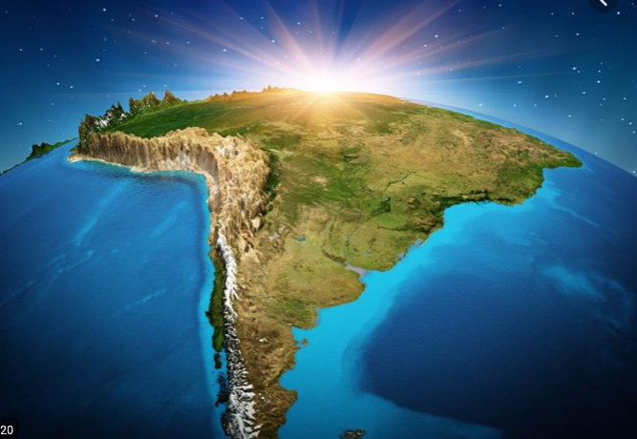 | 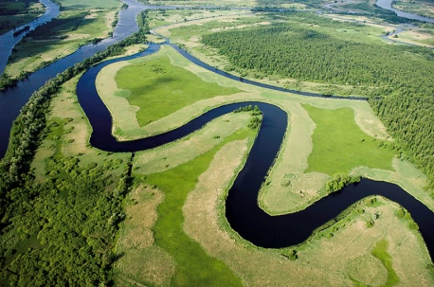
 |  | What is it like in North America?  - Locate the world’s countries using maps, focussing on North America: it’s environmental regions, key human and physical characteristics, countries and major cities.  - Identify the position and significance of latitude, longitude, and time zones  - Use maps, atlases, globes and digital/computer mapping to locate countries and describe features studied.  - Describe and understand key aspects of the human and physical geography of North America. |  |  | How am I linked to South America?  - Locate the world’s countries, using maps focussing on South America: its environmental regions, key physical and human  characteristics,  countries and major  cities.  - Use maps, atlases, globes and digital/computer mapping to locate countries and describe features studied.  - Identify the position and significance of the Equator, Northern Hemisphere, Southern Hemisphere, the Tropics of Cancer and Capricorn, Arctic and Antarctic Circle.  - Identify the position and significance of the Prime/Greenwich Meridian and time zones.  Understand geographical similarities and differences through the study of the human and physical geography of a region of the UK and a region within South America. | Why are rivers so important?  - Describe and understand key aspects of physical geography, including rivers and the water cycle  - Describe and understand key  aspects of human geography.  - Name and locate key topographical features of the UK (including rivers) and land-use patterns; and understand how some of these aspects have changed over time.  - Gather evidence through fieldwork.  - Use Ordnance Survey maps and four-figure grid references to locate landmarks and features.  - Create a map of the River Aire using scale, symbols and compass points.
 | Autumn 1 | Autumn 2 | Spring 1 | Spring 2 | Summer 1 | Summer 2
Year 3, Year 3/4 and Year 4 Cycle B |  | 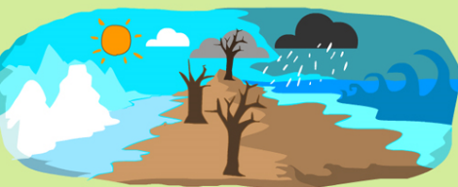 |  | 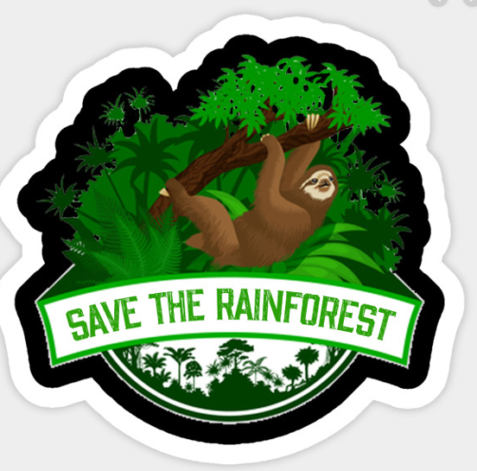 |  | 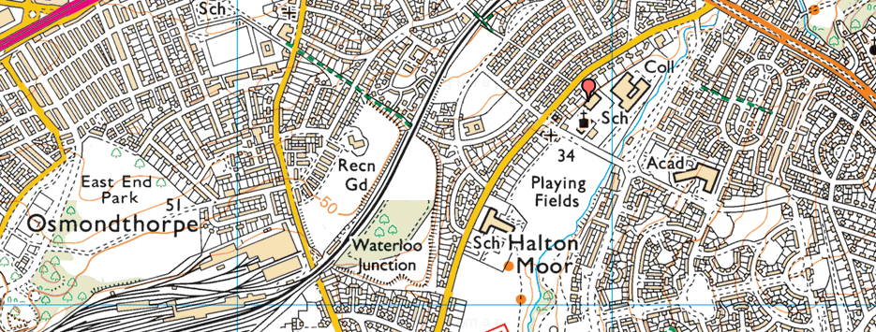
 |  | Is Climate Cool?  - Identify the position and significance of latitude, longitude, the Equator, Northern Hemisphere, Southern Hemisphere, the Tropics of Cancer and Capricorn, Arctic and Antarctic Circle and time zones.  - Use maps, atlases, globes and digital/computer mapping to locate countries and describe features studied.  - Describe and understand key aspects of physical geography, including: Climate zones. |  | Why should we help to save the Amazon Rainforest?  - Locate the world’s countries, using maps focussing on South America: its environmental regions, key physical and human  characteristics,  countries and major  cities.  - Use maps, atlases, globes and digital/computer mapping to locate countries and describe features studied.  - Identify the position and significance of the Equator, Northern Hemisphere, Southern Hemisphere, the Tropics of Cancer and Capricorn, Arctic and Antarctic Circle.  - Identify the position and significance of the Prime/Greenwich Meridian and time zones.  - Understand geographical similarities and differences through the study of the human and physical geography of a region of the UK and a region within South America. |  | What is special about our local area?  - Describe and understand key aspects of physical and human geography.  - Use maps, atlases, globes and digital/computer mapping to locate countries and describe features studied.  - Name and locate key topographical features of the UK (including rivers) and land-use patterns; and understand how some of these aspects have changed over time.
 | Autumn 1 | Autumn 2 | Spring 1 | Spring 2 | Summer 1 | Summer 2
Year 5, Year 5/6 and Year 6 Cycle A |  |  |  | 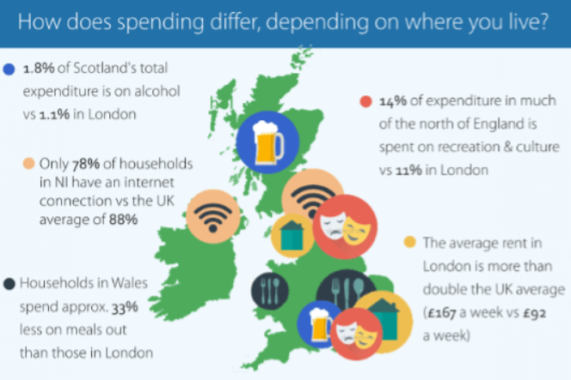 |  | 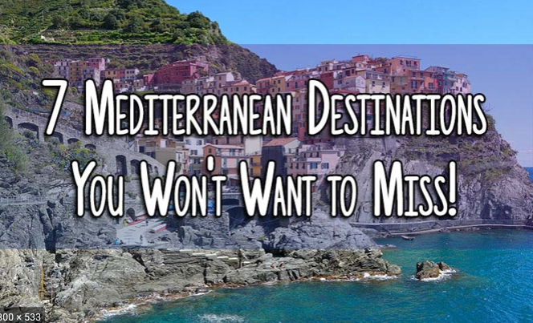
 |  | How does Leeds meet people’s needs?  - Locate the region and local area in relation to other places.  - Use aerial images to describe key physical and human features.  - Understand local, regional, national and international links to the Leeds.  - Consider how Leeds can meet the needs of its population.  - Gather evidence through fieldwork.  - Use Ordnance Survey maps and six-figure grid references to locate specific sites.  - Create a land use map using scale, symbols and compass points. |  | What do people do in the UK?  - Name and locate counties and cities of the United Kingdom, geographical regions and their identifying human and physical characteristics, key topographical features and land-use patterns; and understand how some of these aspects have changed over time  - Use maps, atlases, globes and digital/computer mapping to locate countries and describe features studied.  - Describe and understand key aspects of human geography, including: types of settlement and land use, economic activity including trade links, and the distribution of natural resources including energy, food, minerals and water. |  | Why should you visit the Mediterranean?  - Locate Europe’s countries, their environmental regions, key physical and human characteristics, countries, and major cities  - Use maps, atlases, globes and digital/computer mapping to locate countries and describe features studied.  - Describe and understand key aspects of human and physical geography.  - Understand geographical similarities and differences through the study of human and physical geography of a region in a European country.

 | Autumn 1 | Autumn 2 | Spring 1 | Spring 2 | Summer 1 | Summer 2
Year 5, Year 5/6 and Year 6 Cycle B |  | 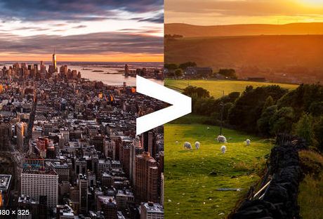 |  | 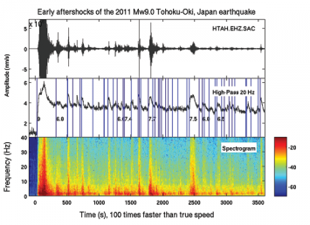 |  | 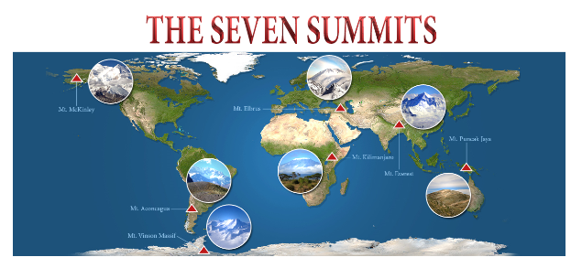
 |  | Why go to school in an inner city?  - Locate the region and local area in relation to other places.  - Use aerial images to describe key physical and human features.  - Name and locate counties and cities of the United Kingdom, geographical regions and their identifying human and physical characteristics, key topographical features and land-use patterns; and understand how some of these aspects have changed over time  - Gather evidence through fieldwork.  - Use Ordnance Survey maps and six-figure grid references to locate specific sites.  - Create a land use map using scale, symbols and compass points.  - Understand geographical similarities and differences between the local area and a rural area. |  | Does the Earth shake, rattle or roll?  - Locate volcanoes in countries around the world, their environmental regions, key physical and human characteristics, countries, and major cities.  - Use maps, atlases, globes and digital/computer mapping to locate countries and describe features studied.  - Describe and understand key aspects physical geography, including volcanoes and earthquakes. |  | What are the Seven Summits?  - Locate Europe’s countries, their environmental regions, key physical and human characteristics, countries, and major cities  - Use maps, atlases, globes and digital/computer mapping to locate countries and describe features studied.  - Describe and understand key aspects of human and physical geography.  - Understand geographical similarities and differences through the study of human and physical geography of a region in a European country.

