**English**

***As readers, the children will…***

Continue to develop their fluency, including reading all common graphemes.

Be able to read many common words containing GPCs taught so far, without needing to blend the sounds out loud first.

Listen to and discuss a wide range of stories, poems, plays and information books.

***As writers, the children will…***

Retell familiar fictional stories, including creating character descriptions.

Write a letter, using inspiration from ‘Meerkat Mail’.

Create a set of instructions, linked with a DT project.

**History**

***As historians, the children will explore…***

Who Guy Fawkes was and why did he want to blow up the Houses of Parliament

How we celebrate Guy Fawkes Day.

Why and how we celebrate Remembrance Sunday.

How Remembrance Day celebrated in the UK and places around the world.

What Apartheid is in south Africa.

Who Nelson Mandela was and what he achieved.

What impact Nelson Mandela has made.

**Religious Education**

***As theologians, the children will…***

**Learn about Mysteries**

Know the difference between a puzzle and a mystery.

Reflect on mysteries.

To know that there are three persons in one God, and we think of God in different ways.

To know about and reflect on God’s choice of Mary and Joseph.

Recognise and retell the story of the Annunciation.

To know that Jesus is God’s gift to the world.

Recognise and describe signs and symbols of advent.

**PSHE**

***As citizens, the children will…***

Learn about keeping safe in the home, including fire safety

Learn about keeping safe outside.

Learn about road safety.

**Design and Technology**

***As designers, the children will****…*

Design, make and evaluate a mail bag link with our Writing ‘Meerkat Mail’

design purposeful, functional, appealing products for themselves and other users based on design criteria

select from and use a range of tools and equipment to perform practical tasks [for example, cutting, shaping, joining, and finishing]

**Mathematics**

***As mathematicians, the children will…***

***Learn about addition and subtraction***

Solve problems with addition and subtraction

Use addition and subtraction facts to 20 fluently, and derive and use related facts up to 100

Add and subtract numbers using concrete objects, pictorial representations, and mentally.

Recognise and use the inverse relationship to check calculations and solve missing number problems

***Learn about multiplication and division***

Recall and use multiplication and division facts for the 2, 5 and 10

Show that multiplication of 2 numbers can be done in any order.

Solve problems involving multiplication and division, using materials, arrays, repeated addition.

**Year 2**

**How do we remember the past?**

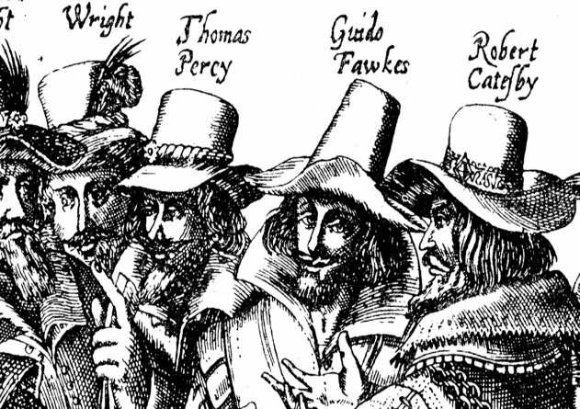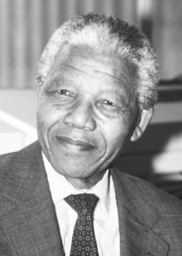

**Modern Foreign Languages- Spanish**

***As linguists, the children will…***

Be introduced to days of the week.

Be introduced to months of the year.

Be introduced to some classroom commands.

Be introduced to the vowels sounds in Spanish

Be introduced to consonants in Spanish

Be introduced new letter strings in Spanish Say some letters of the alphabet.

**Physical Education**

***As gymnasts, the children will…***

Be confident to perform in front of others

Perform the basic gymnastic actions with some

control and balance.

Plan and repeat simple sequences of actions.

Use directions and levels to make my work look interesting

Use shapes when performing other skills.

Work safely with others and apparatus.

**Science**

***As scientists, the children will explore…***

Notice that animals, including humans, have offspring which grow into adults

Find out about and describe the basic needs of animals, including humans, for survival (water, food and air)

Describe the importance for humans of exercise, eating the right amounts of different types of food, and hygiene

**Music**

***As musicians, the children will…***

Play tuned and untuned instruments musically

Listen with concentration and understanding to a range of high-quality live and recorded music.

Experiment with, create, select and combine sounds using the inter-related dimensions.

**of music.**

* **singing games.**