PSHE at Corpus Christi Catholic Primary
Mindmate runs throughout the year,a lesson is delivered at the beginning of every half term when pupils have returned from a break from school.
Year Group | Transition after lockdown | Autumn 1  Healthy Lifestyles | Autumn 2  Friendships | Spring 1  Relationship and Sex Education | Spring 2  Drug Education | Summer 1  Global Dimensions  Sustainability Citizenship  Transition | Summer 2  Economic Wellbeing Transition
Year 1 | Helping them to make sense of their world and their role in it. | Keeping the body healthy | Making friends | Myself and others  Feelings | Around the house | My world near and far |  | Looking after my money
 | 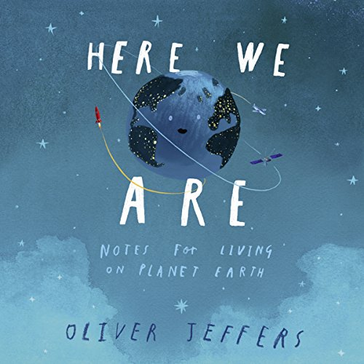 | 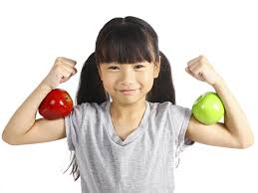 | 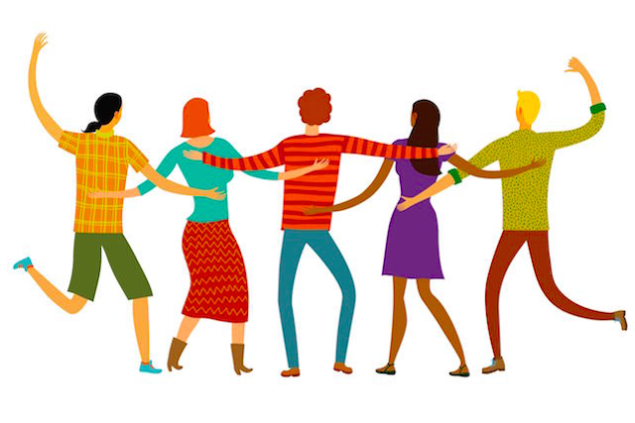 | 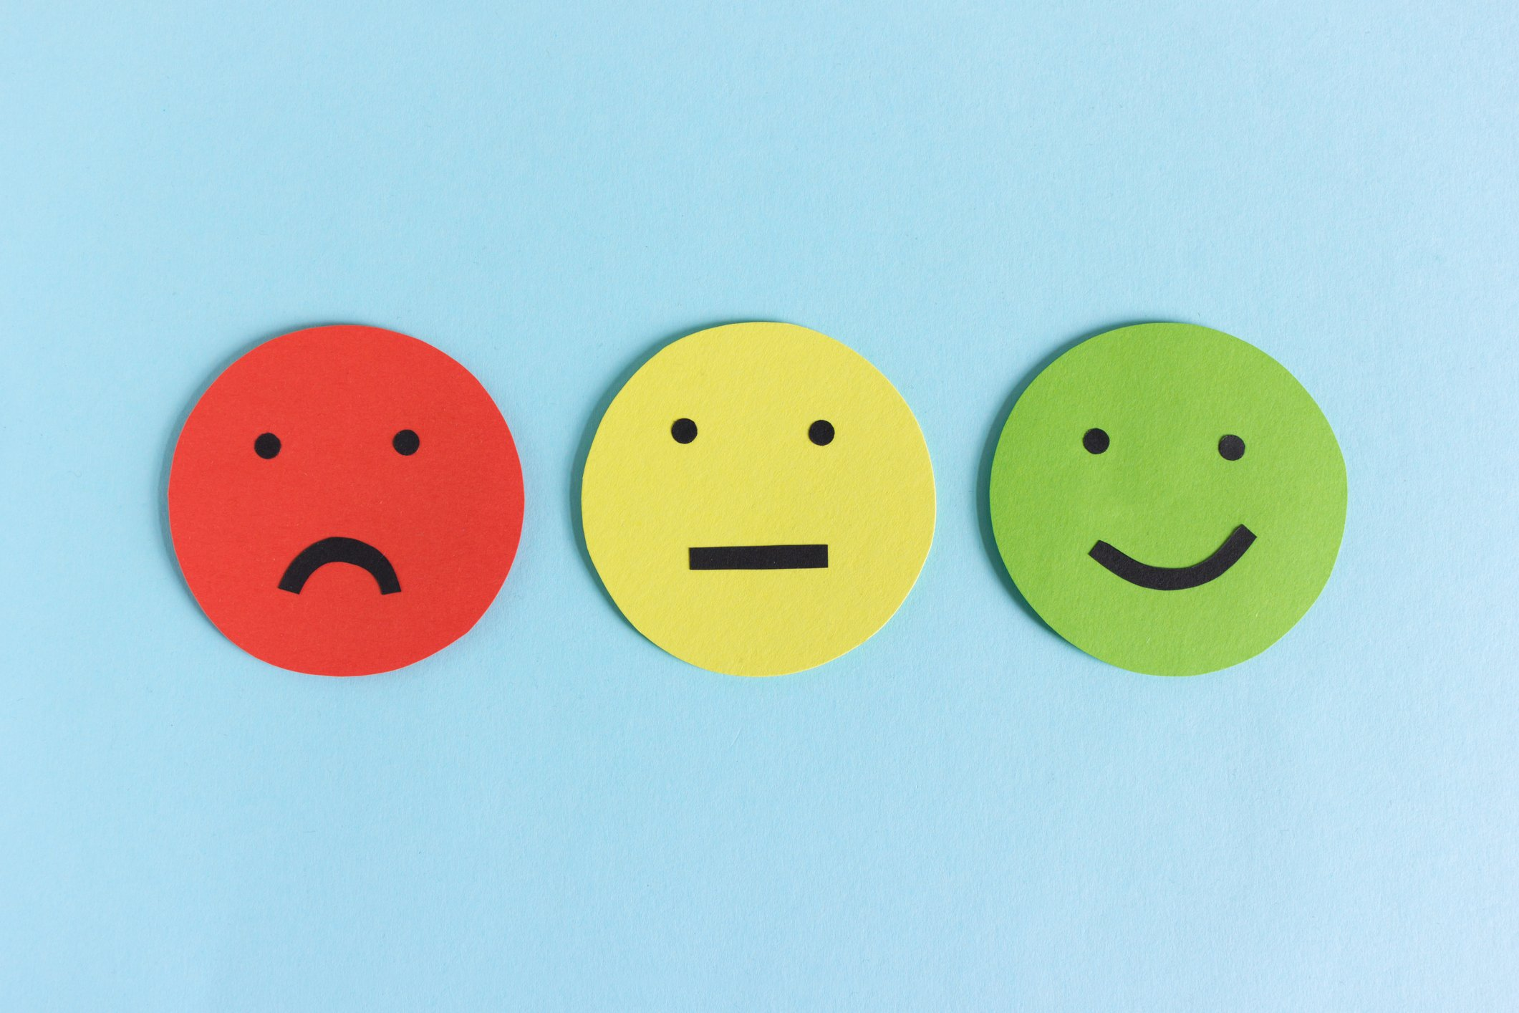 | 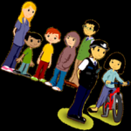 |  |  | 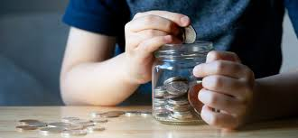
Year 2  &  Y2/3  (To extend year 3’s where possible) | Helping them to make sense of their world and their role in it. | Making choices for a healthy life  Body image and self esteem | Taking care of one another | Families | Medicines | Planet protectors  Waste and recycling |  | Transfer to the next key stage
 | 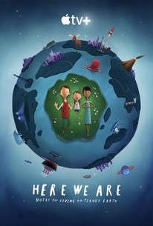 | 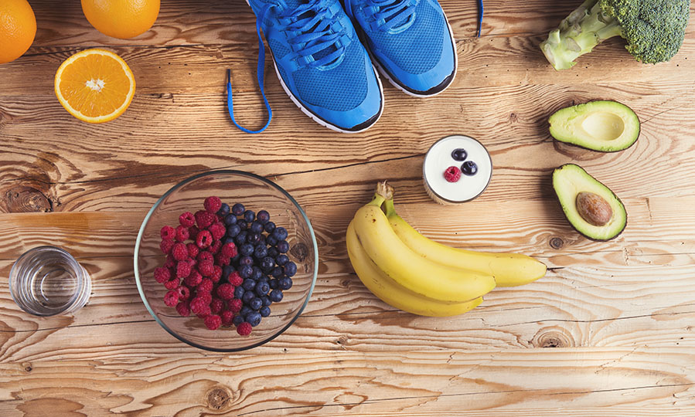 | 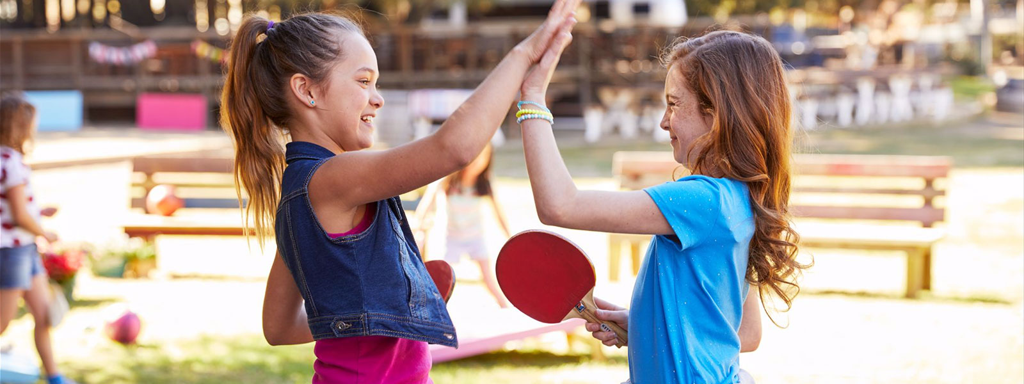 | 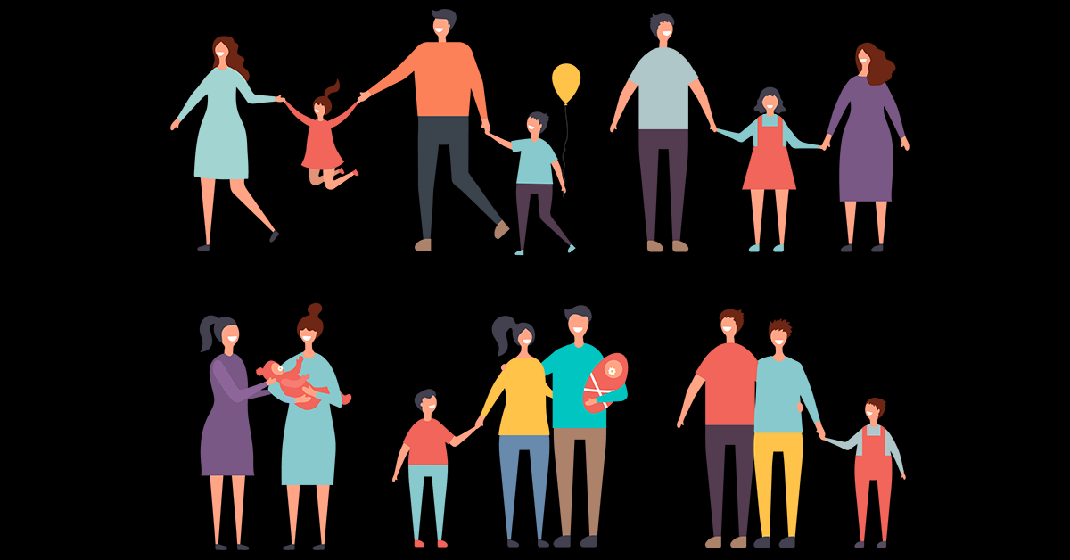 | 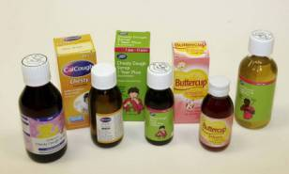 | 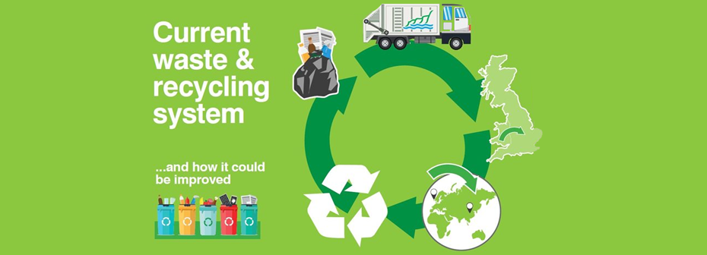 |  | 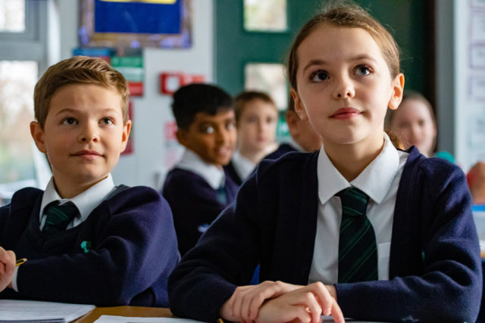
 |  | Autumn 1 | Autumn 2 | Spring 1 | Spring 2 | Summer 1 |  | Summer 2
Year 3/4 | Helping them to make sense of their world and their role in it. | Eating healthily being active | Feelings and relationship | What is happening to me? | Smoking | Health promoting environments |  | Developing economic wellbeing
 | 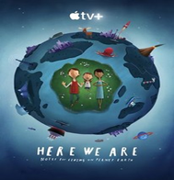 |  |  | 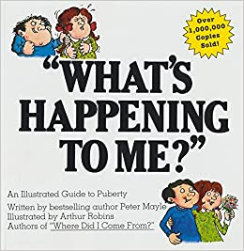 | 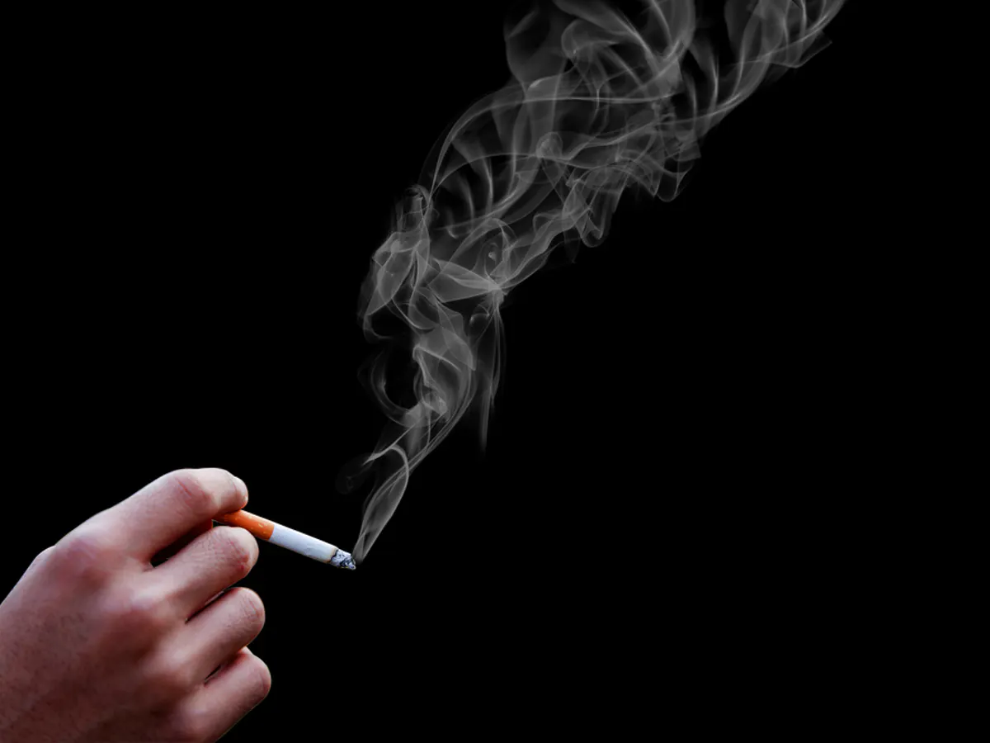 | 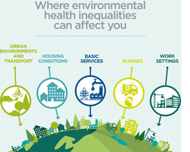 |  | 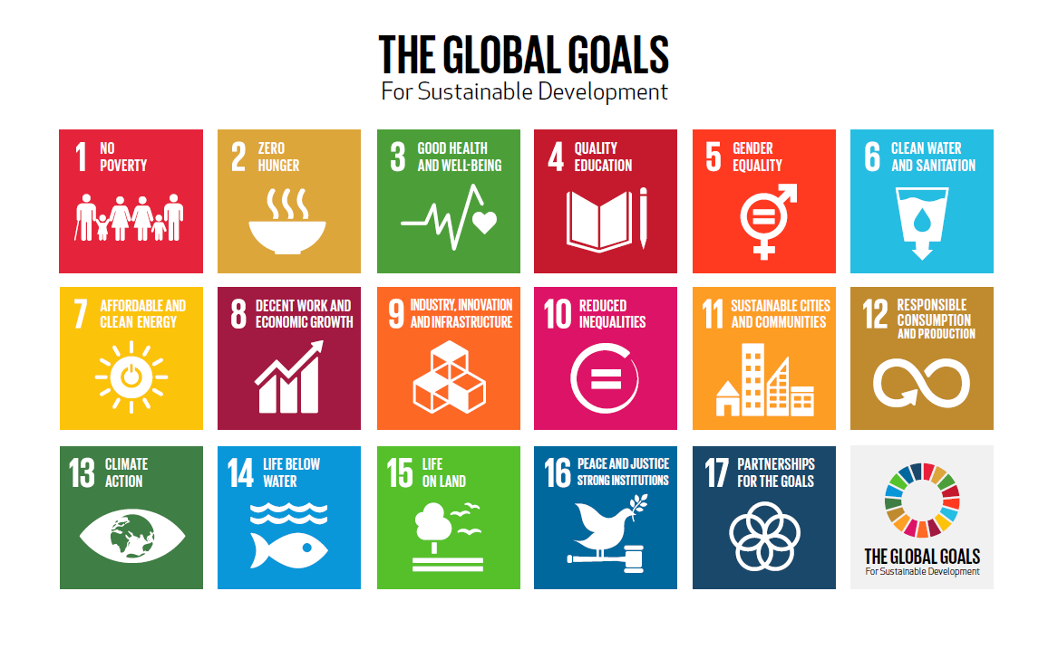
Year 4 | Helping them to make sense of their world and their role in it. | Keeping safe | Resolving conflicts | Addressing concerns about growing and changing | Alcohol | Resolving conflicts  Valuing others and their communities |  | Work related learning and enterprise
 | 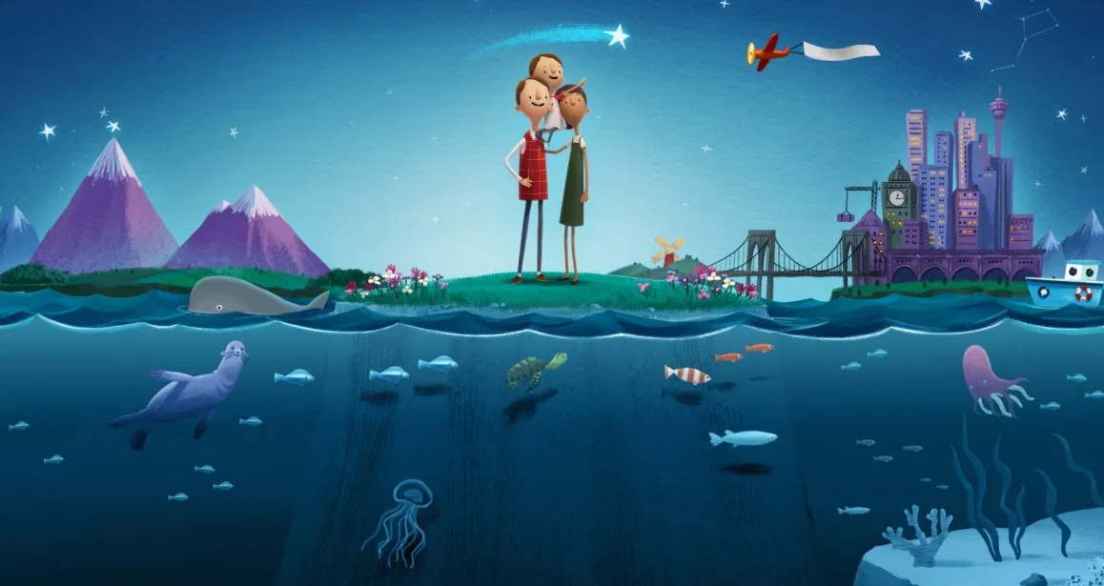 |  | 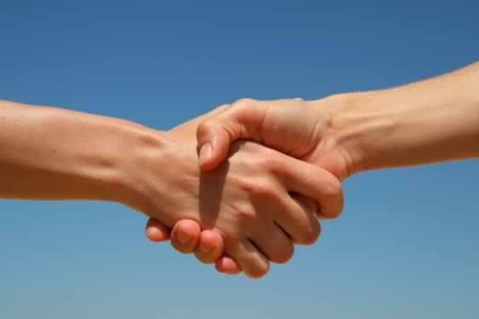 | 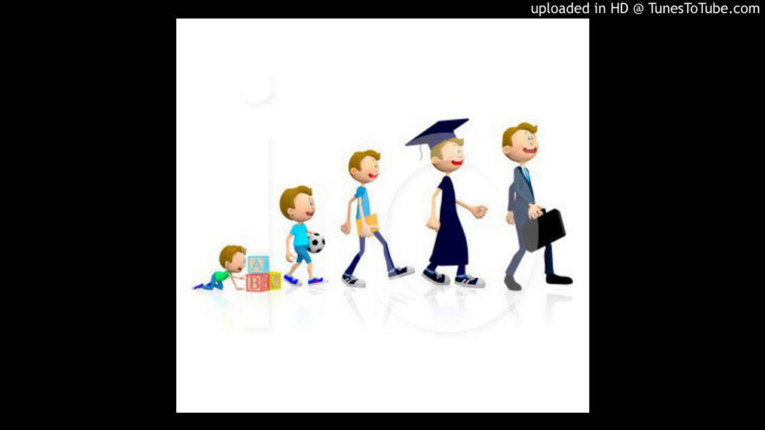 | 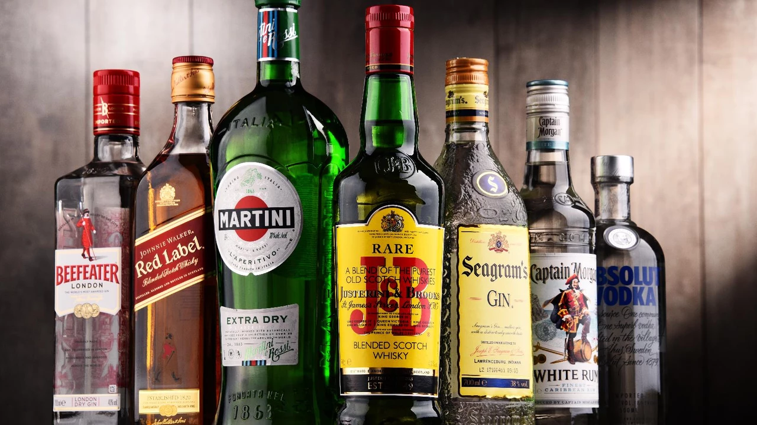 | 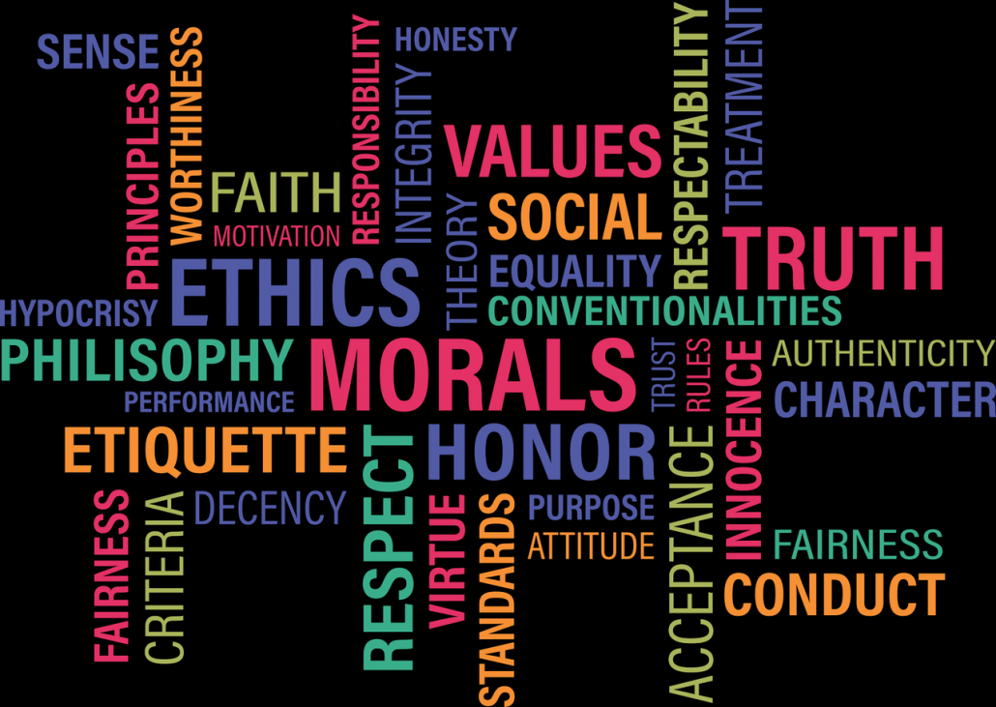

Year 5  Year 5/6 | Helping them to make sense of their world and their role in it. | Recognising risk and responsibility  Self esteem, body image | Living in a diverse world  Taking care of the world around us. | Growing and changing  Puberty | Drugs and volatile substances | Friendship groups and peer pressure | Work related learning and enterprise
 | 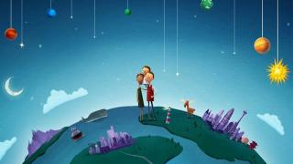 | 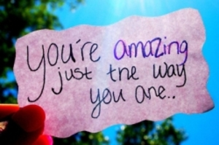 | 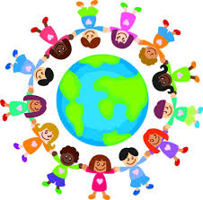 | 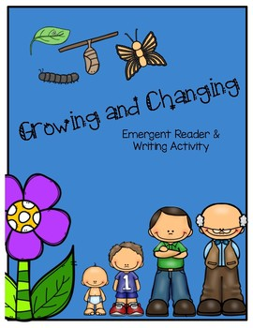 | 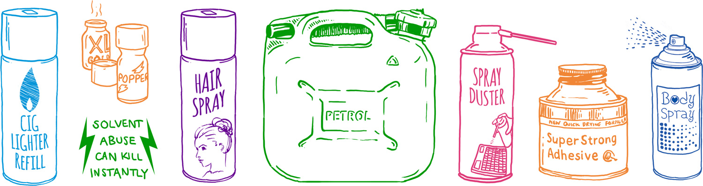 | 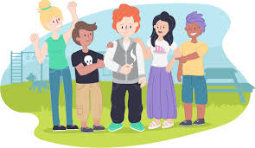
Year 6 | Helping them to make sense of their world and their role in it. | Personal safety | Dealing with barriers to friendships | Puberty, body image and sex education | How drugs affect us | Transfer to high school  Working alongside the high schools.  Pupils go to settling in days.  Residential
 | 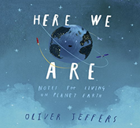 | 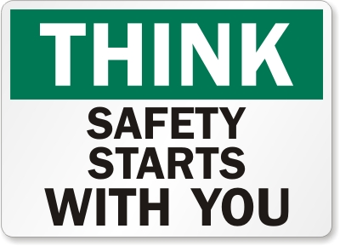 | 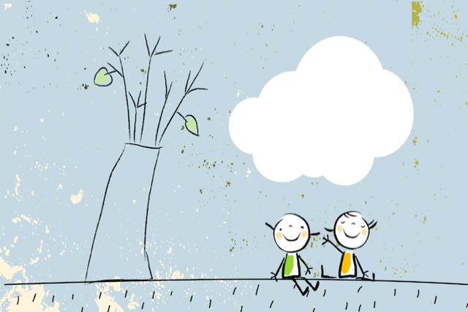 | 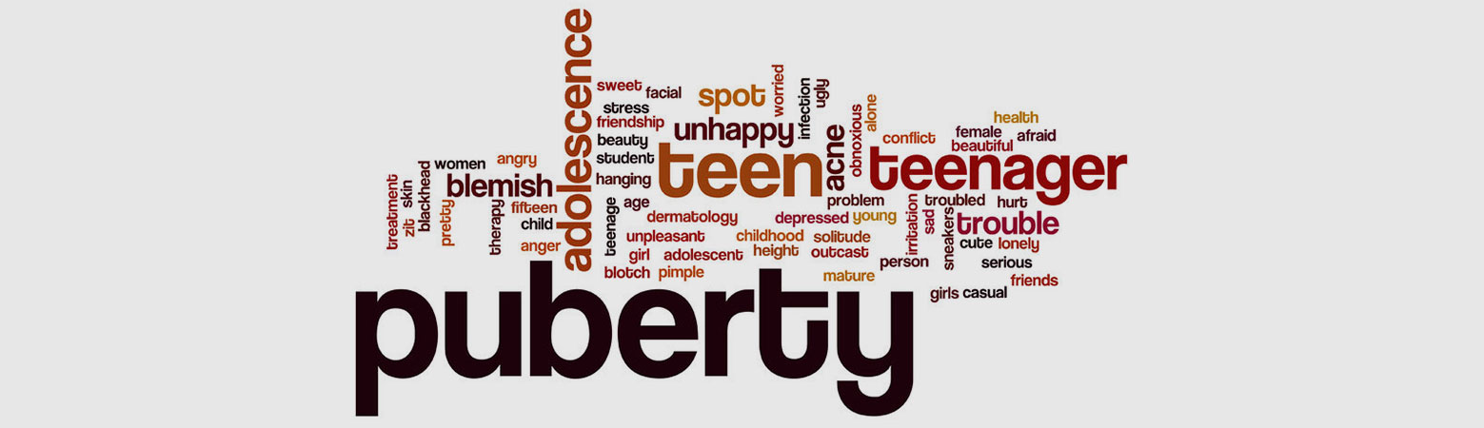 | 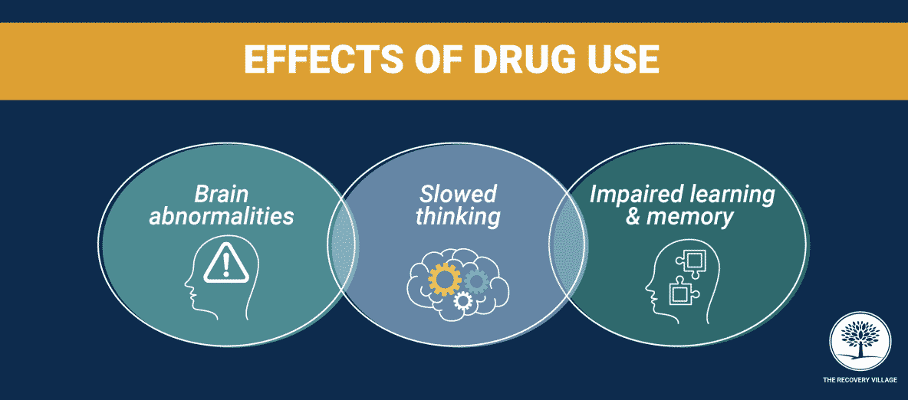 | 