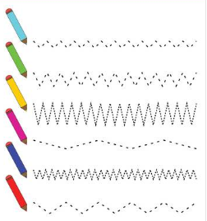Name: _________________________________________________________________