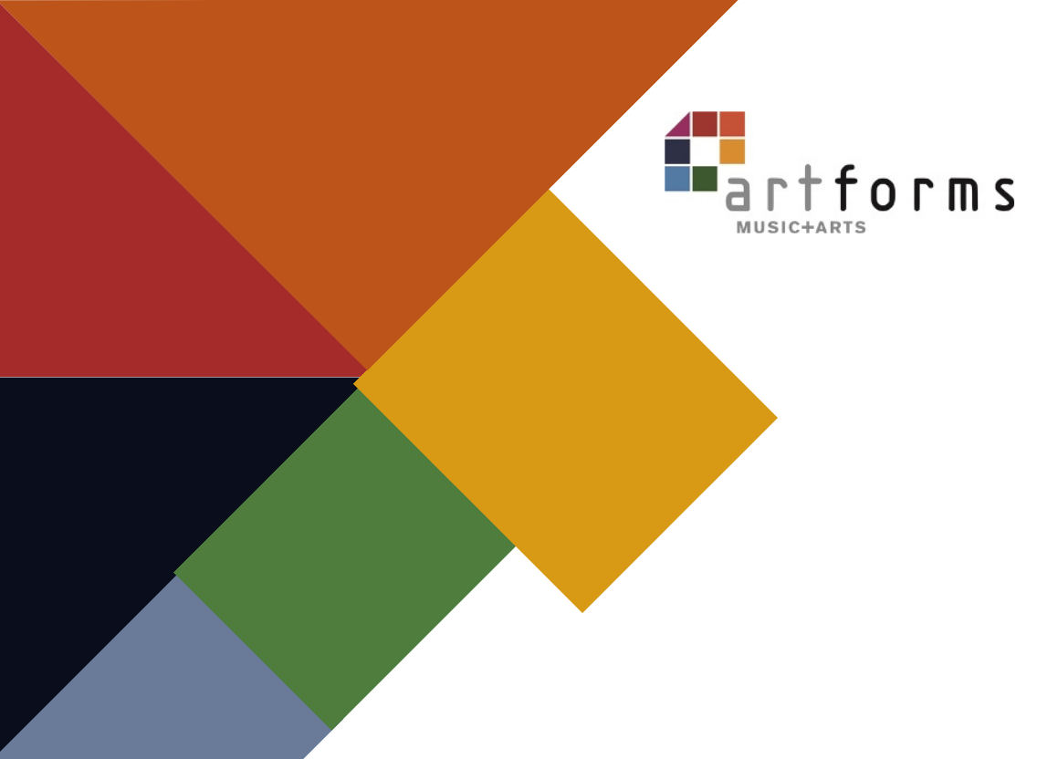
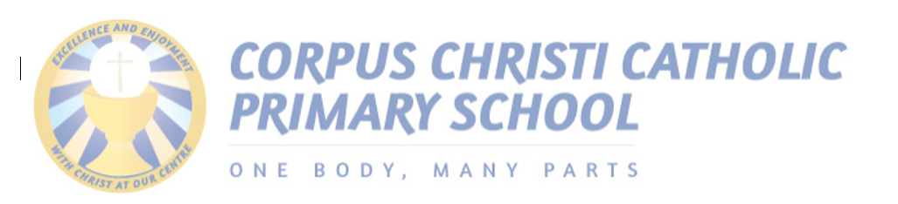

Music Development plan 2026-2027

School address
99 Basic way
leeds
LS1 1sl

Headteacher: Mrs W Walsh
Music Lead Teacher: Mrs J Clay



At Corpus Christi we believe that music is a powerful and unique way for children to express themselves. It helps mould both culture past and present and allows children to be part of that. Music gives children the opportunity to listen, learn and create. Through our curriculum we encourage every single one of our children to become a musician themselves through composing and performing a wide of genres both vocally and using instruments (djembes, recorders, ukulele, and glockenspiel to name a few). At Corpus Christi, we support the children to be able to self and peer assess performances during lessons which are delivered by expert music teachers.
We aim to deliver engaging and exciting music lessons here at Corpus Christi. Throughout school we employ the services of specialist music teachers which allows our children to make rapid progress in music from a very early age. The pupils also have the opportunity to join a range of music extracurricular clubs.
Across school, we provide a range of exciting music opportunities. In Years 3 and 4 the children have the opportunity to learn how to play djembe drums which is delivered by a peripatetic teacher and year 5/6 and 6 pupils are learning how to play the melodica which is delivered by a specialist teacher. In Year 3, 4 we have a specialist choral teacher and a specialist music teacher delivers curriculum music to all other year groups.
Additionally, as part of our music curriculum, we ensure our children learn to become skilled performers by being involved in musical productions. Children in Reception and KS1 begin with performing Nativity productions, KS2 deliver carol concerts, Lower Key Stage 2 deliver Easter plays and Year 6 perform a final leavers production; each of these productions show a variety of musical talent across school. In line with this, we ensure our children are provided with a wide range of opportunities to partake in music outside of school such as being represented at local events by a range of our pupils; these include singing at First Direct Arena with seventy other schools across Leeds to form a choir and at a Gala Concert held by the Diocese of Leeds at St Anne’s Cathedral and also children performing at an annual samba drumming music concert where pupils perform with pupils from across the city.



1 – Not yet in place | 2 - Emerging | 3 - Established | 4 - Embedded
Prioritise for support and development | Further development and support required. Not yet sure of impact on outcomes | Effective in producing good outcomes. Some ongoing support may be required to maintain or further improve provision | Highly effective in producing excellent outcomes.

Area | Category | Description | Comments
Curriculum Music | Timetabling | 1 - Not all classes receive a regular music lesson each week | 4. There are weekly timetabled curriculum music lessons in all years plus other provision which totals 1 hour per week for all children.  - Weekly Artforms led curriculum teaching music lessons  - Year 3/4 weekly whole class untuned instrument djembe lessons  - Year 3/4 weekly singing sessions delivered by Diocesan Singing Programme  - Whole school - fortnightly hymn practice delivered by Diocesan Singing Programme  - Year 5 and 6 weekly whole class tuned instrument melodica lessons via Diocesan Organ Programme
Curriculum Music | Timetabling | 2 - Music lessons are scheduled but not always delivered regularly
Curriculum Music | Timetabling | 3 - There are weekly timetabled curriculum music lessons in all years
Curriculum Music | Timetabling | 4 – There are weekly timetabled curriculum music lessons in all years plus other provision which totals 1 hour per week for all children (can include singing assemblies etc)
Curriculum Music | Curriculum design | 1 - Musical activity takes place in some or all classes but not tied to a formal school-wide curriculum | 4. There is a whole school curriculum in place which clearly maps progress and skills across the key stages. Teaching staff are aware of how their year fits into the bigger picture. Additional aspects are embedded into the planning such as whole class instrumental music, school performances and special musical events  - See long term plan written linked to progression plan with expert peripatetic music teacher involvement  - Provision plan outlines planned performances for pupils across school
Curriculum Music | Curriculum design | 2 – There is a whole school curriculum in place for music but progression over the years is not clear or well understood
Curriculum Music | Curriculum design | 3 - There is a whole school curriculum in place for music which covers all parts of the National Curriculum. It is clear how each year builds on the previous years and lays a foundation for what the children will learn next
Curriculum Music | Curriculum design | 4 - There is a whole school curriculum in place which clearly maps progress and skills across the key stages. Teaching staff are aware of how their year fits into the bigger picture. Additional aspects are embedded into the planning such as whole class instrumental music, school performances and special musical events
Curriculum Music | Assessment | 1 - No or very little formal assessment takes place in music. There is limited capacity and/or expertise for assessing musical progress | 3. Assessment and progress is documented in all year groups and verbal feedback in lessons is of good quality  Assessment is generally formative, Verbal feedback is of a good quality with peripatetic teachers modelling best practice to school staff.  Next steps  - Continue to ensure video recordings are taken from before and after  - Continue to focus on the quality of feedback that is given to children during lesson observations/ monitoring by Music Lead  - Continue to incorporate pupils’ self and peer assessments of their work into medium term planning/learning journey and annotate planning/adapt provision accordingly.
Curriculum Music | Assessment | 2 – Some assessment and recording of progress is taking place in some classes. Quality of verbal feedback in lessons varies widely and further support is needed
Curriculum Music | Assessment | 3 – Assessment and progress is documented in all year groups and verbal feedback in lessons is of good quality
Curriculum Music | Assessment | 4 - Progress is clearly recorded using a variety of methods and ML works closely with class teachers to monitor and support quality of feedback in lessons. There are opportunities for pupils to self and peer assess their work planned into lessons
Curriculum Music | Quality of teaching | 1 - The teachers delivering music are mostly lacking confidence and expertise in the subject | 4. Music teaching is consistently good quality and is regularly monitored and supported  All music lessons are delivered by expert music teachers from external partners, class teachers are present during these taught sessions and have input into the assessment of pupils. Peripatetic teachers are observed and monitored by Music Lead and their line managers.
Curriculum Music | Quality of teaching | 2 - Music teaching is of a mixed standard, there is still a need for further CPD and support.
Curriculum Music | Quality of teaching | 3 - Music teaching is mostly or all good quality throughout school
Curriculum Music | Quality of teaching | 4 - Music teaching is consistently good quality and is regularly monitored and supported
Curriculum Music | EYFS music | 1 - It is uncertain how much music takes place in Nursery/Reception classes or whether it is of consistently good quality | 4- Music teaching and singing leading is of good quality in EYFS. Regular lessons include appropriate songs and activities and the children clearly make progress  All timetabled curriculum music lessons are delivered by expert music teachers from external providers  Teachers are involved in these lessons to develop skills for their own teaching
Curriculum Music | EYFS music | 2 - Music is regularly planned in to EYFS though some CPD and support would still be beneficial
Curriculum Music | EYFS music | 3 - Music teaching and singing leading is of good quality in EYFS. Regular lessons include appropriate songs and activities and the children clearly make progress
Curriculum Music | EYFS music | 4 - Music is an integral and essential daily part of EYFS life. Songs and activities are appropriate to developing voices and carefully chosen to support early progress
Whole class instrumental provision | Whole class | 1 - No whole class instrumental provision is currently in place | 4. Whole class learning is fully integrated into the wider music curriculum and is deliberately placed for pupil progression. The instrument/s are also selected for progression and quality of delivery is consistently good. Some children choose to carry on with that instrument (or a related instrument) at the end of the year in whole class follow on or small group lessons.  Children carry on djembe in whole class tuition at the end of the year and then have the opportunity to learn a tuned instrument in Years 5 and 6.  The progression model has been agreed for this academic year to allow progression of djembe skills for pupils in year 5  Pupils leave school with the experience of learning to play both untuned and tuned instruments through whole class tuition. Therefore, they have excellent knowledge of music and have experience of reading music. High school feedback that pupils have excellent subject knowledge compared to peers from other feeder schools.
Whole class instrumental provision | Whole class | 2 - Children are given a ‘taster’ on one or more instruments in whole class lessons which is less than one year in duration
Whole class instrumental provision | Whole class | 3 - Children are given a full year to learn an instrument and as such develop basic skills and knowledge securely in that time. There are opportunities during the year for the children to perform to others
Whole class instrumental provision | Whole class | 4 - Whole class learning is fully integrated into the wider music curriculum and is deliberately placed for pupil progression. The instrument/s are also selected for progression and quality of delivery is consistently good. Some children choose to carry on with that instrument (or a related instrument) at the end of the year in whole class follow on or small group lessons.
Singing | School / KS / Year group singing | 1 - Children rarely or never sing together as part of a larger group | 4. Regular singing assemblies are led by a specialist. Singing is an important and integral part of curriculum lessons, delivered by confident teachers skilled in delivering healthy singing  Singing sessions are delivered weekly by Diocese of Leeds Music teacher, following the Diocese singing programme.  Next steps  This year it has been planned to include more/ all KS1 and KS2 classes in the weekly/ fortnightly hymn practice.
Singing | School / KS / Year group singing | 2 - Children sing together occasionally at some points during the year (e.g. Christmas, Harvest)
Singing | School / KS / Year group singing | 3 - Children sing together all or most weeks as part of a singing assembly or similar
Singing | School / KS / Year group singing | 4 - Regular singing assemblies are led by a specialist. Singing is an important and integral part of curriculum lessons, delivered by confident teachers skilled in delivering healthy singing
Singing | Choirs | 1 - There are currently no school choirs taking place regularly | 4 There are one or more school choirs, led by skilled singing leaders which have opportunities to perform regularly and/or take part in wider community events./  Music expert teacher delivers an after-school choir, this is open to KS2 pupils, they perform in assembly and also for parents throughout the year. This group have also performed at community celebrations and events.  Next step  Lunch time choir or music group
Singing | Choirs | 2 - A school choir forms for special occasions only (e.g. Christmas, Young Voices)
Singing | Choirs | 3 - There is at least one school choir which meets regularly led by a skilled teacher
Singing | Choirs | 4 - There are one or more school choirs, led by skilled singing leaders which have opportunities to perform regularly and/or take part in wider community events There are one or more school choirs, led by skilled singing leaders which have opportunities to perform regularly and/or take part in wider community events
Instrumental and vocal lessons | Tuition | 1 - There are currently no opportunities for children to learn to play an instrument in school | 3. Children have the opportunity to learn to play an instrument in two or more musical families (e.g. woodwind and guitar). We have a universal offer so all pupils in the year group learn to play.  4.  Pupils are given the opportunity to learn two instruments, melodicas, from the reed and keyboard family, and djembes, from the percussion family, through curriculum teaching so we have a universal offer rather than individual tuition. Pupils have regular opportunities to perform with and to others.  This year 8 pupils in year 5 will have the opportunity to progress their djembe skills.
Instrumental and vocal lessons | Tuition | 2 - Children have the opportunity to learn an instrument in at least one family of instruments. There are occasional opportunities for children to perform on their instruments
Instrumental and vocal lessons | Tuition | 3 - Children have the opportunity to learn to play an instrument in two or more musical families (e.g. woodwind and guitar) There is a healthy uptake each year of students wanting to learn to play
Instrumental and vocal lessons | Tuition | 4 - There are opportunities for children to learn an instrument in various instrumental families with regular opportunities to perform to others. School regularly engages and plans with their instrumental tutors allowing for a consistent approach to music provision
Instrumental and vocal lessons | Whole class follow on | 1 - There is currently no whole class instrumental teaching taking place in school | 3. There are opportunities for children to continue learning the instrument (or a closely related instrument) after whole class lessons have finished.  4. There are opportunities for children to continue learning the instrument  Previously tried this but it was not cost effective to run this as too few pupils were able to commit to this. Therefore, this is provided through curriculum whole class provision over two years for both untuned and tuned instruments.  This year 8 pupils in year 5 will have the opportunity to progress their djembe skills
Instrumental and vocal lessons | Whole class follow on | 2 - There are currently no opportunities for children to continue learning an instrument they have started in whole class teaching
Instrumental and vocal lessons | Whole class follow on | 3 - There are opportunities for children to continue learning the instrument (or a closely related instrument) after whole class lessons have finished.
Instrumental and vocal lessons | Whole class follow on | 4 - There are opportunities for children to continue learning the instrument (or a closely related instrument) after whole class lessons have finished and a good number of children choose to do this, ultimately progressing on to small group lessons.
Instrumental and vocal lessons | Ensembles | 1 - There are currently no instrumental ensembles in school | 3 and 4 As we have a universal offer for djembes and melodicas, pupils play together in a class group weekly. - Ensemble workshop days are planned into the school year. Pupils who play instruments are encouraged to join these.  CLYM group information is shared via class dojo.  Pupils across school encouraged to perform in front of an audience e.g in assemblies, ensembles or musical celebration events  Next step  Pupil survey to identify interested pupils and then target routes of progression for these children including music centres and CLYM
Instrumental and vocal lessons | Ensembles | 2 - Children learning some instruments are encouraged to join ensembles and signposted to music centres or CLYM groups
Instrumental and vocal lessons | Ensembles | 3 - There is a school ensemble which allows some children to play together regularly in a group
Instrumental and vocal lessons | Ensembles | 4 - Any child learning any instrument in school has the chance to play that instrument in an ensemble. There are regular performing opportunities with the group. Routes of progression for children including music centres and CLYM are signposted as appropriate
Inclusion | Inclusion | 1 - There are no provisions in place to support less affluent families. There is little adaptation in music lessons for children with additional needs or varying ability and there are limited opportunities to experience the music of different cultures | 3. School applies for LMEP bursaries or finds other ways to support children from low income backgrounds to learn an instrument.  Curriculum and instrumental lessons are planned to cater for children with varying needs and abilities. Pupils have opportunities to listen to and engage with music from different cultures and traditions  4. All staff (including visiting staff) are fully aware of any relevant additional needs in their classes. Lessons are well differentiated to cover all needs and abilities.  Groups of SEND pupils have an additional small music session on a Friday afternoon, where they can learn to play and perform in a quieter environment with a music expert teacher.  Pupils with more complex SEND needs have access to a weekly small group music session delivered by a music peripatetic expert teacher.  Next Steps  -Apply for LMEP bursaries for interested pupils to learn an instrument  -Further adapt untuned and tuned whole class tuition for pupils with additional needs
Inclusion | Inclusion | 2 - There is some provision in curriculum music lessons for children with additional needs or disabilities. Occasional opportunities to experience music from different cultures and traditions
Inclusion | Inclusion | 3 - School applies for LMEP bursaries or finds other ways to support children from low income backgrounds to learn an instrument.  Curriculum and instrumental lessons are planned to cater for children with varying needs and abilities. Pupils have opportunities to listen to and engage with music from different cultures and traditions
Inclusion | Inclusion | 4 - All staff (including visiting staff) are fully aware of any relevant additional needs in their classes. Lessons are well differentiated to cover all needs and abilities. Children are sensitively guided to learning an appropriate instrument for their specific needs- Pupils have opportunities to listen to and engage with music from a wide variety of different cultures, traditions and eras
Wider involvement | Hub participation | 1 - The school generally don’t engage with the Leeds music hub (LMEP) or other partner organisations in music | 3 - There is a good level of engagement with LMEP and Music Connect with annual participation in local events  School usually take part in the Big Samba drumming event.  School have recently taken part in Little Sing, Leeds Arena Primary Choir music event, Cathedral Choir Radio 4 recording, The snowman with live orchestra, SEND Christmas sing along and Live Nativity.  Next Steps  - Possibly look at using the innovative music grant to allow pupils to continue to access these.  - Continue to develops strong partnerships with LMEP, Music Connect, Diocese of Leeds and/or other organisations with regular participation in multiple local events and concerts
Wider involvement | Hub participation | 2 - The school engages with LMEP or other partner with occasional participation in local events
Wider involvement | Hub participation | 3 - There is a good level of engagement with LMEP and Music Connect with annual participation in local events
Wider involvement | Hub participation | 4 - The school has strong partnerships with LMEP, Music Connect and/or other organisations with regular participation in multiple local events and concerts
Wider involvement | CPD | 1 - There is little capacity within school for the music lead or other staff to engage with music CPD | 3/4 Music is taught by external providers so ongoing CPD is covered by these expert peripatetic partners to enable class teachers to develop and close any gaps in their skills and knowledge.  Music lead attends network meetings termly and the annual conference
Wider involvement | CPD | 2 - Music lead has occasional opportunities to access CPD, other staff only rarely
Wider involvement | CPD | 3 - Music Lead regularly accesses CPD in music teaching and has opportunities to pass this on to other staff in school
Wider involvement | CPD | 4 - Music Lead and other staff in school access CPD in music. Music Lead has a good understanding of where gaps lie in staff knowledge and works to address those over time
Wider involvement | Links with other schools | 1 - There are currently no musical links with other schools | 3- Some links are made with peer schools, other MAT schools, religious school networks or cluster networks. Occasional musical events may take place within these communities or resources and expertise are shared. There are some transition arrangements in music with the local secondary schools  4-Strong links are made with other schools with opportunities to share resources, expertise and to organise events. There are strong links made to local secondary schools for Y6 transition.  Annual meeting with music leads from local high school to arrange events and links :  Last two years…  - Djembe workshop for Arts Council delivered by High school music lead  - Pop band performed in school  - Afterschool club provided by high school to develop links and help with transition, this has also allowed year 5 and 6 pupils to access this.  - Pupils in school invited to shows at the High School
Wider involvement | Links with other schools | 2 - Occasional links are made with other local schools for musical events or activities
Wider involvement | Links with other schools | 3 - Some links are made with peer schools, other MAT schools, religious school networks or cluster networks. Occasional musical events may take place within these communities or resources and expertise are shared. There are some transition arrangements in music with the local secondary schools
Wider involvement | Links with other schools | 4 - Strong links are made with other schools with opportunities to share resources, expertise and to organise events. There are strong links made to local secondary schools for Y6 transition.
Wider involvement | Live music | 1 - There are currently no opportunities for children to experience and enjoy live music | 3. All children have opportunity to experience live music over the course of the school year.  Over the past two years:  - Folk group performances  - Year 4/5, 5 and 6 experienced ‘Oliver!’ the musical and ‘ A Christmas Carol’ at the theatre  - Year 1, 1/2 and 2 experienced singing on their trip to The Polar Express  - Year 2 watched ‘ The Snowman’ with live orchestra  - Pop Band performance from local high school  - Back Chat Brass performance organised by ARTS council for KS2 pupils  - Chestra music group performance organised by ARTS council for KS1 pupils  - ‘in house’ live music: djembe, melodica and singing performances  Next steps  Continue to plan into the school’s curriculum and organise live music from a range of musicians which reflects the diversity of music in our world.
Wider involvement | Live music | 2 - There are occasional opportunities for some children to experience live music either on a trip or from visiting musicians
Wider involvement | Live music | 3 - All children have opportunity to experience live music over the course of the school year.
Wider involvement | Live music | 4 - All children have the opportunity to experience live music from a range of musicians which reflects the diversity of music in our world. Live music is integrated into the school’s curriculum with wider opportunities to explore the genres



MUSIC DEVELOPMENT PLAN
Overall objectives | Intent  At Corpus Christi our music program is dedicated to fostering inclusivity and expanding cultural capital for all students. We believe that every child should have the opportunity to engage with and enjoy the transformative power of music. Our mission is to provide enriching experiences and unique opportunities that exceed the ordinary, ensuring that every student, regardless of background, can discover, explore, and develop their musical talents. Through diverse and innovative musical activities, we aim to inspire creativity, build confidence, and cultivate a lifelong appreciation for music in our students.
Key components | List the key components that will make up the music provision in your school. The list below is an example and should be adapted for your school.  Music curriculum taught by expert peripatetic teachers, including use of music technology across school  SEND pupils offered smaller group sessions where deemed appropriate to allow them to enjoy music in a calmer environment  Classroom instrumental teaching of djembe for year 3 and year 4 pupils and melodicas for year 5 and year 6 pupils  Links with external music organisations  Pupil Premium student engagement  Music CPD  Choirs/ensembles  Whole school singing assemblies/ hymn practice  Performance opportunities including sharing with parents  Musical engagement with feeder secondary schools  Additional funding from hub/charities/fundraising  Musical theatre experiences  Pupil voice – Arts council
Communications | All information about the music curriculum will be shared on the school website.  Performances and experiences will be shared on class dojo and also the school newsletter
Budget, materials and staffing | How do we resource the provision –  Artforms cashback funding for teachers and instruments  1 x staff from Artforms to deliver weekly curriculum music lessons  1 x staff from Artforms to deliver Djembe lessons weekly  1 x staff from Artforms to deliver Djembe progression sessions  1 x Diocese of Leeds Singing Programme staff to deliver singing sessions  1 x Diocese of Leeds Organ Programme music staff to deliver melodica sessions  School budget for resources such as additional instruments, subscriptions and other equipment

Key Areas development plan 2026/2027
Target | Area for development  (Intent) | Actions ( Implementation) | Date to be completed by | Evaluation  ( Impact)
 | Further develop opportunities for children to be given the opportunity to play a musical instrument in an ensemble. | - Meet with expert music teacher discuss and plan ensemble pop ups 3x ensemble workshops throughout the year.  - workshops and follow on performances shared with whole school to raise awareness  - Share workshop photos on whole school newsletter to raise awareness  - Before and after videos recorded to demonstrate progress | Initial meetings September 2026  Workshops 1 Autumn, spring and summer
 | To develop more opportunities for pupils to experience live music from a range of genres | - Meet with high school music lead, plan live music to be delivered by high school pupils.  - Apply for Artforms innovative grant to attend at least 2 Artforms events or live music into school events  - Arts council to secure and organise dates for 2 x live music events  - Plan musical theatre events, year groups to have the opportunity to visit the theatre  - Whole school invited to music group performances (djembes, melodicas and singing) end of the year  - Choir to continue to perform in assemblies - 3 x a year  - Encourage ‘hidden’ musicians in school to perform in weekly assemblies | Initial meeting with high school September 2026  Arts council organise music events by October 2026  Musical theatre to be planned July/ September 2026
 | To develop monitoring systems for retention of knowledge to develop pupil voice in school | - Pupil questionnaires to be completed by all year groups, 2 pupils from each class, questions to involve knowledge retention. Answers/ analysis from this to be shared with all music providers – action plan decided  - Arts Council to ask key questions to classes and feedback as a group  - Composer of the term planned, outlining key vocabulary and terminology to be used when describing music, also share this on dojo with parents/ carers  - Music lead to observe music lessons, monitoring questioning and pupil knowledge demonstrated in responses. | Questionnaires to be completed and analysed by Autumn 2026  Composer of the term planned July 2026  Observations of music lessons November 2026
 | To develop opportunities for children to continue learning the instrument | - Djembe progression group set up with 8 pupils from a range of groups e.g. PP, SEND, G and T attend 30 minutes continuation lesson weekly  - Perform to whole school providing more ‘live music’  - Pupils to develop skills and achieve higher certificates from Artforms | Set Up September 2026 – to run until July 2027

