Corpus Christi Primary School – We are Scientist!
Science: What’s That Sound? | Phase: LKS2 | Strand: Physics
Key Vocabulary
Vibrations | moving (wobbling) very quickly back and forth.
Pitch | how high or low a sound is
Volume | how loud or quiet a sound is
Decibel | The measurement of sound.
Ear drum | This is inside your ear. It is a thin flap of skin which is stretched tight like a drum and vibrates when sound waves hit it.
Soundproofing | Soundproofing – a way to reduce the movement of sound.
Sound wave | Sound wave – how sound/vibrations travel through the air.
Insulation | Materials use to quieten sound
Vacuum | This is a totally empty space, sound cannot travel through empty spaces.
Noise Pollution | harmful or annoying levels of noise
Top Facts
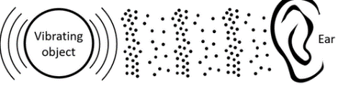
- Sound is made by air molecules vibrating.

- When vibrations are made (e.g. when you clap your hands) the air around the object vibrates. This is the air molecules vibrating.
- The vibrations pass on from air particle to air particle until the ones near your ear vibrate.
- When air molecules inside the ear vibrate, they shake tiny hairs on the insides of the ears. The hairs are connected to nerves under the skin. These nerves send messages to your brain to tell you that you heard a noise.
- On a stringed instrument: shorter, thinner and tighter strings produce a higher pitch.
- On a wind instrument: shorter columns produce a higher pitch.
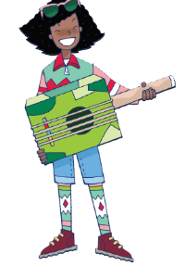
- Sound can travel through solids, liquids and gases. Like light, sound travels through the air in waves.
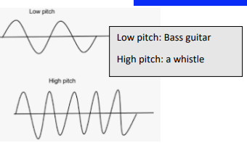

What I already know?
I can identify name, draw and label the basic parts of the human body and say which part of the body is associated with each sense.

What will I know by the end of the unit?
I will be able to identify how sounds are made, associating some of them with something vibrating. Recognise that vibrations from sounds travel through a medium to the ear. Find patterns between the pitch of a sound and features of the object that produced it. Find patterns between the volume of a sound and the strength of the vibrations that produced it. Recognise that sounds get fainter as the distance from the sound source increases.

