Corpus Christi Primary School – We are Scientists!
Topic: Animals including humans | Phase: KS1 | Strand: Biology
What I should already know?
Year 1 - Children can classify and name animals by what they eat (carnivore, herbivore and omnivore). They can link the correct part of the human body to each sense. and name a variety of animals including fish, amphibians, reptiles, birds and mammals. Children can sort animals into categories (including fish, amphibians, reptiles, birds and mammals) and living and non-living thing.

Top 10 Vocabulary
adult | A fully grown animals or plant.
develop | To grow and become stronger.
life cycle | The changes living things go through to become an adult.
offspring | The child of an animal.
Reproduce | When living things make new living things of the same kind.
young | Offspring that have not reached adulthood.
Live young | Offspring that has not hatched from an egg.
germs | Germs can invade plants and animals and can sometimes make them sick.

Top 5 Facts
- Some animals lay eggs which hatch into live young.
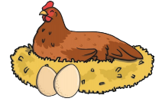
- Some animals give birth to live young. Their offspring normally look like them when they are born.
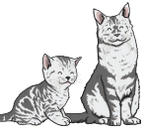
- Some animals have offspring that do not look like them.
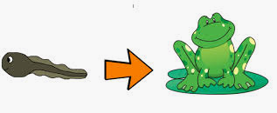
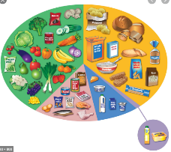
- There are 5 food types, carbohydrates, fruit and vegetables, dairy, protein, and fats.

- To stop illness and infection spreading, we must be hygienic and keep ourselves clean.
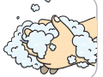

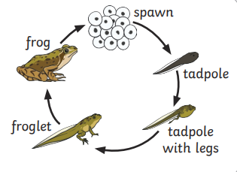
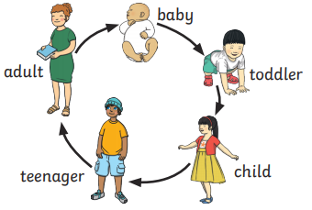
What will I know by the end of the unit?
I can notice that animals, including humans, have offspring which grow into adults
I can find out about and describe the basic needs of animals, including humans, for survival (water, food and air)
I can describe the importance for humans of exercise, eating the right amounts of different types of food, and hygiene.

To stay alive, all animals
have 3 basic needs:

