|  |
| --- |
| Phonics & pronunciationwe will see: |
| 1. Recommended phonics focus: CH J Ñ LL RR 2. • CH sound in ocho 3. • J sound in rojo & naranja 4. • Ñ sound in España 5. • LL sound in amarillo 6. • RR sound in marron 7. • Stress Placement. Words that end in a consonant (apart from ‘n’ or ‘s’ 8. should be stressed on the last syllable as in a-zul. For words that end in a vowel 9. or ‘n’ and ‘s’ it is normally the second to last syllable like na-ran-ja. 10. • Accents. Accents can only be written over vowels in Spanish and indicate 11. the vowel is stressed – regardless of the other rules! As seen in có-mo. 12. • Ñ tilde. This changes the ‘n’ to a ‘ny’ sound like in the English word onion. |

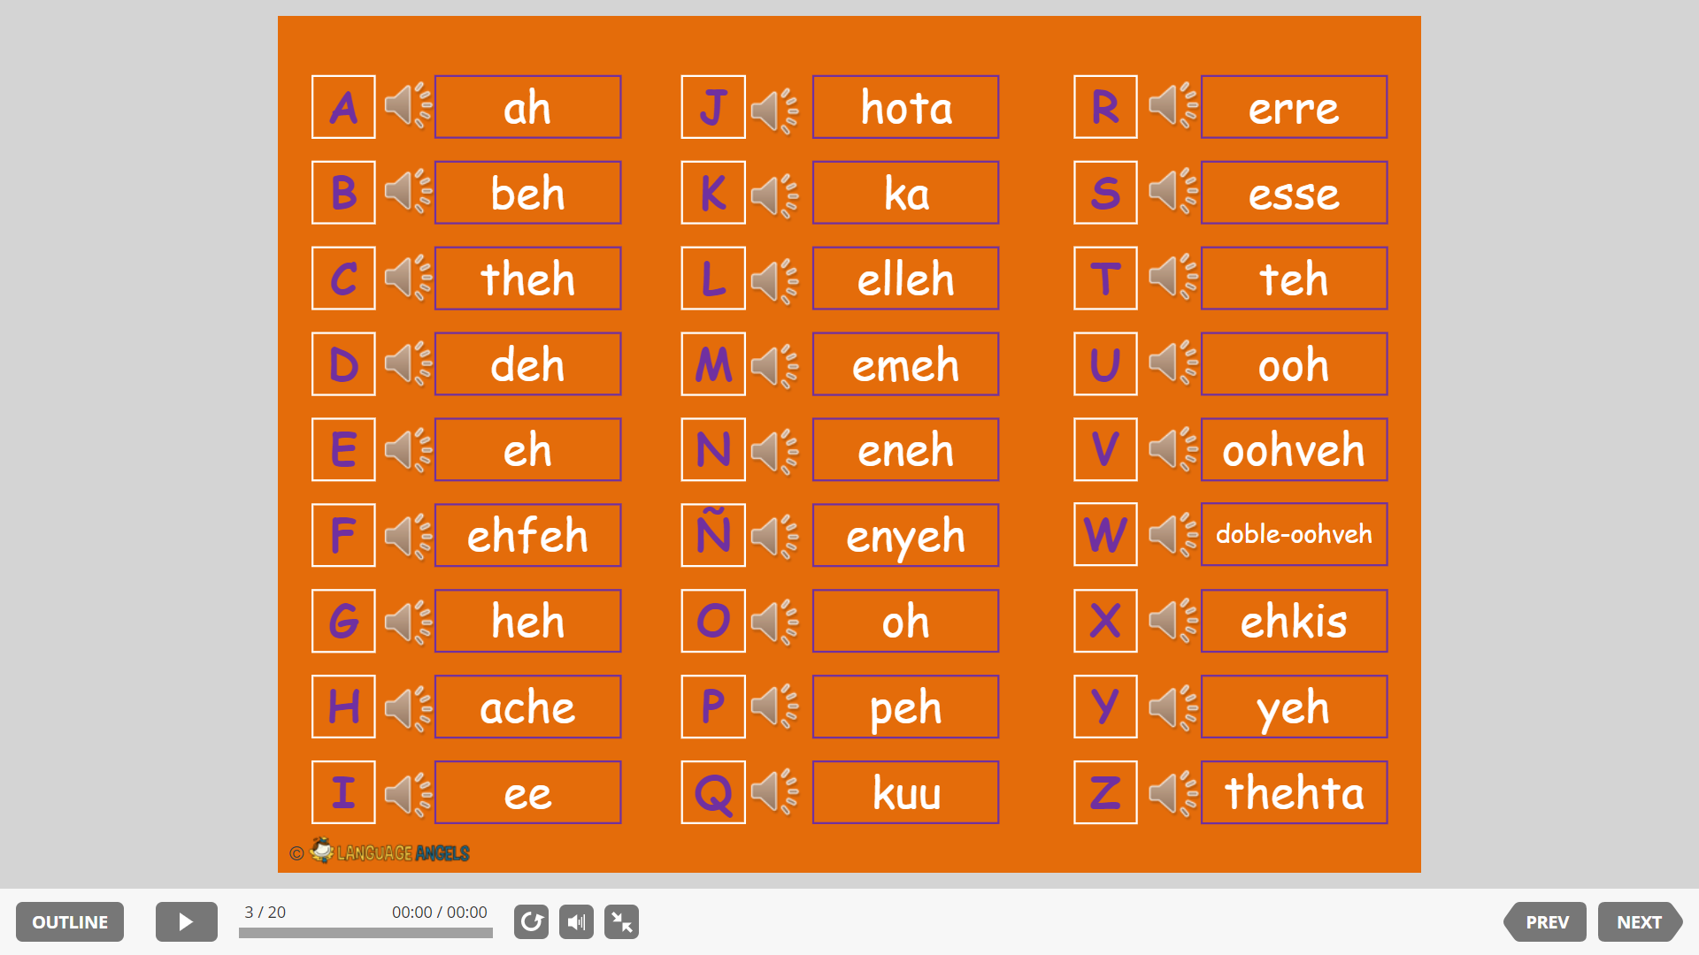

|  |  |  |
| --- | --- | --- |
| **Corpus Christi Primary School – We are Linguists** | | |
| Topic: Vocabulario básico y Fonentica | Phase KS2 | Strand: |

|  |
| --- |
| What I should already know? |
| I know that Spain is in Europe.  I know that Spanish is spoken in other countries than Spain.  I know how to ask how someone is feeling, how to say my name and ask someone what their name is.  I know how to count to ten and how to count in tens to one hundred. |

**“Simon dice…”**



|  |  |
| --- | --- |
| Top Vocabulary | |
| ¡Escribid! | write |
| ¡Repetid! | repeat |
| ¡Leed! | read |
| ¡Silencio! | silence |
| ¡Cerrad los libros! | close your books |
| ¡Abrid los libros! | open your books |
| ¡Pensad! | think |
| ¡Preguntad! | ask |
| ¡Levantad la mano! | raise your hand |
| La clase | The class |
| Por favour | please |
| Gracias | Thank you |
| Y = ‘ee’ | and |

|  |
| --- |
| What will I know by the end of the unit? |
| I know that the Spanish alphabet has 29 letters  I know the five vowels in English.  I know there are more consonant sounds in the Spanish alphabet then in the English alphabet.  I know and recognise the eight letter strings in the Spanish alphabet.  I know how to place classroom commands to actions.  I know and can follow classroom commands given in a game. |

