**Glossary**

**clause** - a group of words containing a subject and verb

**conjunction** – a word to join ideas within the same sentence (and, but, or, so, when, if, whilst, after, before etc)

**homophone**— words that sound the same but have different spellings

**expanded noun phrase**—description (adjective / adverb) that changes the meaning of the noun

**noun**—an object, person or thing

**progressive form (tense)** - a progressive action—leading up to the present (I have been waiting for this bus for half an hour.)

**subject** - person or thing doing something in a sentence

**verb** - doing word

.**Joined Handwriting**

* Use continuous cursive.
* Form lower case and capital letters of the correct size, orientation and relationship to one another.

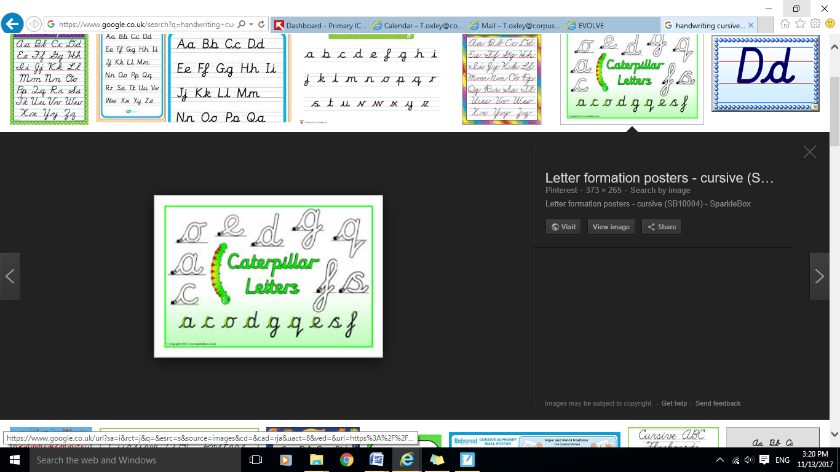

**Ways to help your child**

Practising patterns of joined up letters (such as a string of connected 'c's) helps children master cursive. ‘The more your child practises patterning, the sooner they will establish the neuro-motor pathways that make them automatic,’

**Year 2 Expectations of Spelling, Punctuation, Grammar and Handwriting**

______________________________________



**Before children leave year 2 they should be able to...**

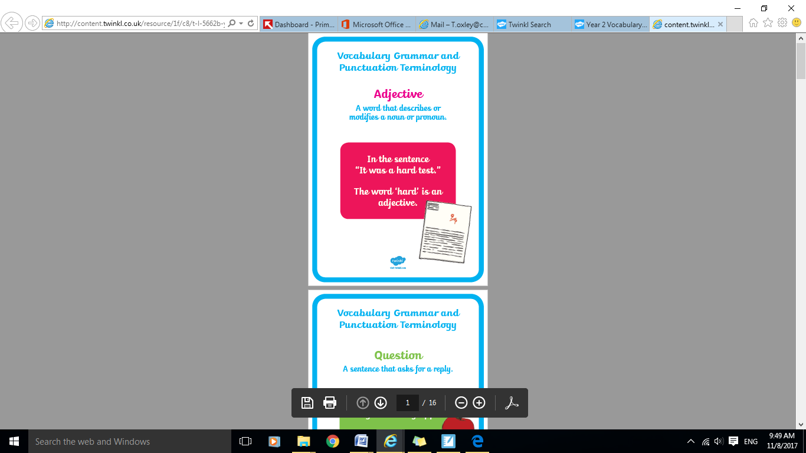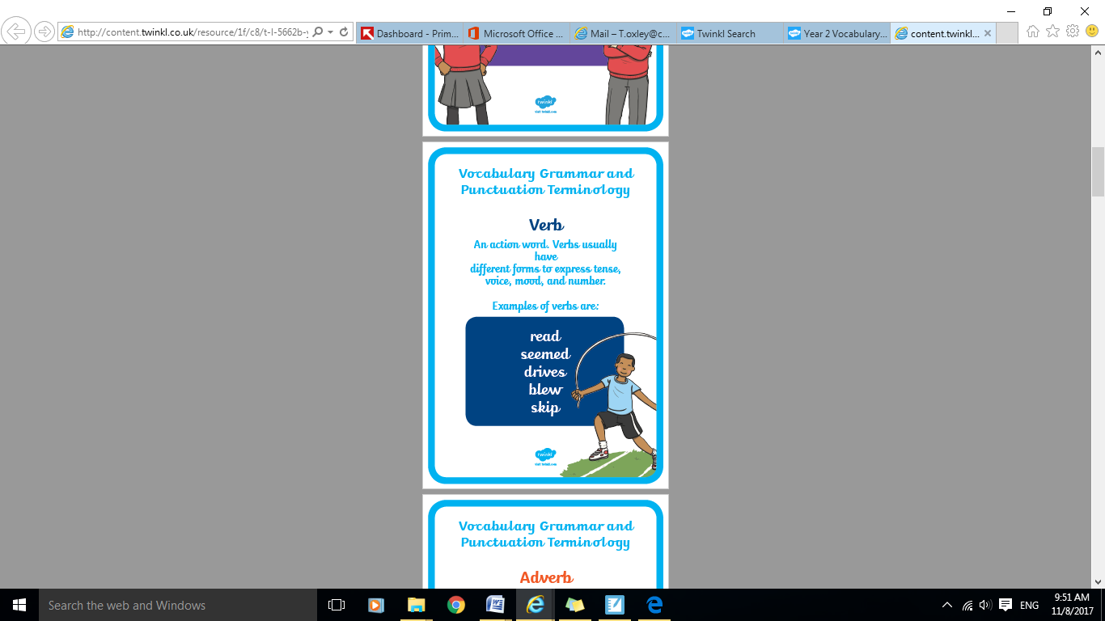

**Spelling**

* Spell words with alternative graphemes for known phonemes including common homophones.

* Spell common exception words.

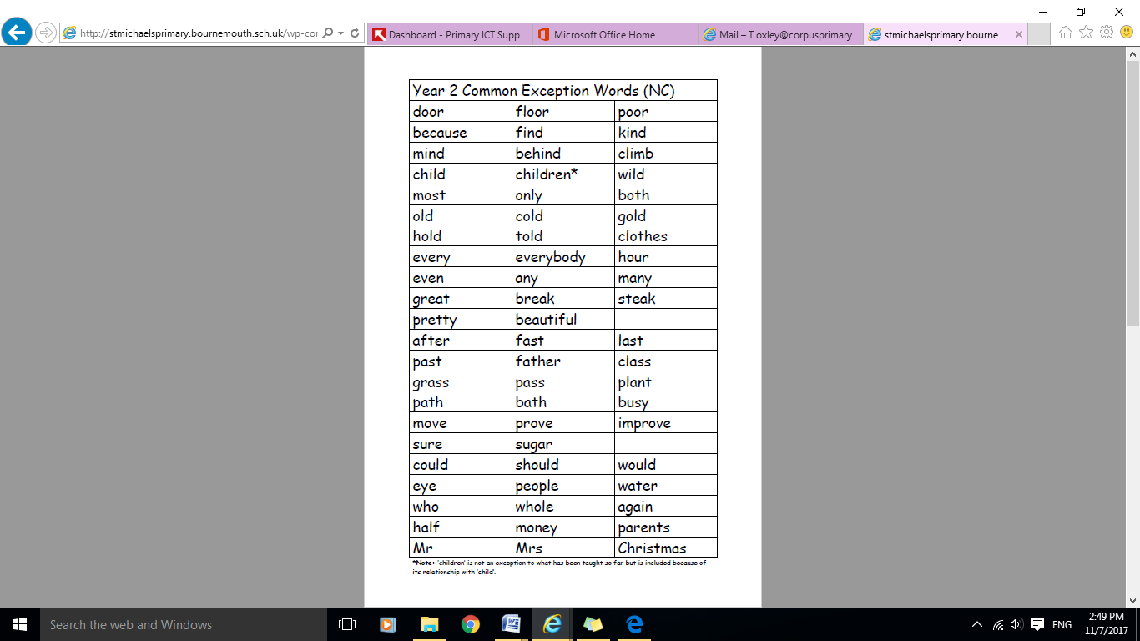

**Apostrophes**

Uses the possessive apostrophe with singular nouns and spells words with contracted forms.

The **dog’s** food looked unappealing to the cat.

I **can’t** believe my eyes

[](http://www.google.co.uk/url?sa=i&rct=j&q=&esrc=s&source=images&cd=&cad=rja&uact=8&ved=&url=http://www.bbc.co.uk/kent/content/articles/2009/02/04/apostrophe_feature.shtml&psig=AOvVaw37vP3Hwvb6cVcSbxGhZmRM&ust=1510221494562556)

**Suffixes and Prefixes**

Add suffixes –ed, -er, -est and -ing to words ending in y and suffixes -ment ness, -ful, -less and -ly to root words.

**Ways to help your child**

Children learn that to add some suffixes, you have to change the root word. E.g 'pat' has to have another 't' added before the suffix 'ed' can be added. 'Copy' has to have the 'y' removed before 'ied' is added. Encourage children to identify these patterns in words.

**Punctuation**

Uses full stops, capital letters and exclamation marks to demarcate sentences.

Uses commas to separate items in a list.

For example: The boy ate his delicious, green apple. I bought two coats, a cat, three umbrellas and a toadstool from the shop.

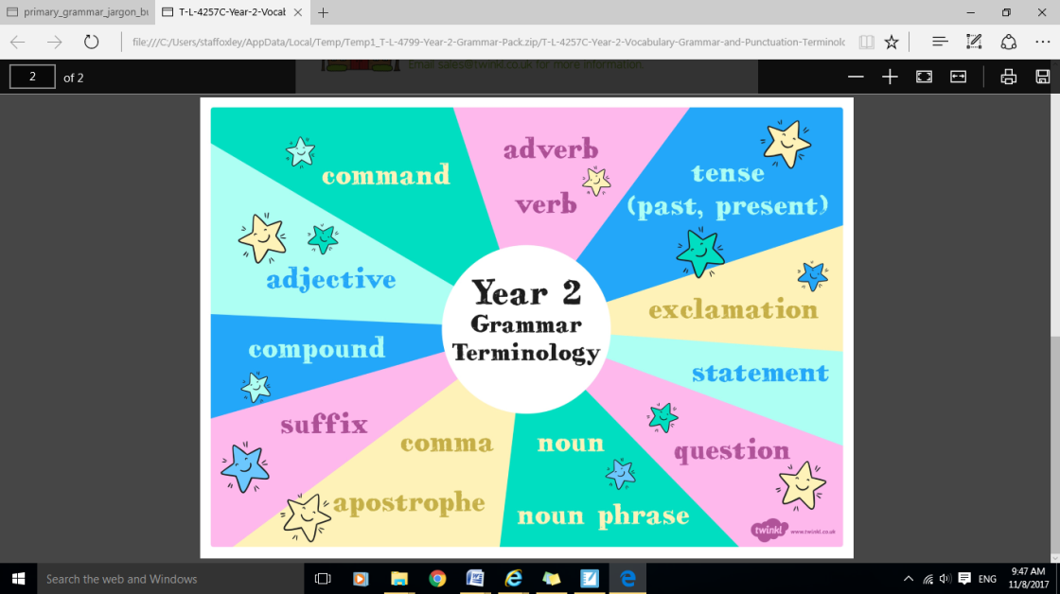

**Grammar**

* Use expanded noun phrases to expand and specify.
* Use subordinating conjunctions (when, if, that, because) and coordinating conjunctions (or, and, but) to join clauses.
* Use the present and past tenses correctly and consistently including progressive form.