**Glossary**

**adverb -** describes a verb (usually ends in-ly and describes how, where, when and how often something happened)

**article -** determines the noun (i.e a cat, the cat, an apple etc)

**clause -** a group of words containing a subject and verb

**conjunction -** word to join ideas, phrases and sentences -within sentences- (e.g. and, but, or, so, when, if, although, until, because etc)

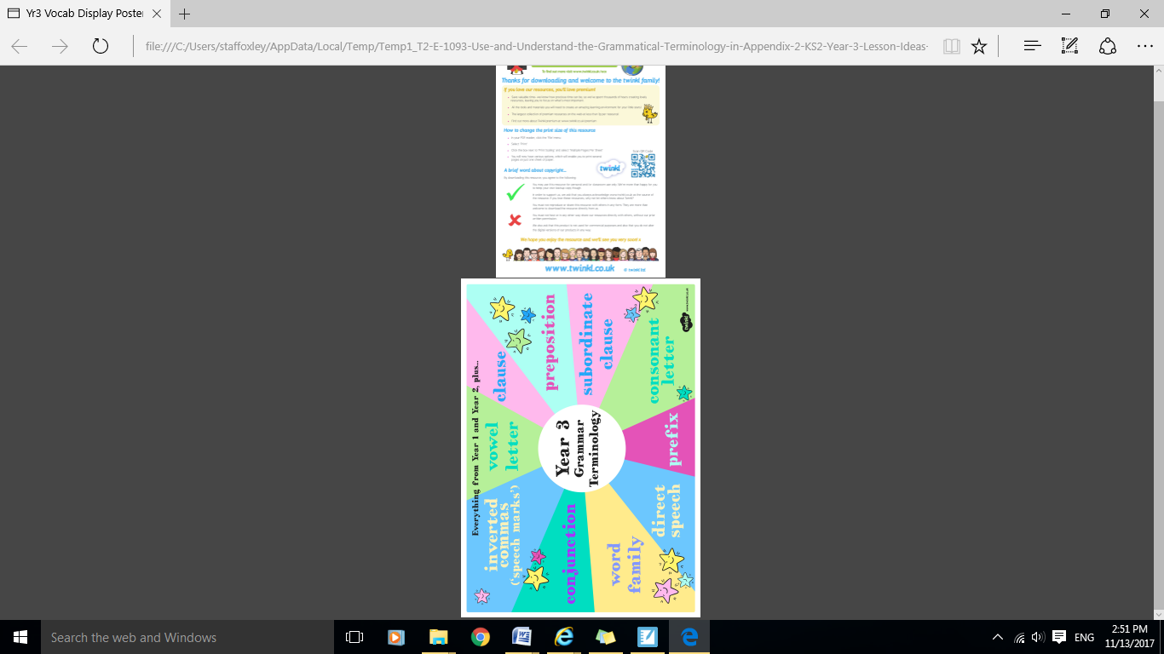**present perfect (tense) -** a progressive action - leading up to the present (I have been waiting for this bus for half an hour.)

.**Joined Handwriting**

* Use continuous cursive.
* Use the diagonal and horizontal strokes that are needed to join letters & know which letters, when adjacent to one another, are best left unjointed.



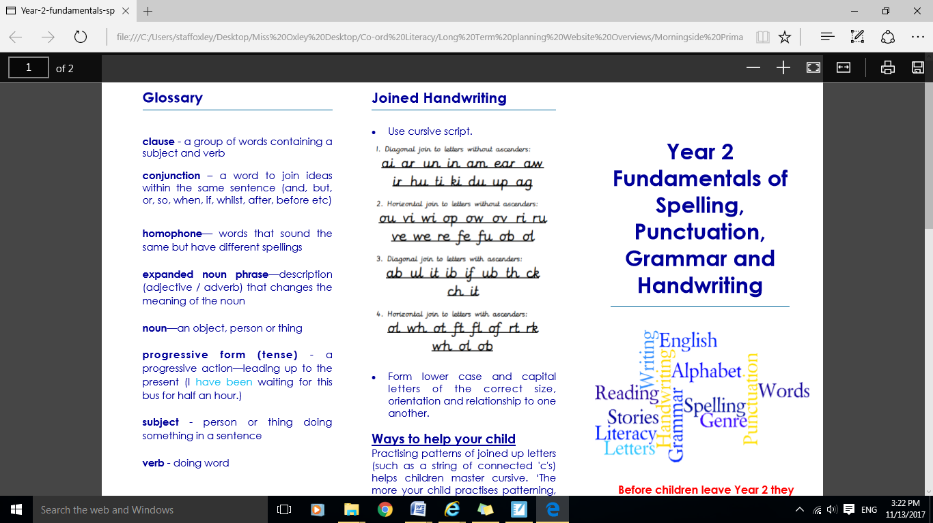

**Ways to help your child**

Motivate your child by providing him/ her with a variety of tools such as felt tips, chalks and paint as handwriting requires a lot of practise.

**Year 3 Expectations of Spelling, Punctuation, Grammar and Handwriting**

______________________________________

**Before children leave year 3 they should be able to...**

**Spelling**

* Spell all of the commonly misspelt words

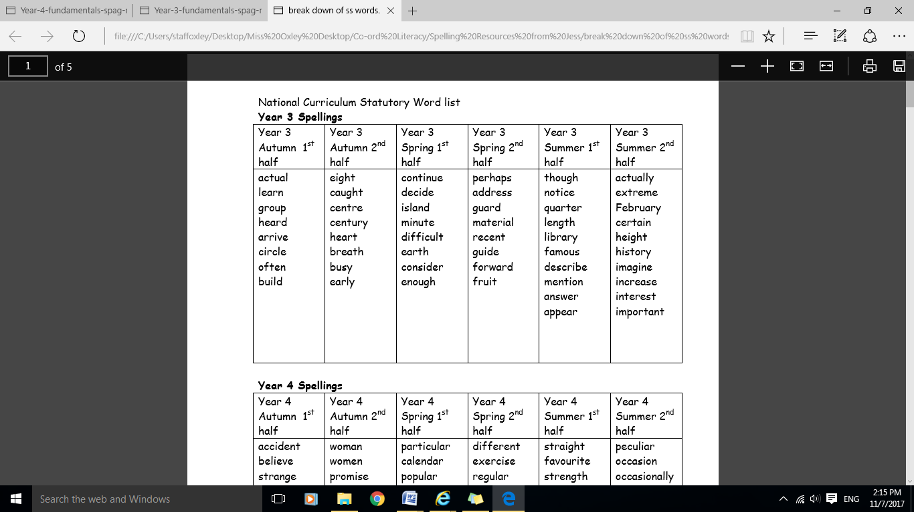



**Apostrophes**

Place the possessive apostrophe accurately in words with regular and irregular plurals.

Julia found the family of foxes’ den.

The children’s feet were cold from pond dipping.

**Suffixes and Prefixes**

Add suffixes (ing, er, en, ed) to words with >1 syllable and use and understand the suffixes –ation, -ly and –ous.

Use and understand prefixes un-, dis, mis– and in-

Spell words ending –sion, -ure and ei (eigh/-ey), words with ‘y’ within them and with ou (-uh).

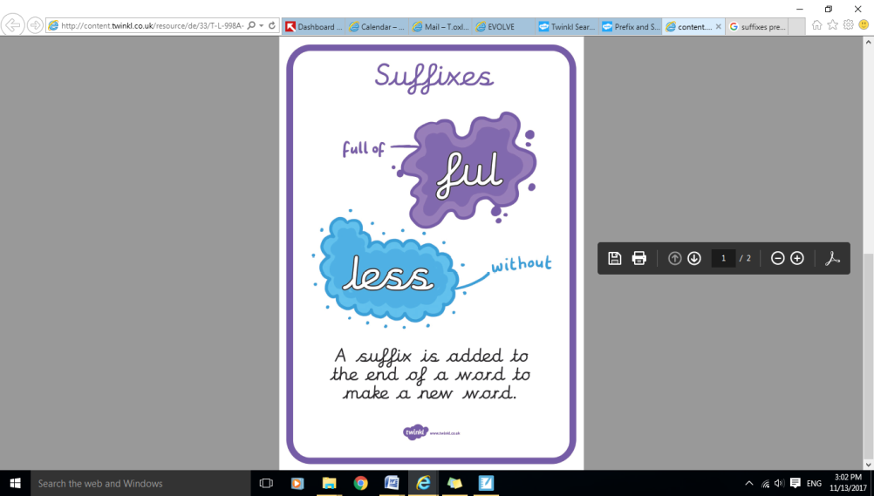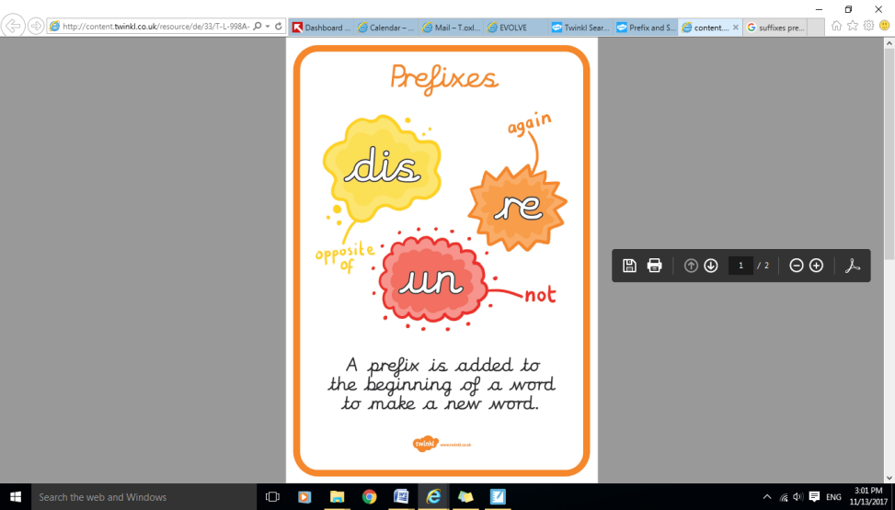

**Punctuation**

* Use inverted commas and other punctuation to indicate direct speech.

[](https://www.google.co.uk/url?sa=i&rct=j&q=&esrc=s&source=images&cd=&cad=rja&uact=8&ved=&url=https://www.thoughtco.com/quotation-marks-inverted-commas-1691713&psig=AOvVaw3xkig4NumurnFWLWq6WKkB&ust=1510671763721010)

**Grammar**

* Use articles ‘a’ and ‘an’ correctly.
* Express time, place and cause using conjunctions, adverbs and prepositions (e.g.. on, above, next to…)
* Extend sentences with more than one clause by using a wide range of conjunctions.
* Use present perfect form of verbs.