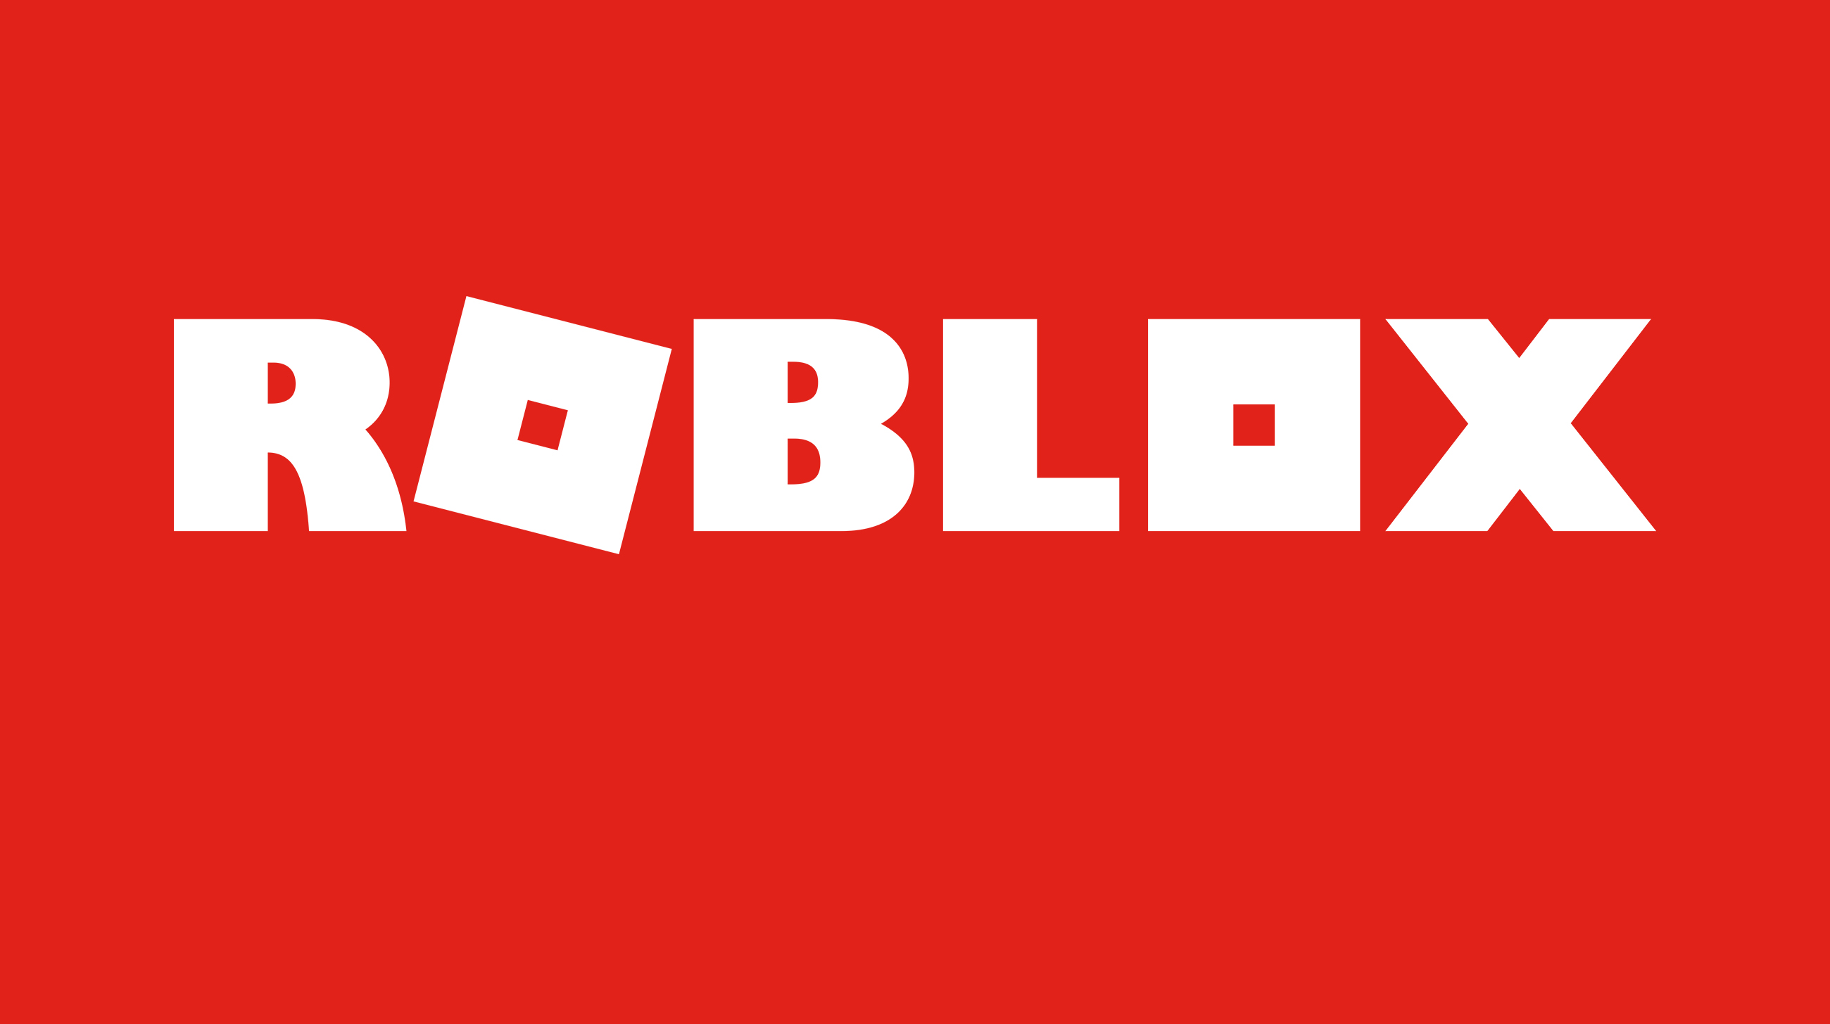

Roblox Game - a guide for parents

What is Roblox?
Roblox is a gaming platform where multiple players interact and play together online. The site has a collection of games aimed at 8-18 year olds, however players of all ages can use the site. Roblox is currently available on PC, phone, tablet and Xbox One.
Every game on Roblox is created by users, and there are a wide variety to choose from. These can vary from delivering pizzas, to roaming a kingdom as a medieval knight, to even starring in a fashion show. This variety is one of the reasons that Roblox is so popular with young people.

Top tips for parents to help young people stay safe on Roblox.

In our education sessions, young people and parents often mention Roblox, the popular gaming site. Young people regularly tell us how much they enjoy the different games and levels within it. This blog explains a bit about Roblox, what to be aware of as a parent and offers our top tips on how to ensure your child stays safe.
This is will include:
- Communication: how Roblox can be used to communicate with other users
- Content: what content is available on Roblox that might not be suitable for children
- Costs: what ways children might accidentally run up costs while using Roblox
Plus we will share our top tips for staying engaged with your children’s use of Roblox and making the most of the safety features available on the service.

Key things for parents to be aware of
1. Communication: how users can communicate with others
Whilst the games are aimed at 8-18 year olds, there are no age restrictions. This means both adults and young people can play and communicate with each other on the platform. All games are multiplayer and include a written chat feature, which is visible to players within each individual game. Users can also make and receive friend requests during gameplay and this means that they can chat to each other outside of the game. You can read more about the Roblox chat features and the way that these are moderated on the Roblox community guidelines and within their safety features.

2. Content: what content is available that might not be suitable for children
The Roblox Studio is a section where players use their imagination and skills to create their own games and share these with others. The ability to create and play games can be very appealing to young people who like to create the content they see online.However, because content is user-generated it can mean that some games might not be appropriate for young children. For example, whilst the graphics are not very life like, some of the games feature weapons and blood.

3. Costs: How children might accidentally run up costs
By creating games, users can earn Robux, the in-game currency. You can also buy Robux in the game. Players can spend money on items, such as membership to the Builders Club. If game creators attract players and in-game adverts, they can earn a lot of Robux, which they can convert into real money. To do this, players must be over the age of 13, have paid for Roblox’s premium subscription, and have access to a Paypal account. This means that younger players would need to talk to an adult to be able to exchange their Robux for real money.

Top tips for parents

Whatever gaming sites your children use, our advice remains the same. It is important to have a conversation with your child about the sites they use and carry on having open discussions. This will encourage them to come to you with any concerns they may have.

Involve your child in discussions and decisions about online safety and their internet usage. This will help them understand the importance of staying safe whilst having a great time online. It will also help to educate them about how they can keep themselves safe online and know what to do if something goes wrong.

1. Stay engaged and have regular conversations
Show an interest in the games your children are playing. This could be through having a conversation about what they like to play or could be through watching them play the game. You could even have a go at playing the games yourself! If children know you have an interest in the game, they may feel more comfortable talking to you about it or coming to you for help if they need it.

2. Help them understand the importance of personal information
Check that your child understands:
- the importance of keeping their personal information safe
- that the should speak to an adult straight away if the chat goes from being about the game to meeting up offline, personal information or sending images.

3. Set rules around spending money in games
Have a conversation with your child to make sure they realise that is possible to spend real money on the game. Make promises that work for your family; perhaps your child will have to ask you for permission before they make an in-game purchase.
If you want more help to create these promises for your family’s internet use, please refer to our family agreement.

4. Make use of the safety features available
Block and report:
Make sure your child knows how to find and use the report and block functions. Use theRoblox how to make a report page to learn how to do this.
Safety settings:
Set up the parental controls that are right for your family. You can also disable chat, set up the Parent PIN and use the Account Restrictions within Roblox. Click here for more information on how to use the Safety features.
Settings for under 13s:
There are additional safety features for under-13s , so it’s worth checking your child’s account is registered with the correct age. Players under the age of 13 have a <13 symbol next to their username on the game at all times, however this is not displayed to other players.

5. Encourage them to tell you about concerns
Remind your child that they should come to you if they ever see something inappropriate, mean comments or if anything worries them within the game. If you know how to report this type of content within Roblox, you will be in the best position to help them if they need it.

For more detailed instructions and guidance on how to use the safety features of Roblox visit the Roblox websit.

For further advice around this topic:

Our hot topic page about gaming: www.childnet.com/parents-and-carers/hot-topics/gaming

For more information around gaming, games consoles and how to keep young people safe when playing games visit the UK Safer Internet Centres website: www.saferinternet.org.uk/advice-centre/parents-and-carers/parents-guide-technology/gaming-devices

If you ever have concerns about the communication between your child and someone they have never met and only know online you should report this to CEOP here: www.ceop.police.uk/ceop-report/
For advice tailored for families around gaming: www.askaboutgames.com/

