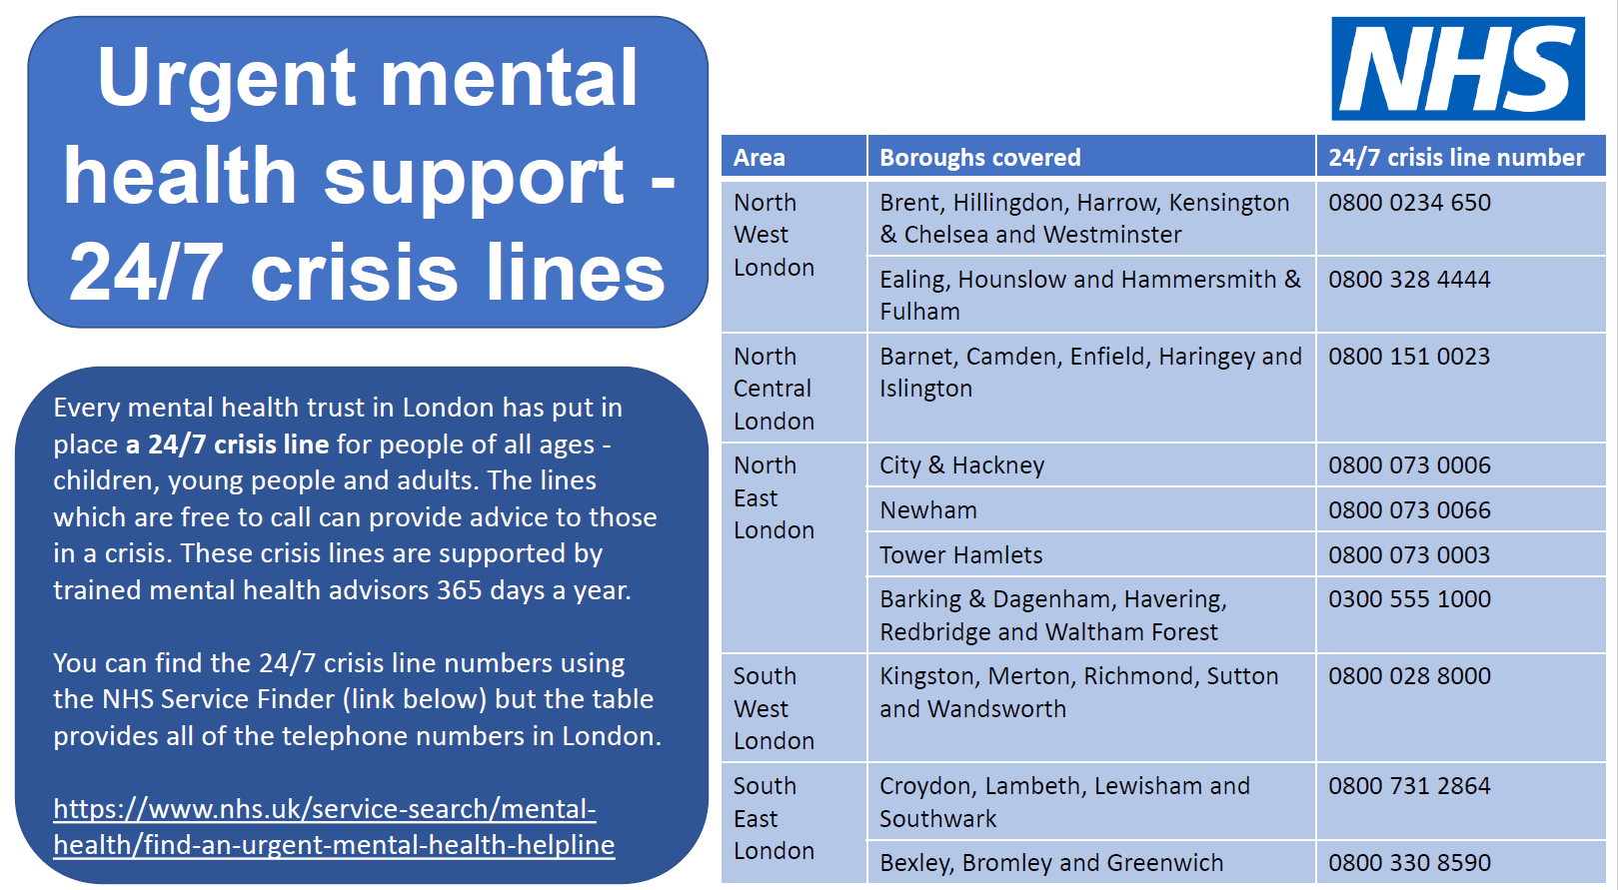

Hillingdon offer a counselling service for young people called LINK at Fountains Mill and self referrals can be made by calling 01895 277 222.
