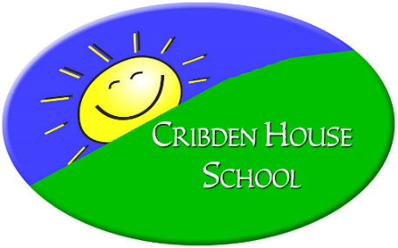

Cribden House School Curriculum Policy

Our school Curriculum
Our children need to believe they can succeed and so our curriculum aims to meet each child’s individual needs by relentlessly removing barriers to learning. This allows our children to achieve the best possible academic success alongside their holistic development as unique and valued individuals.

Curriculum Aims
- To help each child develop their self-belief and social skills so they can become confident, independent and collaborative learners.
- To meet each child’s individual academic needs through a personalised curriculum which enables them to acquire, practice and build upon skills.
- To recognise and value each pupil as an individual and build upon their emotional and physical wellbeing.
- To provide equality of opportunity to every learner and embrace the diversity of our school community and society irrespective of gender, race, disability, or religion.
- To promote the spiritual, moral, social and cultural development of pupils to live within a diverse society.
- To work in partnership with all families, involving them in their child’s education and welcoming their involvement in the daily life of the school.
- To promote opportunities for inclusion within and outside of school.
- To continually review our curriculum to ensure that the changing needs of our cohort are fully met.

IMPLEMENTATION
Early Years Curriculum
Our Early Years children and those with more significant learning disabilities follow the Early Years Foundation Stage Curriculum where appropriate.

Key Stages 1 and 2
Children are taught in nurture groups throughout school with flexible age groupings to best meet the needs of the children.
They are taught a core curriculum consisting of English, Mathematics, Science & Outdoors and PSHRE (using the most appropriate National Curriculum year group expectations/units of work). The Thrive Approach (Emotional Learning) is embedded throughout school for individuals and groups.
A Creative curriculum is also taught which ensures children access a wide range of learning activities within Foundation NC subjects, outdoor learning and therapeutic interventions (including Thrive). Teachers plan and incorporate core and foundation subjects into themes on a long term plan.

The Wider Curriculum
Throughout school, the emphasis is placed firmly upon removing barriers and maximising opportunities for every pupil so that each child accesses the National Curriculum at an appropriate level so that they can explore a much wider curriculum that meets their very individual needs.
Our wider curriculum reflects the diversity of needs of our pupils and is flexible so we can adapt to any changing needs of individuals. We seek to continuously improve the outcomes for our pupils so we are always looking for innovative ways to extend our wider curriculum.
Some of our wider curriculum at present includes:
- Thrive - a therapeutic approach to help support children with their social and emotional development.
- Therapeutic provision - Scrummy Crew (food therapy), Wild Crew (forest therapy), SmArty Crew (art therapy), Time Travellers (play based therapy), Wild Things (younger child forest therapy), Messy Crew (sensory therapy), Construction Crew (Lego based therapy), Build A World (design therapy), Fitbods (physical activity therapy.)
- Sensory learning
- Swimming
- Inclusion with local mainstream primary schools and secondary schools.
- Inclusion links with other special schools.
- Inspiring visitors
- Theme weeks/days
- Learning for leisure e.g. outward bound courses, bowling, cinema, restaurant visits,etc.
- Aesthetic and creative experiences e.g. performers, artists, shows, musicians.
- School trips
- Play skills

IMPACT
Our children make excellent academic progress across all curriculum areas and develop a love for learning. They meet challenging personal targets which support the outcomes of their EHC plans. In turn their behaviour improves and so does their progress in their social and emotional skills and their mental health.
There are many ways in which they experience success – good attendance, increased time spent in class, confidence, improved friendships, trust of adults and a sense of security and safety. Most importantly they develop a firm belief that they can succeed which enables them to make a happy and successful transition to the next stage of their education.

REVIEW
This policy was reviewed in September 2021.
Will continue to be reviewed in line with the whole curriculum review in Autumn 2021.

